
Assignment Cover Sheet
Subject Code: | CSIT321
Subject Name: | Capstone Project
Submission Type: | Report
Assignment Title: | Final Report
Student Name: | Team InnoVision: Saadiyah Asif, Roshni Warrier, Sadhguna Kumar, Masuma Calcuttawala, Manisha Narendra, Vinisha Gavin Suresh, Nita Murugan
Student IDs: | 8416655, 8276067, 8448899, 8288185, 8266852, 8283114, 8192571
Student Number: | 052-5079186, 050-7314651, 058-5948850, 056-9252900, 056-7554679, 056-7443800, 058-9523322
Student Email: | sa841@uowmail.edu.au, rmw375@uowmail.edu.au, svsk777@uowmail.edu.au, mmc951@uowmail.edu.au, mn702@uowmail.edu.au, vgs031@uowmail.edu.au, nmm467@uowmail.edu.au
Lecturer Name: | Dr Farhad Oroumchian
Due Date: | 13/4/2026
Date Submitted: | 13/4/2026
PLAGIARISM:  The penalty for deliberate plagiarism is FAILURE in the subject. Plagiarism is cheating by using the written ideas or submitted work of someone else. UOWD has a strong policy against plagiarism.  The University of Wollongong in Dubai also endorses a policy of non-discriminatory language practice and presentation.  PLEASE NOTE: STUDENTS MUST RETAIN A COPY OF ANY WORK SUBMITTED |  | DECLARATION:  I/We certify that this is entirely my/our own work, except where I/we have given fully-documented references to the work of others, and that the material contained in this document has not previously been submitted for assessment in any formal course of study. I/we understand the definition and consequences of plagiarism.  Signature of Student:
Optional Marks:
Comments:

Lecturer Assignment Receipt (To be filled in by student and retained by Lecturer upon return of assignment)
Subject: | Assignment Title:
Student Name: | Student Number:
Due Date: | Date Submitted:
Signature of Student:

Student Assignment Receipt (To be filled in and retained by Student upon submission of assignment)
Subject: | Assignment Title:
Student Name: | Student Number:
Due Date: | Date Submitted:
Signature of Lecturer

UNIVERSITY OF WOLLONGONG IN DUBAI
FACULTY OF ENGINEERING AND INFORMATION SCIENCES
SCHOOL OF COMPUTING AND INFORMATION TECHNOLOGY



FINAL REPORT
CSIT321
Autumn 2025 – Winter 2026

Team InnoVision

Name | ID
Saadiyah Asif | 8416655
Roshni Warrier | 8276067
Sadhguna Kumar | 8448899
Masuma Calcuttawala | 8288185
Manisha Narendra | 8266852
Vinisha Gavin Suresh | 8283114
Nita Murugan | 8192571

Submitted: 13 April 2026

Table of Contents
Table of Contents 1
SEM 1 9
Planning and Feasibility Document 10
Background 10
Project Description and Objectives 11
Our Solution 11
Issues Addressed and Impact 11
Project Scope 12
Competitor Analysis 13
Our Target Niche 14
Pre-requisites 15
A. Skill Prerequisites 15
B. Technical Prerequisites 15
C. User Prerequisites 16
D. Other Prerequisites 16
Limitations 16
Implementation (High-Level Overview) 18
High Level System Architecture 18
High level system architecture diagram: 19
High Level System Operation 20
Use Case Diagram (Customer Facing) 20
Use Case Diagram (Staff/Admin Facing) 21
Activity Diagram 22
Requirements Analysis 23
Software Requirements 23
Hardware Requirements 24
From the Development Team Side 24
From the System Deployment Side 24
For Users / Restaurants 24
Feasibility & Risk Analysis 25
Technical Risks 25
Feature-Specific Limitations 25
3. AR Menu Previews 25
General System-Level Issues 26
Temporal/Time Risks 27
Organizational/Member Risks 28
Financial Risks 28
Legal Risks 29
Future Improvements 29
Timeline & Deliverables 30
Gantt Chart 30
Project Management Approach 31
Team Work Distribution 32
Requirements Analysis Document 34
• Project Preliminaries 34
• System Services 37
Modules 38
i. Customer Interface 38
ii. Staff Interface 41
iii. Core Backend Services 44
iv. AI & NLP 47
v. AR Visualization 51
vi. Analytics & Visuals 53
• FURPS + Non-Functional Requirements: 55
• System Constraints 58
Interface Requirements 58
Performance Requirements: 58
Security Requirements: 59
Operational Requirements 59
Political and Legal Requirements 60
• Project Matters 60
• Appendices: 65
i. System Overview – Activity Diagram 65
ii. Traceability Matrix 66
iii. Requirement Prioritization (MoSCoW): 67
iv. RACI Matrix 68
Design Document 70
Introduction 70
Purpose 70
Scope 70
Overview 71
Definitions and Acronyms 71
2. System Overview 72
2.1 Features/Modules 72
2.2 Design Considerations 72
Design Assumptions 72
Constraints: 72
Design Methodology 73
System Architecture 74
1. Decomposition Description 74
2. Architecture Diagram 74
3. Design Rationale 78
Data Design 78
1. Data Description 78
2. Data Dictionary 79
Component Design 80
1. Customer Interface 80
2. Admin Portal Interface 82
3. Backend Services 84
4. AI/NLP Services 86
5. AR Visualization 87
Human Interface Design 88
1. Customer Interface: 88
2. Staff – Interface: 98
Requirements Traceability Matrix 102
Test Plan Document 106
Test Plan Overview 106
1. Purpose 106
2. Scope 107
3. Objectives 109
i. Functional Objectives 109
ii. System Performance Objectives 109
iii. Usability Objectives 110
iv. Security Objectives 110
v. Reliability Objectives 110
Testing Methodology 110
1. Functional Testing 111
2. Non-Functional Testing 111
Test Execution Plan 111
Test Cases – Functional Testing 113
1. Customer Side: 113
Login and Authentication 113
Landing Preview 115
Translation 118
Menu Page 118
Chatbot 121
Order selection and Cart Management 122
1. Order Finalization 124
Augmented Reality (AR) View 126
Customer Profile 127
2. Admin Side: 129
Login & Authentication: 129
Admin Menu Management: 130
Analytics 136
Test Cases – Non-Functional Testing 137
Accessibility 137
Security 138
Backup & Recovery 139
Performance & Optimization Testing 140
Usability & UI/UX Testing 142
Test Environment 143
Entry & Exit Criteria 144
Entry Criteria 144
Exit Criteria 145
Risks and Mitigation 145
Test Deliverables 146
Test Schedule 147
Conclusion 148
Change Report 148
Introduction 148
Previous Topic Summary 148
Updated Topic Summary 149
Scope & Requirements Changes 149
Functional Requirements 150
i. User interface 150
ii. Admin interface 150
iii. Core backend Services 151
iv. AI & NLP 151
v. AR Visualization 151
vi. Analytics 151
Updated Target Audience & Personas 152
Persona 1 – The Adventurous Foodie 152
Persona 2 – The Busy Parent 153
Persona 3 – The Operations Manager 153
Updated SWOT Analysis 154
Updated diagrams 155
Gantt Chart 160
Test Results 160
Login and Authentication 160
Landing Page 163
Menu Page 166
Order Selection & Cart 169
Order Finalization 172
Admin Side 173
Login and authentication 173
Admin menu management 174
Add menu item 175
Edit menu item 177
Delete menu item 179
Analytics 180
Augmented reality (AR) view 182
Functional test cases 182
Nonfunctional test cases 183
Customer profile 184
Test Cases – Non-Functional Testing 186
Accessibility 186
Security 187
Backup and Recovery 189
Performance and optimization 190
Usability and UI/UX testing 192
Implementation Summary 194
1. Customer Interface 194
2. Multilingual translation 194
3. AI chatbot 195
4. Voice interaction 195
5. AR visualization 195
6. Smart group planning 195
7. Expanded customer profile 195
8. Admin backend features 195
Known Issues & Resolutions 196
1. Translation Accuracy Across Languages 196
2. Chatbot Accuracy Depends on Menu Data Quality 196
3. AR Device Compatibility 196
4. Internet Dependency 196
5. Backup Procedures Were Not Fully Finalized 196
6. Limited Testing Coverage Across Devices 197
User Guide & Tutorial 197
1. Customer User Guide 197
2. Admin User Guide 201
Tutorial Notes 203
References: 204

HOW TO ACCESS AND RUN THE PROJECT
Below is the necessary information required to access and run the Gusto system.
- Access the code files by logging in to your GitHub account and opening the link provided.
Repository: https://github.com/SaadiyahCodes/csit321-project
- Running the project
To copy the code, run:
`git clone https://github.com/SaadiyahCodes/csit321-project.git`
You may also download the project directly from GitHub if preferred.
Setup and run instructions are provided in the README file inside the repository. It is important to follow all instruction including the pre-requisites.
- Viewing the live website
The website has been deployed and is live on the provided links.
Frontend: https://gusto-ae.vercel.app
Backend: https://gusto-ae.onrender.com
Demo YouTube Video: Available in the GitHub repository.

OTHER IMPORTANT LINKS
Informational Website: https://roshni-1011.github.io/gusto-website/

SEM 1

Planning and Feasibility Document

Background
The project addresses a critical communication and operational challenge within the hospitality sector of the UAE, specifically targeting restaurants that serve a high volume of tourists and international residents. (Roland Berger, n.d.)
With more than 200 different nationalities, UAE has a very cosmopolitan atmosphere that, although beneficial, results in a complex linguistic landscape. The official language is Arabic, and the presence of languages like Hindi, Urdu, and Malayalam enhances communication, even if English is frequently used in tourism. (UAE Embassy, n.d.) For both tourists and foreign residents, this diversity frequently results in communication hurdles during routine chores like placing restaurant orders, which can be confusing and frustrating.

This communication gap poses several critical problems that necessitate a technology solution like Gusto:
- Legal Compliance and Cultural Respect: Even for restaurants that cater mostly to tourists and expatriates, local legislation requires that all establishments have Arabic menus and signage. Accurate localization becomes a legal and culturally pertinent issue as some regulations may impose fines or other penalties for noncompliance.

- Operational Risk and Accuracy: This situation can also result in miscommunication between a customer and staff, both of whom have different linguistic backgrounds, leading to order problems or delays and a poor customer experience. More importantly, there is the serious risk to food safety from a miscommunicated allergy or other dietary issues because of a language barrier.

- Comprehensive Solutions: A lot of places try to get around this with visual menus or simple translation programs. That helps, but only up to a point. They tend not to handle the tricky questions, like what's in a dish and how it's cooked or what portion size it might be. Pictures are nice, but they can't hold a conversation.
That’s where Gusto comes in. It’s a multilingual AI platform built specifically for these kinds of challenges in the food service world. It doesn’t just translate, it bridges the gap, so everyone can order with confidence, no matter what language they speak.

Project Description and Objectives

Our Solution
Gusto aims to bridge the gap between restaurants, and customers who want the best experience – from taste to accessibility. Our platform is a restaurant-specific SaaS system which allows restaurants to cater to a vastly diverse population. It leverages personalized and contextual multilingual support on a chatbot for customers to order in their language of choice, so they can ask for details on allergens, ingredients and portion sizes without confusion or compromise.
In addition to facilitating seamless communication between staff and customers in their respective languages, Gusto also supports smart voice-based assistance for users with visual impairments through speech-to-text technology. The menu features a user-friendly interface which expands to show details like allergens and detailed ingredients. To combine usefulness with a technological immersive experience, we integrated augmented reality (AR) in menus which allow users to view the portion sizes of various dishes.
On the administrative dashboard side for kitchen staff, admins can upload menu items with accurate details, update availability of items, and provide accurate visuals.
Finally, the system collects valuable data which can help both the restaurant and the customer. The restaurant can view popular food orders and increase inventory availability and provide promotional offers on those items. If the user opts to save their information using basic credentials, the system will automatically switch to their language, cuisine preferences, and inform them about allergens in their next visit.
Gusto’s highlight is that it does not replace workers in the industry, but rather, complements them by reducing communication barriers and human error. Through extensive language support, an intelligent knowledge-based chatbot, and voice ordering, Gusto empowers every customer to order confidently and independently.

Issues Addressed and Impact
This section highlights the barriers faced by restaurants and customers in the UAE, as well as our proposed solutions to add value and mitigate these issues.
- Language Barriers: Tourists and international diners in the UAE often face difficulties accurately ordering food due to the diversity of languages among restaurant staff and customers. Using translation apps could cause errors in understanding and conversing important details like allergens, ingredients and facilities. Additionally, restaurant staff may misinterpret orders, leading to mistakes, delays, and food safety risks. It also reflects a poor customer experience for the restaurant. This creates a need for integrating multi-language support in the restaurant itself. Through a system which can adapt the menu, chatbot messages and voice support to the language comfortable for the user, as well as intelligently answer questions with context, Gusto can greatly enhance their experience.

- Accessibility: Currently, even medium to high end restaurants do not provide additional facilities or support for people with disabilities or impairments. By integrating voice-based communication in the process, the person can do all their necessary tasks simply through speech, from asking questions to the chatbot to making orders.

- Poor Customer Experience: Inefficiency can be a huge roadblock for restaurants which depend on being efficient and having less friction. Additionally, mismanaging expectations such as portion sizes can leave customers feeling disappointed. Gusto provides an immersive AR feature to the menu, allowing customers to visualize food items and assess portion sizes to choose the food they will be satisfied with. Through a simple API, Gusto can send order details, table or delivery location information and integrate easily with existing restaurant PoS systems which already manage tracking orders and payments. This flexibility allows Gusto to work easily with restaurants that provide both in-dining and home delivery, or just one, without the cost of reworking their infrastructure.

- Lack of Insight: A lot of critical data such as common queries by customers, allergens and dietary needs, language profiles of customers, and other information are undocumented by waiters who have to handle taking orders and solving customer issues. Through analyzing how users interact with the chatbot, anonymizing and aggregating the data, Gusto provides deeper analytics of the customer base, going beyond surface-level data such as top orders to identify the intention and buyer journey of the users before they make the final decision.

Project Scope
The Gusto System aims to transform dining experience in mid-to-high-end restaurants by leveraging AI, NLP, and AR technologies to bridge communication barriers, improve operational efficiency, and enhance customer satisfaction. The scope of this project covers the development, integration, and deployment of the following key modules:
- Voice Assistance & Accessibility
Enables customers to ask queries or to read the menu through natural speech recognition in their preferred language.
The system will convert voice input to text, send the query to the chatbot and reply back in their local language. This enhances accessibility for users who prefer verbal communication, have visual impairments, or have trouble reading due to any issues.

- Real-Time Translation Engine
Provides instant bidirectional translation between customer and the system, allowing smooth interactions even when they speak different languages.
The translation engine will integrate with both the voice module and chatbot, ensuring consistent multilingual support.

- AI-Powered Chatbot Assistance
A conversational AI that handles menu-related inquiries such as ingredients, allergens, portion size, and recommendations.

- AR-Based Menu Previews
Offers customers interactive, realistic visualizations of menu items through AR (Augmented Reality) overlays. By scanning an AR trigger interface such as a plate, users can view dish presentations, portion sizes, and plating before ordering.

- Analytics Dashboard (Staff Side)
Collects and analyzes customer interaction and behavioral data which restaurants usually do not have such as:
- Number of conversions from chatbot conversations (conversion rate).
- Common allergen or dietary restrictions inquiries.
- Frequently asked questions or popular menu items.
- Language distribution profile of user base.
This helps restaurants understand customer preferences, optimize menus, and identify trends for marketing and inventory planning.

Competitor Analysis

Competitor | Key Features | Target Niche | Limitations
MenuAR | •3D/AR visualization of menu items.  • QR-based digital menu access.  • Enhances customer engagement through immersive visuals. | • Modern and tech-driven restaurants seeking visual appeal.  • Upscale or experiential dining spaces aimed at aesthetic presentation. | • No multilingual or AI support.  • No chatbot or personalization options.  • Focused only on visualization, not user interaction or automation.
Zarvo.ai | • Multilingual AR-enabled digital menu system.  • Real-time menu updates and loyalty tools.  • Basic analytics for marketing and sales. | • Mid-sized restaurants and chains with multilingual customers.  • Businesses seeking digital transformation and loyalty management. | • No voice assistance or real-time chatbot.  • Lacks sentiment analysis and accessibility features.  • Focuses mainly on automation, not human-AI collaboration.
Menu Guide | • Digital QR-based menu and online ordering system.  • Basic data analytics and customization options.  • Simple user interface for small restaurants. | • Traditional or small-scale restaurants need digital menus.  • Businesses starting basic digital adoption without complex tools. | • No AI chatbot or translation features.  • Limited personalization and accessibility options.  • Focused mainly on digitization, not intelligent support.

Our Target Niche

Gusto targets restaurants in multicultural countries, where customers and waiters typically speak distinct mother tongues.
Primary Users:
- International tourists and expats struggle to order with confidence due to differences in language or food allergies.
- Restaurant waiters and managers seeking simpler communication, fewer mistakes, and faster services.
Secondary Users:
- People with visual impairments, reading difficulties, or lack of literacy who prefer voice-based communication in their own language and can feel empowered through voice support.
Ideal Clients:
- Mid-market to upscale dine-in restaurants, cafes, and hotel restaurants looking to reinvent the dining experience without eliminating human hospitality.
- Tourist restaurants within cities like Dubai, Abu Dhabi, Sharjah, and extended rollout to other multilingual markets (e.g., Singapore, Qatar, Malaysia).
Gusto's value proposition is the synergy of hospitality, AI translation, and real-time food service optimization.

Pre-requisites
The following pre-requisites include the requirements for the development and implementation of Gusto.
They are divided into three parts: Student/Developer Skill Prerequisites, System/Technical Prerequisites, and User Prerequisites; so that the development process continues unobstructed and system functioning remains perfect.

A. Skill Prerequisites
- Programming & Web Development: Python (FastAPI) for backend, JavaScript (React) for frontend, RESTful APIs, asynchronous programming, microservice architecture.
- Database Management: NeonDB (PostgreSQL) for managing menus, users, and order records; Alembic for schema design and maintenance.
- Artificial Intelligence & NLP: Gemini API for chatbot (with retrieval-augmented generation conceptual implementation) and translation modules; natural language processing and intent extraction.
- Frontend & AR Integration: React for responsive interfaces, Web Speech API and WebXR for voice interaction and AR functionality.
- Cloud Deployment & API Integration: Vercel for frontend hosting and Render for backend hosting; integration with NeonDB for cloud database.
- Version Control & Collaboration: GitHub for version control, Visual Studio Code for collaborative development, and Notion for project management.
- UI/UX & Accessibility Design: Accessibility standards awareness to design interfaces for visually impaired and multilingual users.

B. Technical Prerequisites
- Frontend Access: Ability to deploy on Vercel; access to Web Speech API and WebXR in supported browsers.
- Backend Access: FastAPI server hosted on Render; access to Python environment and required libraries (FastAPI, LangChain, Gemini Google Studio SDK).
- Database Access: NeonDB PostgreSQL account; credentials to create/manage schemas for users, menus, orders, and logs.
- AI Services Access: Gemini API key, Google Speech-to-Text; network access for API requests.
- Development Tools: Visual Studio Code, GitHub repository access for version control and collaboration.
- Hardware Requirements: Smartphone/tablet for AR and voice testing; PC or tablet for testing customer-facing system and staff dashboard.
- Internet Connectivity: Stable connection for AI services, AR loading, and real-time voice/chat responses.

C. User Prerequisites
For optimal use of Gusto, customers and restaurant staff should meet the following basic requirements:
- Device Accessibility & Basic Digital Literacy
  - Users should possess an appropriate device, and should be able to navigate a web interface, scan QR codes, and follow on-screen prompts for ordering and communication.
- Language Selection Awareness
  - Users must select or confirm their preferred language upon entry to ensure accurate translation and chatbot interaction.
- Internet Access
  - A secure internet connection is required to access live translations, AR menus, and chatbot features.
- Browser Compatibility
  - Google Chrome, Safari, or Microsoft Edge are recommended browsers for full functionality and AR support.
- User Account (Optional)
  - Registered users can optionally store preferences and allergies for easy access; however, guest access is available for a quick order.

D. Other Prerequisites
Data: Restaurants need to provide digital menu data on their admin dashboard, ideally with images as well as AR models which can be created through Gusto’s support staff.
Operational: Basic staff training sessions (15–30 minutes) for dashboard operation and order management.
Financial: GeminiAPI credits to access LLMs for integrating in chatbots for both natural language conversations and handling chatbot-based orders, as well as voice interaction and translation. ARCode credits for creating downloadable GLB models based on 360 view videos of real dishes.

Limitations
- Limited Language Coverage (Initial Phase)
The initial version of Gusto will support only 6 languages - English, Arabic, Urdu, Hindi, Spanish and French. Expansion to additional languages and dialects will be considered in later phases based on demand and data availability.

- No Full POS or Payment Integration in Phase 1
Gusto will integrate with existing POS systems only at the order and menu level.
Advanced features like payment gateways, billing, or inventory synchronization will be addressed in future versions once pilot testing is complete.
- Limited AR Complexity
To manage development time and cost, the AR previews will initially use semi-3D or photogrammetry-based visuals, not full 3D interactive models.
High-fidelity 3D rendering will be an enhancement for later stages once system performance and restaurant adoption are validated.
- Limited Customization for Each Restaurant
Gusto will provide a standardized UI and dashboard across all restaurant clients.
Advanced brand customization (colors, fonts, layouts) will be limited to basic theming only.
This ensures scalability but may reduce design flexibility.

- No Direct Hardware Integration
The system will run entirely on existing devices (phones, tablets, PCs).
Integration with robotic waiters, kiosks, or IoT hardware will not be part of this project’s deliverables but may be explored in future R&D phases.

- Dependence on Restaurant Data Accuracy
Gusto’s AI chatbot and analytics depend on the accuracy of data provided by the restaurant.
Data validation and quality assurance are outside the system’s automated functions in Phase 1 and will require manual oversight by the restaurant or consultants.

- Geographic Scope - Pilot Rollout Only
The project will be tested and deployed initially within a single geographic region (e.g., UAE or a specific city). Cross-border scalability and international rollout are beyond the current implementation phase.

- Customer Device Dependence
Gusto will rely on customers who have their own smartphones or tablets to access the website.
Dedicated restaurant hardware (like in-table screens or kiosks) is optional to minimize implementation costs for client restaurants. However, restaurants are suggested to provide free Wi-Fi for customers to access the website on their own devices.

Implementation (High-Level Overview)

High Level System Architecture
Layered Architecture diagram:
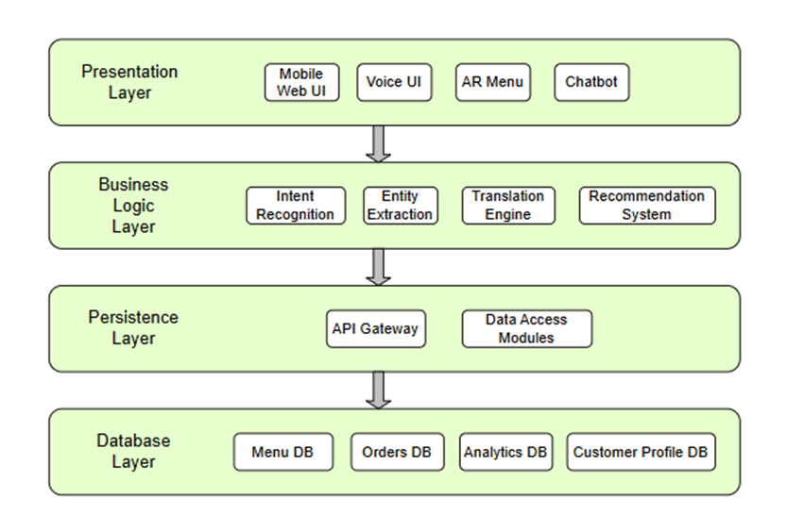
Our system follows a four-layered architecture, ensuring modularity and scalability.
- The Presentation Layer hosts different user interactions including voice assistance, Augmented Reality viewing, and a chatbot (for context understanding and question answering).

- The Business Logic Layer hosts the backend logic including the AI and NLP modules for understanding user intent, order logic, translating communication, and generating recommendations for the user.

- The Persistence Layer manages secure API calls, and controls data exchanges between modules.

- The Database Layer maintains the different structured databases associated, including the restaurants, menu, orders, analytics data, and customer profile and session information.

High level system architecture diagram:
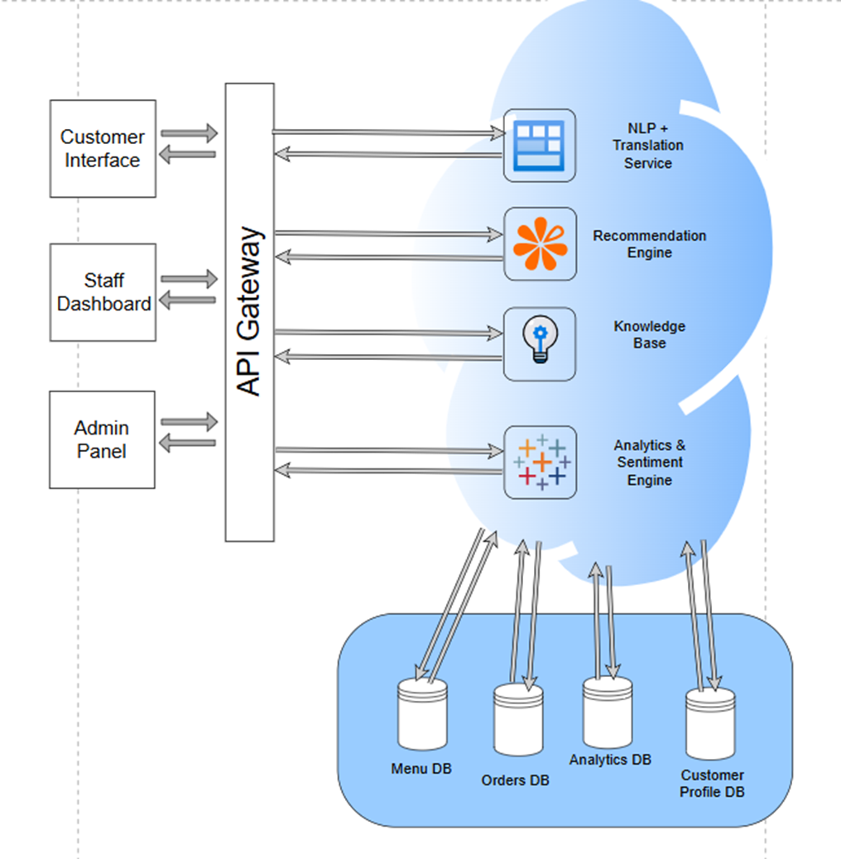

The high level architecture describes how the customers, staff and administrators interact with the Gusto platform. All requests are sent to the API Gateway, which routes these requests to the respective backend service. The different services managed by the backend include NLP processing, translation, recommendations, and continuous collection of insights for restaurant operations analytics. The database layer consists of the restaurant menu, details of the orders, customer profile information, and analytics data. This layer ensures reliability and traceability.
The modular microservice design helps ensure maintainability, scalability, and rapid iteration. Hence, it is an ideal design that supports an agile development model.

High Level System Operation

Use Case Diagram (Customer Facing)
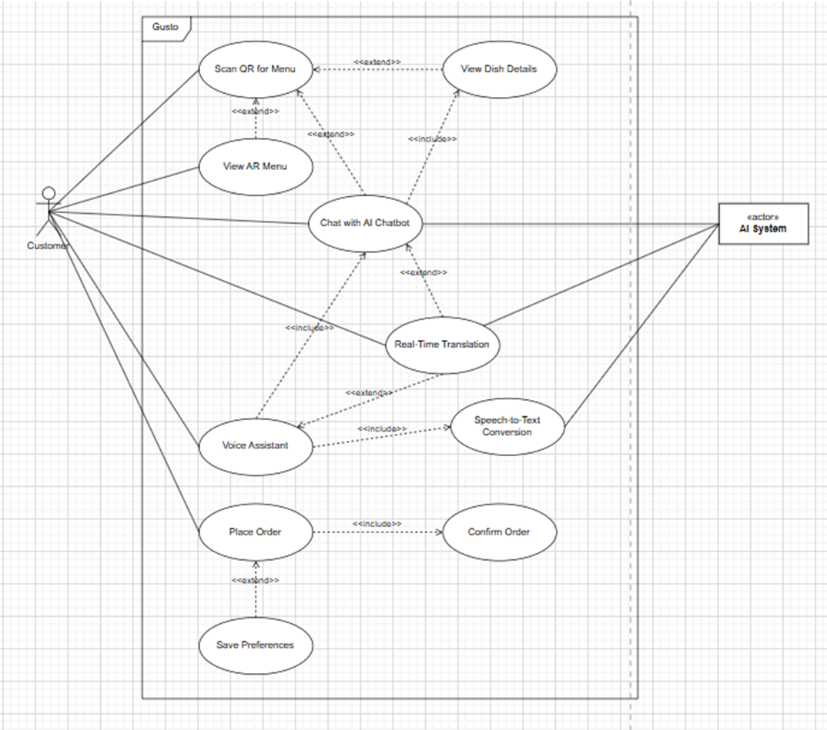

The customer-facing use case diagram lists the different interactions that the customer has with the Gusto system. The customer can scan QR for the menu, which lists various options including an AR viewing feature, details of the dish, and an option to chat with the chatbot (for specific queries regarding the dishes). The customer can also interact with the system in their preferred language (listed in the system), through the real-time translation feature, through either voice or text. Finally, the customer can place their order and also optionally save their preferences to their profile.

Use Case Diagram (Staff/Admin Facing)
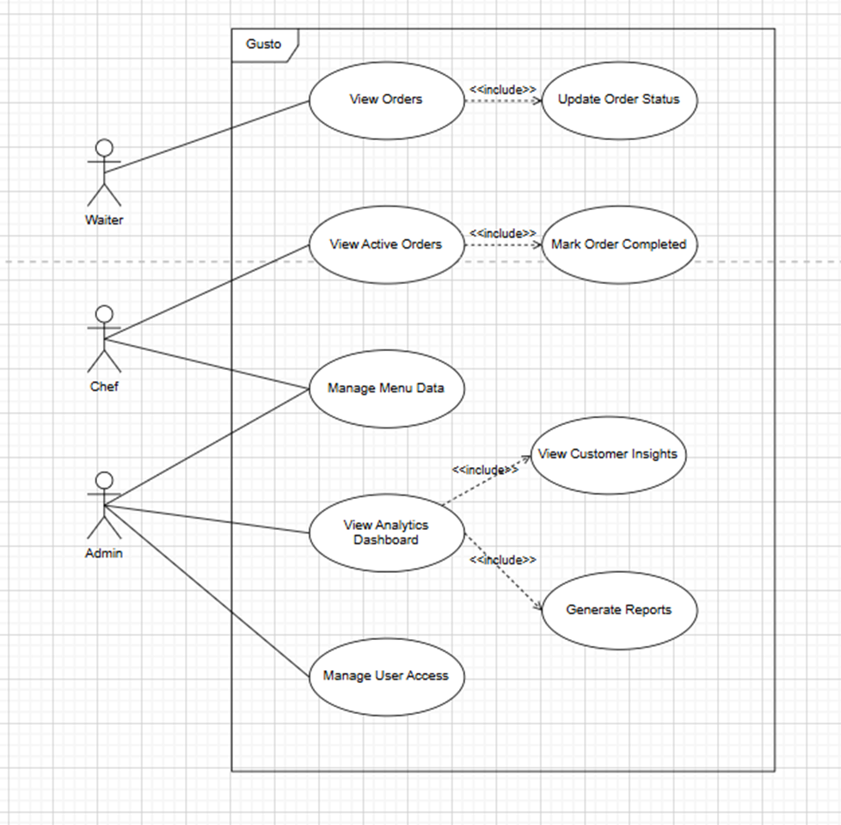

The staff-facing use case diagram displays how the admin can manage the items listed on the menu. The admin has control over the menu data and uploads menu item details and availability status. They can also access in-depth analytics based on customer interaction and order data from the analytics dashboard. In the future, they can generate reports based on these analytics which could enhance their menu optimization and marketing strategies.

Activity Diagram
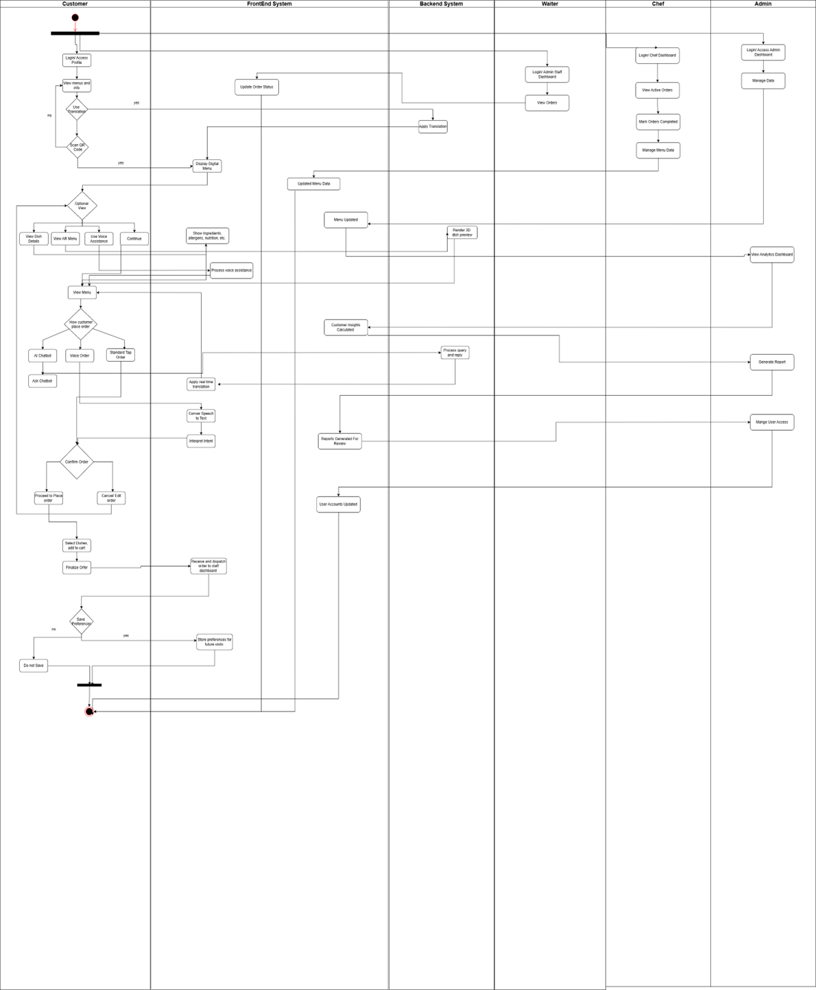

Requirements Analysis

Software Requirements
Feature/Module | Tools/Technologies | Explanation
Website Frontend (User and Admin Dashboard) | React (JavaScript), Web Speech API | The web application interface for customers and kitchen staff.  React and Vite was chosen for its scalability and support for real-time and fast UI responses. The Web Speech API enables voice input and speech output for accessibility and spoken queries.
AR Menu | WebXR | Displays 3D models or AR overlays of dishes for customers from the menu. Enhances visualization of portion sizes before ordering.
Backend (Core Logic and APIs) | FastAPI | Manages all backend logic, chatbot interactions, and API requests between frontend, AI services, and the database. Chosen for its performance, simplicity, and Python compatibility for AI integration.
Database | NeonDB (PostgreSQL) | NeonDB was chosen due to its suitability for the data type stored by the system, simple integration, and the team members’ familiarity with the platform. Stores user profiles, sessions, menu item details and transactional data.
AI & Voice/NLP Layer | Google AI Studio – Gemini and Google Translate | Handles natural language understanding, translation, and conversational responses. Converts voice input to text, generates intelligent replies, and extracts intent for the chatbot and order flow.
Analytics Layer (Staff View) | React | Visualizes operational data such as popular dishes and allergen frequency to support restaurant decision-making.
Development & Version Control | Visual Studio Code, GitHub | Collaborative development, version control, code management, and continuous integration support.
Deployment and Hosting | Vercel (Frontend), Render (Backend & AI APIs) | Vercel is used for seamless frontend deployment. Render is used to host the FastAPI backend and database connections efficiently.

Hardware Requirements

From the Development Team Side
- Personal computers / laptops:
  - Used for coding, testing, and running local development servers.
  - Requirements: Any modern laptop/PC with at least 8GB RAM and internet connectivity.
  - Optional: A device with webcam/microphone for testing voice input.

From the System Deployment Side
- Cloud server:
  - Hosted on a free-tier or developer-friendly cloud platform.
  - No physical hardware is required; the cloud provider handles the servers.

For Users / Restaurants
- Customer devices: Smartphones, tablets, or PCs with browsers supporting Web Speech API and WebXR. It should have a working built-in microphone if they require the voice assistance feature.
For an app to run well, it must have enough memory (RAM) at least 2GB for basic capabilities like handling voice inputs and real-time translation and 3GB for AR visuals.
- Staff devices: Tablets or PCs for admin dashboards.
This allows employees to manage menu data, update item availability, and view analytics.

Feasibility & Risk Analysis

Technical Risks

Feature-Specific Limitations

1. Real-Time Translation
Limitation:
Machine translation may not always convey contextual or culturally specific meanings, especially in fine dining where dish names or preparation methods have cultural significance.
Impact:
Inaccurate translations could confuse customers or misrepresent menu items, affecting the restaurant’s brand image.
Mitigation:
Adopt a human-in-the-loop translation system where managers verify or adjust translations and maintain a restaurant-specific translation glossary to ensure accuracy.

2. AI Chatbot
Limitation:
The chatbot’s reliability depends on regular data input from the restaurant, such as ingredients, allergens, and preparation methods.
If updates are missed, the system may provide outdated or incomplete answers.
Impact:
This may lead to misinformation or reduced trust from customers seeking dietary or allergy-related details.
Mitigation:
Implement automated data update reminders, provide an intuitive admin interface, and use a data validation workflow before changes go live.

3. AR Menu Previews
Limitation:
Developing high-quality AR visuals requires professional photography, 3D rendering, or modeling, which may involve higher costs and frequent updates for dynamic menus.
Impact:
Restaurants may limit AR previews to a few popular dishes or delay updates, leading to inconsistent user experience.
Mitigation:
Start with semi-3D or photogrammetry-based models for cost efficiency and gradually upgrade to fully interactive AR models as the system evolves.

4. Analytics Dashboard
Limitation:
The analytics module’s accuracy depends on clean, structured data. Inconsistent data input (e.g., allergen info or order tagging) can result in incomplete insights.
Furthermore, analyzing customer interaction data raises data privacy and compliance concerns (e.g., GDPR).
Impact:
Poor data quality could reduce the dashboard’s usefulness for decision-making, and weak data protection measures could create legal risks.
Mitigation:
Use data validation checks, enforce anonymized aggregation, and apply strong encryption protocols to ensure secure and accurate analytics.

General System-Level Issues
1. Internet Connectivity and Infrastructure Dependence
Issue:
Most AI and AR features including live translation and chatbot responses, require a stable internet connection. Network instability can reduce responsiveness or delay AR loading, especially during peak dining hours.
Mitigation:
Implement offline caching of key menus and enable local fallback modes for basic ordering functions.
2. Integration with Existing POS or Management Systems
Issue:
Many high-end restaurants already use customized POS systems, making integration technically complex or time-consuming.
Mitigation:
Develop standardized APIs and offer custom integration support to ensure compatibility with existing infrastructure.

3. Initial Setup and Training
Issue:
Restaurant staff may require training in using dashboards, updating menu data, and interpreting analytics. Initial onboarding can be time-consuming for teams not familiar with digital systems.
Mitigation:
Offer white-glove onboarding and training sessions as part of implementation, including video tutorials and in-person guidance.
4. Cost of Implementation
Issue:
While Gusto is designed to be scalable, initial costs for AR content creation, API subscriptions, and cloud hosting may still be high for smaller mid-range restaurants.
Mitigation:
Adopt a tiered pricing model with optional modules so restaurants can start with essentials (chatbot + translation) and scale up to AR and analytics later.
5. User Adoption and Customer Experience Balance
Issue:
Some customers, especially in fine-dining environments, may prefer human-led interactions over digital ordering tools.
If positioned incorrectly, the system may be perceived as impersonal.
Mitigation:
Promote Gusto as a staff-assisting tool, emphasizing that it supports servers rather than replacing them - preserving the human touch while improving efficiency.
6. Data Security and Compliance
Issue:
Handling multilingual user inputs, order details, and feedback introduces data protection risks. Non-compliance with regional data laws could damage the restaurant’s reputation.
Mitigation:
Use end-to-end encryption, anonymize sensitive data, and comply with international privacy frameworks (GDPR, ISO 27001).

Temporal/Time Risks
Challenges:
The project involves multiple advanced modules, including voice recognition, AI chatbot integration, and AR menu visualization, all requiring parallel development and testing. Coordinating these tasks over two semesters still involves dependencies between backend logic, API integration, and front-end design, which may cause scheduling challenges.
Impact:
Delays in one module (e.g., AR or translation) could cascade into overall project delays, reducing time for integration testing, user feedback, and refinements before the final submission.
Mitigation / Proposed Solution:
Adopt an Agile sprint-based workflow with clearly defined milestones for each feature. Prioritize core functionality (chatbot, ordering, translation) in early sprints and integrate AR features once the core is stable. Use Git-based task tracking and assign contingency time (10–15%) for integration and bug fixing.

Organizational/Member Risks
Challenges:
Team members may have varying levels of technical expertise across the AI, AR, and data analytics modules. Learning curves for frameworks like WebXR (for AR) could slow progress. Coordination issues may also arise if roles and responsibilities are not clearly defined.
Impact:
This could result in inefficiencies, duplicated efforts, or incomplete implementation of key system components, particularly during early development stages.
Mitigation / Proposed Solution:
Clearly assign ownership for each feature and maintain weekly check-ins to track progress and promote knowledge sharing. Utilize available APIs to minimize custom model development time.

Financial Risks
Challenges:
While the system is scalable, implementing AI, AR, and analytics components involves initial costs for paid APIs (for translation or voice recognition) and possible hardware requirements for AR testing.
Impact:
Budget constraints may limit access to premium APIs or slow down development if resources are insufficient, potentially affecting system performance during demonstrations or testing.
Mitigation / Proposed Solution:
Adopt a modular architecture so that non-critical features can be integrated later when resources are available. Optimize the use of available resources and prioritize the development of core functionalities to manage costs effectively.

Legal Risks
Challenges:
Handling customer data (voice recordings, order preferences, translation logs) introduces privacy and data protection responsibilities. Additionally, compliance with local and international laws such as UAE data protection regulations or GDPR must be ensured if user data is stored or processed in the cloud.
Impact:
Failure to comply with data privacy standards could result in reputational damage or penalties and could negatively affect institutional evaluation for ethical handling of user information.
Mitigation / Proposed Solution:
Ensure that all data collection is anonymized and limited to functional requirements. Implement data encryption and restrict access to authorized users only. Use cloud platforms compliant with ISO 27001 or equivalent data security standards. Include a clear data handling disclaimer in the documentation.

Future Improvements
As part of the long-term vision for Gusto, our team has created a strategic development roadmap that goes beyond the main features. While the initial phase focuses on core capabilities such as multilingual voice ordering, AI food inquiry support, AR dish previews, and basic analytics reporting, the platform is designed to evolve into a complete intelligent hospitality ecosystem. Future project phases will incorporate additional features to improve personalization, automation, operational efficiency, and customer engagement.
Smart Recommendations and Dynamic Offers
Future releases will incorporate AI-driven dish suggestions and dynamic combo pricing based on user preferences, peak hours, and sales history. This will support restaurants in increasing upselling opportunities and improving menu performance.
Customer Registration and Loyalty Programs
A customer profile and loyalty module will be introduced to allow returning users to save preferences, track allergies, earn rewards, and receive personalized promotions. This will strengthen customer retention and repeat visits.
Enhanced Accessibility Tools
To further support inclusivity, we plan to add advanced accessibility options including voice navigation commands, screen-reader compatibility, and high-contrast UI settings, ensuring that all users—including those with visual or motor impairments—can interact with the system comfortably.
Sentiment Analysis & Intelligent Feedback Review
Gusto will later support automated emotion analysis on customer feedback, helping restaurants understand satisfaction trends, service gaps, and product performance through AI-powered text evaluation.
Real-Time Inventory Sync and Menu Auto-Updates
Future integration with restaurant inventory and POS systems will enable real-time updates to menu availability, automatically hiding unavailable dishes and reducing the risk of order cancellations.
Marketing Insights & Data Intelligence
A more advanced analytics module will be added to support targeted marketing campaigns, customer segmentation, sales trend analysis, and menu optimization strategies.
Sustainability & Food Traceability Badges
To support eco-conscious diners, Gusto will eventually display sourcing details, sustainability ratings, and ingredient traceability information for participating restaurants.
Multi-Restaurant Chain Management
The system will expand to support centralized control for large restaurant chains, allowing menu administration, analytics, and promotions to be managed across multiple outlets through a unified dashboard.
Hardware-Based Ordering (Kiosk/Tablet Support)
For restaurants preferring a dedicated on-premise ordering device, kiosk and tablet-based interfaces will be supported in later versions of the platform.
Robotic Waiter Integration
As an experimental and future-forward extension, Gusto will offer integration support for service robots, enabling seamless food delivery and digital service in automated dining environments.
Offline-First Capability
To improve system resilience, future development will provide offline ordering capabilities, enabling users to browse menus and place orders when internet access is weak or temporarily unavailable.
Integrated maps with personalized suggestions
The system will provide map-based restaurant discovery and routing assistance, offering tailored suggestions to travelers based on cuisine preferences, dietary needs, location, and past behavior — extending usability beyond in-restaurant ordering to trip dining planning.

Timeline & Deliverables

Gantt Chart
The Gantt Chart below was created in Jira to plan the deliverables of our project throughout the current and next trimester.
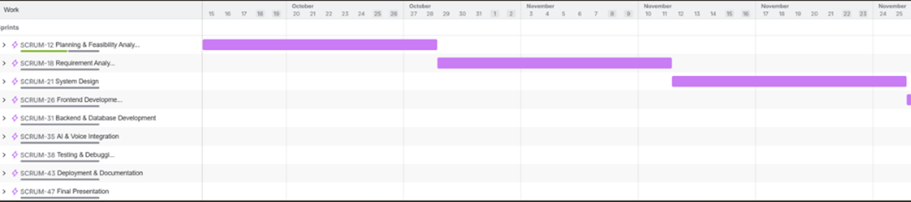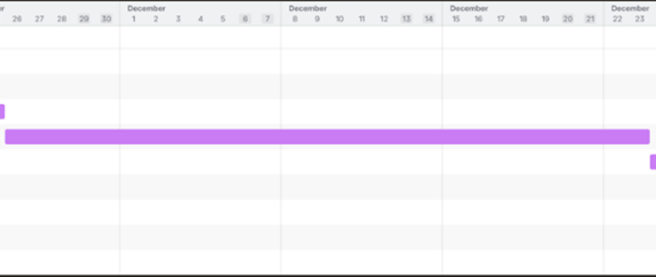
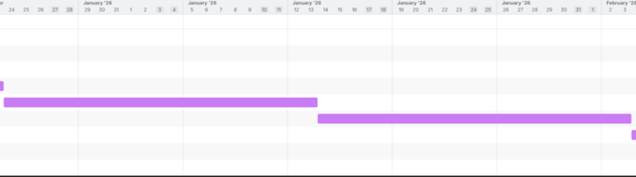
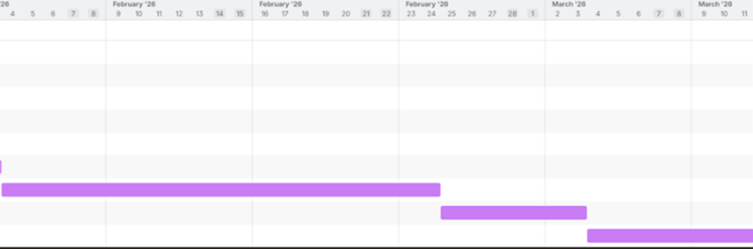

Project Management Approach
To develop Gusto, our group will be using various tools and methods to stay organized, collaborative, and on track. We will use various diagrams to visualize how each feature connects to the others, helping the team understand the overall picture of the project instead of getting lost in small details. A Work Breakdown Structure (WBS) will break the project into smaller, manageable tasks, ensuring that no part feels overwhelming and that everyone has a clear responsibility. Gantt charts will be used to set deadlines and milestones throughout the project, allowing us to track progress at a glance.
For this project, we will follow an Agile approach with two-week sprints. This allows us to focus on tasks more efficiently while remaining flexible to change. The team will have daily check-ins via WhatsApp and weekly meetings either online through Google Meet or face-to-face on campus to ensure everyone stays updated, and any blockers are addressed promptly. Jira will be our main tool for sprint planning, task assignment, progress tracking, and backlog management. GitHub will handle collaborative coding and version control, while Google Docs will be used for meeting notes, design decisions, and documentation.
This setup enables our team to be flexible, adapt quickly, and collaborate in real time. combination of hybrid meetings, structured tools, and continuous quality checks ensures that the development process is efficient, transparent, and focused on delivering a high-quality product.

Team Work Distribution

Report Work Distribution
Task | Member(s)
Idea Discussion and Analysis | All
Background Info about topic | Vinisha
Project Description and Objectives | Saadiyah
Project Scope | Nita, Masuma
High Level Architecture Overview | Manisha, Sadhguna, Roshni
Software and Hardware requirements | Saadiyah, Vinisha
Feasibility & Risk Analysis (Challenges) | Nita, Manisha, Vinisha
Future Improvements | Nita, Saadiyah
Timeline – Gantt Chart | Roshni, Masuma
Project Management tools to be used | Roshni
RACI Matrix | Sadhguna

RACI Matrix – All responsibilities for entire project
Member/Item | Saadiyah | Roshni | Manisha | Vinisha | Sadhguna | Nita | Masuma
Documentation & Weekly Reports | A | R | R | R | R | R | R
Problem & Scope Analysis | A | C | C | C | C | R | C
Competitor Analysis | C | C | C | R | C | R | A
Architecture Design | C | R | R | C | R | C | C
Staff Dashboard Frontend | C | R | C | R | C | C | R
Customer Profile Frontend | C | R | C | R | C | C | R
Backend - Database | R | C | R | C | C | C | C
Backend – Multilingual & Voice Support | R | C | C | C | R | C | C
AI Layer | R | C | R | C | R | R | C
Augmented Reality View | R | C | C | C | R | A | C
Integration | R | R | R | R | R | R | R
Testing & Deployment | R | R | R | R | R | R | R

Requirements Analysis Document

Project Preliminaries
1.1 Purpose and Scope

The purpose of the Gusto system is to enhance the restaurant dining experience by providing multilingual support, accessible ordering, AR-based dish previews, and intelligent analytics for operational improvement. The system aims to reduce communication barriers between customers and staff, improve ordering accuracy, help users with accessibility needs, and generate data-driven insights to support restaurant decision-making.
The scope includes the development of:
- Customer-facing features (menu, translations, chatbot, AR previews, voice interactions)
- Staff-facing dashboard (orders, alerts, simple menu updates)
- Backend microservices (NLP, translation, AR data handling, order processing)
- Analytics & reporting module (basic dashboard showing operational trends)

1.2 Business Context
Gusto operates within the hospitality and food service industry, particularly in multicultural regions such as the UAE where restaurants serve customers speaking diverse languages. Current industry practices rely heavily on:
- Basic QR menus
- Simple static translations
- Limited interactive digital features
- Staff-dependent communication
Competitive platforms like MenuAR, Zarvo.ai, and MenuGuide offer partial digital solutions but fall short on integrated AI, accessibility, or advanced multilingual options.
The advantages of Gusto include:
- An AI-powered multilingual chatbot for real-time Q&A
- Voice-based ordering for accessibility
- AR-based visual previews to reduce ordering uncertainty
- Analytics that assist restaurants understand customer behavior
- A bilingual staff dashboard with automated allergen and preference alerts
The system’s design aligns with emerging industry trends like digital transformation, customer personalization, and compliance with accessibility and language regulations.

1.3 Stakeholders
The stakeholders for the Gusto system can be categorized by level of interest of each group. Hence, they can be considered as primary, secondary or tertiary stakeholders.

Primary Stakeholders
- Restaurant Customers: They are the direct users of the AI/NLP ordering interface. Their needs and requirements are what decides our core features including the multilingual support, the voice assistance, and the personalized recommendations.
- Restaurant Owners: The decision-makers of the restaurant business who are concerned about efficiency, customer satisfaction, and ROI.
- Restaurant Staff (Waiters, Chefs, Managers): They interact with the staff-facing features of the system including order outputs, prioritization, and analytics dashboards.
- Development Team: They are responsible for the design, development, testing, and documentation of the system.

Secondary Stakeholders
- UOWD Professors, Academic Supervisors, Mentors: They provide guidance and insights about the project and its feasibility, and ensure academic standards.
- Industry mentors: They provide real-life insights about the field dealt with in the project. They guide us with information regarding the restaurant operations and technical constraints.

Tertiary Stakeholders:
- Regulatory Bodies: They provide guidelines for compliance with regulations such as data privacy, consumer protection rules, accessibility, etc.
- Competitors & Market Players: They are indirectly involved in shaping the expectations of the system through the industry standards.
- General Public: They would impact adoption and scalability of the solution.

1.4 Ideas for Solutions
Multiple approaches to the solution were considered before finalizing with the current approach for Gusto.

Solution Alternative 1: Customer Self-Service through Google Translate
The main issue with this alternative was that there is no integration with the restaurant knowledge base, through which personalized recommendations could be provided based on ingredients, allergens, customer preferences, etc. Moreover, only using Google Translate creates a rather slow and manual experience for the customers.

Solution Alternative 2: Rule-Based Chatbot
The main issue with this alternative was that though it is fast and predictable (in terms of responses), it cannot handle conversations in natural language variations.

Solution Alternative 3: AR-Only Menu
The main issue with this alternative was that though it is visually appealing, it alone does not solve the issues of accessibility, multilingual support, or user understanding.

Our Selected Solution: Gusto (AI-Powered Multilingual Conversational Platform)
Compared to all of the alternatives, Gusto provides scalability, accessibility, personalization, and a future-proof modular architecture through conversational AI, real-time translation, suggestions, and AR visualization of menu items.
This approach delivers a more complete dining experience and assistance.

1.5 Document Overview
This Requirements Analysis document defines the overall scope of the system, describes the needs of the different stakeholders, justifies the finalized solution architecture, and briefs over the different functional and non-functional requirements for Gusto.

Document Purpose
The purpose of the document is:
- To better establish the scope and boundaries of the system and its functional requirements.
- To understand the requirements of the different stakeholders.
- To establish the design, development, and testing specifications.
- To ensure that there is alignment across the academic, technical, and business stakeholders.

Intended Audience
- The development team
- The academic supervisors, mentors, evaluators
- The industry mentors

Structure of the Document
- Section 1 - Preliminaries: It includes description of the project background, stakeholders, and alternative solutions.
- Section 2 - System Services: It includes description of the different modules to be implemented as part of the solution (frontend, backend, AI/NLP, AR, analytics).
- Section 3 - System Constraints: It includes the various limitations of the system including the technical, legal, performance, and operational constraints.
- Section 4 - Project Matters: It includes description of the risks, schedule, budget, and open issues regarding the project.
- Appendices: It includes additional diagrams, glossary, references, traceability matrix, and the MoSCoW analysis of the system features.

System Services

2.1 The Scope of the System
The Gusto System is a web-based intelligent restaurant management and ordering platform that enhances the dining experience through AI, voice interaction, and augmented reality (AR). The system focuses on improving communication between customers and staff, supporting accessibility for all users, and providing an engaging, interactive way to explore menu items.
The system is organized into six core modules, each responsible for a specific set of tasks. These modules work together through shared APIs and databases, allowing seamless communication, data consistency, and efficient restaurant operations.
Module | Description | Inputs | Outputs/Interactions
Customer Interface (Frontend) | Customers scan QR codes, browse menus, place orders, and interact via chatbot or voice. | QR scans, dish selection, voice or text inputs | Menu display, order submission, chatbot replies
Staff Interface (Frontend) | Used by waiters, chefs, and admins to manage menus, track orders, and update statuses. | Staff login credentials, order data | Updated order tracking, menu edits, and analytics data
Core Backend Services | Processes all business logic, authentication, and database operations. | API requests from frontends | Processed responses (menu items, order details, user data)
AI & NLP Services | Handles chatbot queries, translation, and speech processing for accessibility. | Text or voice queries | Translated text, chatbot replies, speech output
AR Visualization Service | Displays realistic semi-3D dish previews using WebXR-based AR. | Camera feed, recognized dish ID | Real-time AR dish visualization
Analytics and Reporting | Collects and analyzes system data to generate performance insights. | Order logs, chatbot queries, system activity | Reports, charts and performance summaries
Prerequisites
  - A stable internet connection for communication between modules and external APIs.
  - Secure HTTPS deployment to enable camera, voice, and data access permissions.
  - Modern web browsers supporting WebXR, WebGL, and speech APIs (e.g., Chrome, Edge, Safari).
  - Functional device camera and microphone for AR and voice features.
  - Preloaded menu data and 3D assets in the backend database.
Dependencies between Modules
  - Customer Interface depends on the Core Backend for menu data, order handling, and authentication.
  - Staff Interface depends on the Core Backend for order updates, user verification, and analytics data.
  - AI & NLP Services depend on external APIs (e.g., OpenAI, Google Translate, Whisper) for translation and speech processing.
  - AR Visualization Service depends on the Core Backend for data and on device hardware for AR rendering.
  - Analytics & Reporting depends on data from all other modules to generate performance insights.
  - Core Backend acts as the communication hub between all modules, ensuring synchronized data and consistent functionality.

Modules

Customer Interface

User Requirements
- The system will allow users to view the restaurant menu in their preferred language (Arabic, English, French, etc.) upon scanning a QR code, ensuring accessibility for diverse customers.
- The system shall present dish names, ingredient lists, allergen information, and portion sizes in a clear and accurate manner, helping customers make informed dining decisions.
- The system shall provide an augmented reality (AR) feature that enables users to visualize dishes' portion sizes and presentation through their device, giving them a realistic preview before ordering.
- The interface shall support voice commands and voice navigation to assist users with visual impairments or low literacy levels, ensuring an inclusive dining experience for all guests.
- The system shall provide an AI chatbot with natural language understanding to answer customer questions regarding menu items, ingredients, allergens, and dietary restrictions in a conversational manner.
- Users shall have the option to save their preferences, such as preferred language and allergy information, in their profile for future visits, creating a more personalized and efficient experience.
- The interface shall allow guest users to browse and place orders without creating an account, providing quick and convenient checkout functionality for customers who prefer immediate service.

System Requirements
- The system shall provide a responsive, web-based interface that works smoothly on modern browsers (Chrome, Safari, Edge) across mobile and tablet devices.
- The frontend shall be built using React.js, integrating WebXR for AR experiences and Web Speech API for voice interaction to create an engaging user experience.
- The interface shall communicate with FastAPI-based backend APIs to handle menu retrieval, order submission, user profile management, and analytics efficiently.
- The chatbot shall utilize AI services (Gemini API) to deliver contextual, real-time translations and natural responses to customer questions.
- Dish AR visuals shall use photogrammetry or semi-3D models to ensure quick loading times while maintaining good visual quality for customers.
- Customers will provide explicit consent before saving personal information like allergies and preferences.
- The interface shall follow WCAG 2.1 accessibility standards to ensure all customers, including those with disabilities, can use the system comfortably. (www.w3.org, n.d.)
Expected Data Flow
Feature | Input | Process | Output
QR Code Scanning | User Scans QR | System decodes QR and retrieves linked data | Displays related menu or offer
Menu Display | User Request | Fetches menu data from backend | Shows menu items with images and details
Language Selection | User selects language | Updates interface text dynamically | Interface appears in chosen language
Order Placement | Selected items | Sends order to backend → Validates and confirms | Displays order confirmation
AR Viewer | User chooses an item | Fetches 3D model → Renders in AR | Displays interactive AR view
Voice Input | User speaks | Converts speech to text → Executes command | Shows results or places order
Chat Interface | User sends message | Sends to chat service → Gets reply | Displays response in chat window
Use Case Diagram:
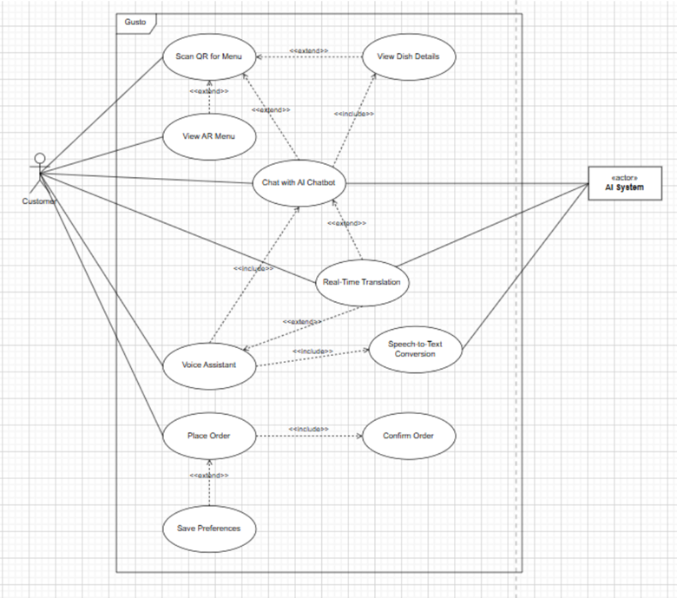
Figure 1: Use Case Diagram - Customer Interface
Prerequisites
- Customer devices must support modern browsers with WebXR and Web Speech API capabilities to access the full range of features.
- Restaurants must provide accurate and up-to-date digital menu content, including complete allergen information for customer safety.
- Users should have basic digital literacy skills to scan QR codes and navigate the interface effectively.

Dependencies
- The system relies on third-party AI services to deliver multilingual translation, speech recognition, and intelligent chatbot functionalities.
- Restaurant staff must regularly update and validate menu information and allergen data to ensure accuracy for customers.
- (See Core Backend Services module for the Backend Infrastructure dependency)

Constraints
- Initial language support will be limited to 3-5 major languages, with the capability to expand based on customer demand and regional needs.
- AR visuals will use optimized semi-3D models rather than fully interactive 3D models in the initial release due to performance and cost considerations.
- Payment gateway integration and POS system synchronization are excluded from phase 1 scope and will be addressed in future development phases.
- Real-time interactive features are optimized for on-premises restaurant use; customers accessing the system offsite will have limited functionality, primarily menu browsing.

Staff Interface

User Requirements
The staff interface needs to offer dashboards tailored for their roles that will help the restaurant run smoothly. Servers need to view order statuses quickly and confirm deliveries to tables, while the chef needs a comprehensive real-time view of the kitchen order queue with clear allergy notifications and prep instructions. Restaurant managers and administrators need robust ability to manage menu items, business performance through visual analysis of data, generating operating reports, and managing access to the system. Also, the interface must be intuitive so that people with a varying level of technical know-how can effectively use with minimal training.

System Requirements
- Dashboard access based on roles, including unique interfaces for Waiters, Chefs, and Administrators.
- Ability to view all orders and their status in real time.
- Ability to change order status (Preparing, Ready, Completed).
- Ability to manage the menu, including the ability to add, edit, and delete menu items.
- An analytics dashboard that provides sales trends and performance metrics.
- Ability to create an account for staff members and manage access.

Use case Diagram
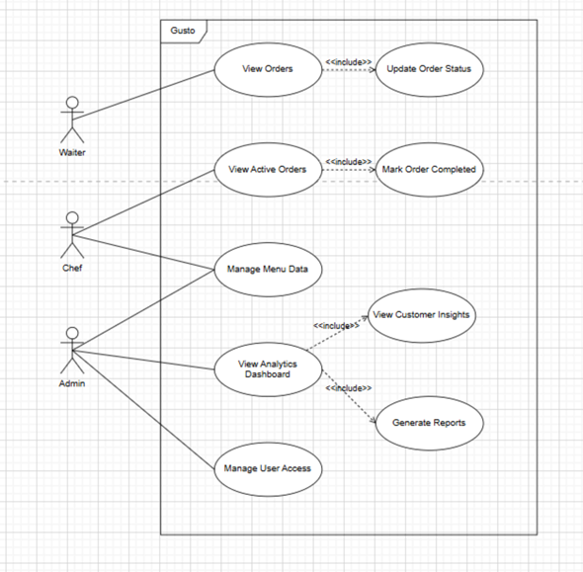
Figure 2: Use Case Diagram - Staff Interface

Expected Data Flow
Feature | Input | Process | Output
View Orders | Staff login credentials | System fetches orders based on user role | Display of order queue
Update Order Status | Staff selects order and new status | Backened updates order status | Status changes visible to all roles
Mark Order Completed | Waiter confirms delivery | System archives order, triggers feedback request | Order removed from active lists
Manage menu data | Admin inputs item details | Validation and storage in menu database | Updated menu reflected in customer interface immediately
View analytics dashboard | Admin selects date range/filters | Analytics service processes order data | Visual charts showing sales, popularity
Generate reports | Admin selects report type/period | Data aggregation and formatting | Pdf/excel reports for business analytics
Manage User Access | Admin creates/modifies staff accounts | System updates user database with credential/role | New staff can login assigned permissions

Pre- requisites
- Backend services must be operational and accessible
- Database must be configured for staff roles and permissions
- Each staff member must have assigned, unique log ins into the system
- Some role specific training for their role and the functions of the dashboard

Dependencies
- Core backend services that manage data operations and business logic
- Analytics Module to report data and provide dashboard insights
- WebSocket Services for pushing order updates in real-time
- Order management features depend on the core order processing system
- User management depends on authentication and authorization services.

Constraints
- Limits response time for real-time updates on orders.
- Types of media that can be uploaded/managed on the menu are restricted.
- Maximum capacity for menu items and staff accounts is limited.
- Only a single restaurant can be supported in the first version of the product.
- Limited real-time data window for the analytics dashboard.

Core Backend Services

This module plays a central role in integrating all the system’s core features. It acts as the business logic layer, ensuring seamless communication between the database, frontend, and external services.
It manages staff authentication, dashboard analytics, order tracking, location-based verification, and integrates AI chatbot and AR functionalities into a unified service architecture.

User Requirements
- Restaurant staff should be able to log in securely to access the admin dashboard.
- Staff can view and update order statuses for each table, where it is marked by default as “pending” when the customer places an order, and can be updated to “preparing,” “ready,” or “served” accordingly.
- Customers should be able to access a public website and select their preferred language to view all content and menu options.
- Customers should be able to interact with the chatbot through voice or text in multiple languages.
- Customers should be able to view menu items in Augmented Reality (AR) through supported devices.

System Requirements
- The system should only allow order placement when customers are physically within the restaurant premises.
- The system should be able to accurately identify user location using browser-based geolocation data once permission is granted, ensuring orders can only be placed within the restaurant’s predefined coordinates.
- The system should support integration with external AI APIs for translation, chatbot, and speech processing.
- The system should serve pre-stored 3D model metadata for AR visualization upon request to minimize latency and process overhead.

Expected Data Flows

Feature | Input | Process | Output
Language Selection | Customer selects preferred language | Backend retrieves localized menu and website content from database | Displayed content and menu in selected language
Chatbot Interaction | Customer text input | AI API (OpenAI) processes query using knowledge base and language model | Response displayed in user’s selected language
Voice Interaction | Customer voice input | Speech-to-text converts voice → text → AI processes query → text-to-speech converts reply | Spoken and text chatbot response
AR Menu Preview | Customer selects AR option | Backend fetches pre-stored 3D model metadata | 3D dish visualization rendered on frontend
Order Placement | Customer selects menu items and confirms | Backend validates location → creates order entry in database | Order confirmation displayed to user
Order Tracking (Staff) | Staff login credentials | Backend verifies role → retrieves relevant orders | Orders displayed by table and status
Update Order Status | Staff selects order and updates status | Backend updates database record and triggers real-time UI update | Status reflected across staff dashboards
Analytics and Reporting | System logs order and chatbot interactions | Backend aggregates and analyzes data | Dashboard charts showing popular dishes, peak hours, and trends

Class Diagram

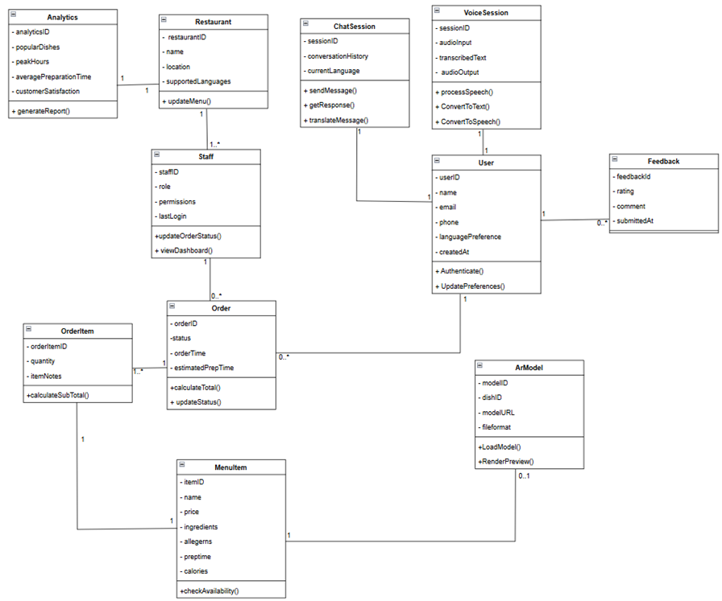

Figure 3: Class Diagram - Core Backend

Pre-requisites
- PostgreSQL database schema must be created and configured before deployment.
- Admin/staff authentication must be setup.
- API keys and access credentials for AI (Gemini, Google Translate) must be configured.
- 3D models for AR menu items should be pre-uploaded and stored in the backend.

Dependencies
- Stable internet connection is required for API requests and real-time updates.
- External APIs must integrate reliably.
- Frontend and backend should be integrated for order placement and status updates.
- Cloud hosting environment is required for backend and database services to be provided.

Constraints
- Depends on stable internet and API connectivity for AI and AR modules.
- Limited to in-restaurant operations to accommodate restaurants which do not provide delivery. Hence, ordering is disabled outside verified location.
- Must comply with privacy and data security standards such as encrypting user data and voice input as well as confidentiality of user health information such as allergies.

AI & NLP

The AI & NLP Service is the intelligent layer of the system. It enables natural language interaction between the users and the system, alongside context-awareness. It also provides multilingual support through translation, communication through both voice and text, and also personalised recommendations based on user preferences and restaurant knowledge base. For the staff, it provides optimisation of order priorities. All these features together enhance the efficiency of the system and improve customer experience.

User requirements
I. Customer-facing:
- Users should be able to view the entire menu in their preferred language. This would be done through real-time translation (Google Translate API).
- Users should be able to interact with the AI chatbot through natural language (in their preferred language), where they can inquire about menu items and availability, allergens and ingredients, and can also request additional information about preparation methods and substitutions. They should be able to receive personalised recommendations.
- Users should be able to converse through voice to the system. The system in turn should assist them towards ordering their preferred dish (through audio responses). This is especially for visually impaired users who require real-time audio descriptions of UI elements, and audio-based feedback for confirmations.
- Users must be able to communicate their preferences within conversations (eg: “make it spicy”, “extra cheese”, “gluten-free” etc), and the system should understand and process the context.
- Users should receive personalised recommendations according to the data stored in their profile (if they have stored their preferences previously). These personalisations are made using RAG combined with the restaurant’s knowledge base.

II. Staff facing:
- Staff should be able to view the analytics dashboard powered by the data collected from user’s behavioral and conversational interactions, leverage NLP and profile customer audiences in terms of languages, common concerns and allergen inquiries.

System Requirements
- Multilingual support: The system should support at least 10 languages.
- User context maintenance: The system should maintain and retrieve user context from their saved profile information. This would be used for personalised interactions and recommendations. Additionally, the system should also combine information from the restaurant’s knowledge base and current trends (including time-of-day analysis, popularity trends, etc).
- Intent recognition: The NLP engine should be able to identify the intent of the user from natural language input, and it should be able to accurately categorize them into actions (eg: menu_inquiry, allergy_check, order_placement, etc).
- Accuracy of speech recognition: The speech-to-text (STT) service should be accurate up to 90%, across all the supported languages, and different accents and dialects.
- Translation performance: The translation latency should only be a minimum of 2 seconds per query. This is to adapt to real-time flow of conversation.
- Chatbot response time: The response time of the chatbot should not exceed 3 seconds, to avoid user frustration.
- Concurrent session handling: The system should be able to efficiently handle multiple concurrent sessions without a degradation in performance (A minimum of 50 concurrent sessions).
- Session context retention: The context of conversation must be retained throughout the session duration.

Expected Data Flow

Feature | Input | Process | Output
Voice Input Flow | Customer speaks in preferred language. (Audio data & User session ID) | Captured audio sent to STT service → Transcription in official language → Query processing and intent recognition by chatbot → Relevant menu data fetched by RAG → LLM generated personalised response → Translation back to original language → Conversion of text to audio by TTS service | Audio response of personalised recommendation in customer’s language
Text Input Flow | Customer types query in their preferred language. (Text input & User session ID) | Translation of text to official language → Query processing and intent recognition by chatbot → Relevant menu data fetched by RAG → LLM generated personalised response → Translation back to original language | Text-based personalised recommendation in customer’s language
Menu Translation Flow | User language selection | Translate menu items through API (if translation is cached, return instantly) → Display menu in selected language | Translated menu
Order Prioritisation Flow | Order details of each customer & Status of kitchen | Validate order details with restaurant’s knowledge base → calculate estimated prep time per dish → analyse kitchen workload & availability of staff → ML model based optimisation using priority scores → calculate total ETA | Priority score & queue of dishes, Optimised ETA

Sequence Diagram
Voice-assisted user intent recognition and menu item recommendation - Example flow
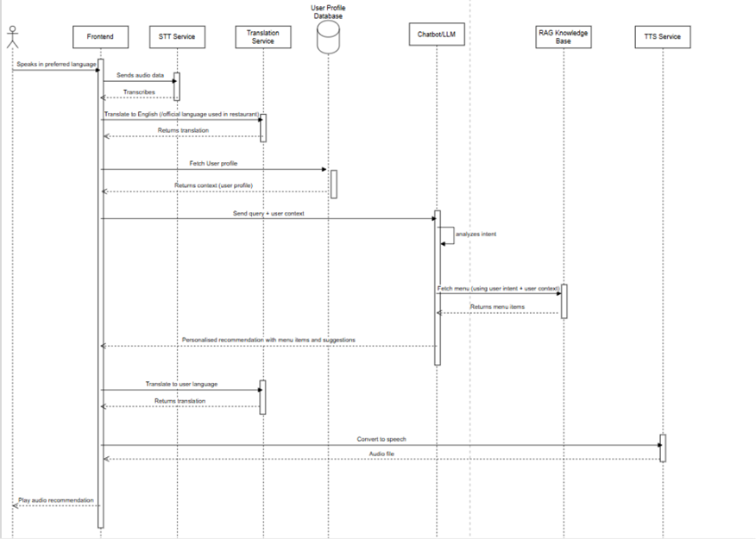
Figure 4: Sequence Diagram for Chatbot

Pre-requisites
- Active API subscriptions and keys for Gemini and Google Cloud APIs (Translate, TTS, STT)
- Devices with microphone access for voice input and speakers/headphones for audio output.
- React and Node.js for frontend integration.
- Python with the necessary libraries (google-genai, langchain, mysql-connector).

Dependencies
- Depends on the Staff Interface module to display the calculated ETA and the optimised order prioritisation queue.
- Depends on Gemini API, Google Translate API, and STT and TTS APIs for the chatbot, intent recognition, real-time translation, and conversion between speech and text.
- (See Core Backend Services module for the Backend Infrastructure dependency)

Constraints
- Rate limits in Gemini API and Google Translate API, while using the free tier.
- Latency requirements in voice response. (STT: 1s, Translation: 2s, Chatbot: 3s, TTS: 1s)
- Constraints with language support as some dialects may have lower STT accuracy.
- Browser compatibility with microphone access requirements.
- Privacy constraints which lets conversation logs retention of only 90 days.
- There is no control over the downtime of third-party APIs.
- API costs scale linearly with increase in volume of users.
- Mixing of languages may reduce accuracy.

AR Visualization
User Requirements
- Users should be able to activate AR dish previews by tapping the ‘View in AR’ option within the menu.
- Users should view realistic semi-3D or photogrammetry-based dish representations overlaid through their device camera.
- Users should experience smooth, responsive visuals that load quickly and maintain clarity.
- Users should not need to install any additional applications; AR previews should work through their device browser.

System Requirements
- The system should support browser-based AR visualization through WebXR integration.
- The system should detect AR markers and map dish models onto real-world surfaces accurately.
- The system should load pre-stored semi-3D or photogrammetry-based dish models efficiently to minimize latency.
- The system should render visuals through a lightweight 3D rendering engine optimized for mobile performance.
- The system should ensure that 3D assets are loaded securely from the backend.
- The system should function independently from other AI or chatbot modules to preserve modularity and reduce dependencies.
Expected Data Flow
Feature | Input | Process | Output
Frontend App | Customer selects “View in AR” from digital menu | Initializes AR session and requests camera permission through WebXR API | AR session ready with live camera feed
WebXR API | Camera access and session request | Activates device sensors and camera → Establishes AR tracking environment | Live AR environment stream for processing
AR Marker Detector | Camera feed frames | Detects and decodes AR marker → Extracts marker data | Sends marker data to WebXR API
WebXR API Spatial Mapping | Marker Data | Maps spatial coordinates → Identifies linked dish model | Sends dish ID to 3D Model Loader and spatial context to Renderer
3D Model Loader | Dish ID | Fetches corresponding semi-3D or photogrammetry model from backend | Passes model data to renderer
Renderer | Model data + spatial context + camera feed | Combines 3D model with live camera feed to create AR overlay | Displays realistic dish visualization in user’s environment

Component Diagram
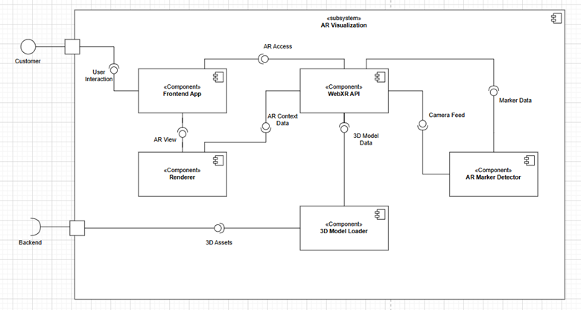
Figure 5: Component Diagram – AR Menu

Pre-requisites
- Modern web browsers with WebXR and WebGL support (e.g., Chrome, Edge, Safari).
- Device equipped with a functioning camera and motion sensors
- Restaurant-side backend preloaded with AR model data and mapping between dishes and AR markers.
- Secure HTTPS deployment for accessing device camera (required by WebXR standards).

Dependencies
- WebXR API for camera access, environment setup, and spatial tracking.
- AR Marker Detector for identifying and decoding physical or virtual AR markers to trigger the correct model.
- 3D Model Loader component to fetch dish models from the backend or local storage.
- Renderer component to combine model data and live camera feed for visualization.
- (See Core Backend Services module for the Backend Infrastructure dependency)
Constraints
- Only semi-3D or photogrammetry-based models will be supported initially to reduce processing time and storage requirements.
- Full 3D interactive rendering is planned for future enhancement once performance and adoption are validated.
- Browser and device compatibility are limited to those supporting WebXR; older devices may not run AR features.
- Performance may vary based on device hardware (camera quality, GPU power).
- AR performance may vary based on lighting conditions or reflective surfaces commonly found in restaurant environments.

Analytics & Visuals
This module acts as the intelligence layer of the Gusto system, converting raw data from orders, chatbot interactions, and menu usage into meaningful insights for restaurant staff. It runs independently from daily operations and provides visual reports on dish popularity, allergy trends, peak hours, and common customer queries. By offering clear, data-driven dashboards, this module helps restaurants improve menu planning, service efficiency, and overall customer experience.

User Requirements
The system must allow restaurant staff to:
- View dish popularity over time
- Track frequently encountered allergens
- Monitor chatbot query trends
- Analyze order patterns (peak hours, item frequency)
- Access visual reports through simple charts
- Filter analytics by date range
- Export or screenshot reports

System Requirements
- The system must collect and store data logs from orders, chatbot interactions, and customer feedback.
- The system must aggregate raw data into clear and meaningful metrics for staff use.
- The system must generate visual charts and insights using Chart.js or Plotly.
- The system must display analytics on allergen frequency, top ordered dishes, and common customer questions.
- The system must provide filter options such as the date range and dish category.
- The system must restrict analytics access to authorized staff accounts only.
- The analytics dashboard must load efficiently, ideally within 3 seconds on stable internet.
- Analytics data must be refreshed on a scheduled basis (e.g., daily) for up-to-date reporting.
- All stored and processed data must be anonymized to protect customer privacy.
- The dashboard and charts must be mobile-responsive and accessible on tablets used by restaurant staff.

Expected Data Flow
Feature | Input | Process | Output
Order Analytics | Order logs (items, timestamps) | Sata Collector extracts → Aggregator processes counts & trends | Top dishes, peak hours chart
Chatbot Interaction Analysis | Chatbot logs (questions, languages) | Extraction & categorization of query patterns | Most frequently asked questions chart
Menu Usage insights | Menu data (views, clicks, categories) | Log cleaning → Aggregation of item-level interactions | Menu popularity and user-interest trends
Allergen Trend Tracking | Feedback & order notes (allergy tags) | Frequency calculation via Aggregator | Allergen frequency graph
General Reporting | All combined logs (orders, queries, feedback | Data structured into Analytics DB → processed into metrics | Filterable dashboard with summaries & visual charts

Pre-requisites
- Functional menu, chatbot, ordering modules
- PostgreSQL schema supporting log collections
Dependencies
- Stable data transfer between microservices
- Correct logging format
- (See Core Backend Services module for the Backend Infrastructure dependency)
Constraints
- Limited dataset during initial deployment
- No machine-learning predictions in Phase 1
- Analytics accessible only to authenticated staff

FURPS + Non-Functional Requirements:
The FURPS framework makes sure the platform works well for restaurants, their customers, and the people in charge, covering what they need in terms of experience and how well things run behind the scenes.

Functionality
- Gusto provides a multilingual interface between restaurant staff and customers through an AI-powered chatbot.
- Offers real-time voice assistance using speech-to-text and text-to-speech capabilities.
- It also displays menu items in an Augmented Reality (AR) format, allowing customers to preview dish portions and the presentation of the dishes.
- Includes a smart analytics dashboard that visualizes restaurant performance metrics, such as popular or best-selling dishes and customer trends.
- Ensures precise real-time translation and context-aware responses powered by AI.
- Maintains secure data handling for user information, including encryption of orders, profiles, and feedback.

Usability
The system:
- Offers a simple and responsive web interface compatible enough for both mobile and desktop browsers.
- It complies with WCAG 2.1 accessibility standards, ensuring usability for visually impaired and differently abled customers.
- Supports QR-based access for direct menu loading and language selection.
- Uses clear, high-contrast layouts and comprehensible design for all users.
- Enables staff to become proficient in using their dashboards with minimum training period.
- Provides visual and audio feedback during operations.

Usability will be evaluated through user testing sessions to achieve a minimum 90% task success rate among test participants.

Reliability
The system shall:
- Maintain a 99% uptime during restaurant operational hours.
- Recover routinely within 10 minutes after unanticipated downtime.
- Conduct daily automated backups of menus, orders, and analytics data.
- Provide basic menu browsing remains available even if AR or AI modules are temporarily offline or when the users aren’t in the restaurant.
- Ensure that the system’s data integrity is conserved in case of connectivity interruptions through periodic synchronization with the database.

Performance
- Delivers the chatbot responses within seconds on average.
- Processes speech recognition and translation within 4 seconds of user input.
- Loads AR visuals within 5 seconds for typical dishes.
- Can handle at least 50 restaurant sessions at once without slowing down or having glitches.
- Respond to all database queries in under 1 second under normal server load.

Supportability
- Follows a modular microservice setup, so each part (AI, AR, Analytics, Backend) can be updated on its own.
- It comes with complete documentation, including API info, setup steps, and integration guides.
- Supports cloud deployment (Render, Vercel, or Railway) for easy scaling and upkeep.
- Enable quick changes like addition of new languages and restaurant clients just by changing settings; no coding is needed.
- It can handle future upgrades like payment systems, loyalty programs, or POS syncing without needing a big overhaul.

Non-Functional Requirements:

Category | Requirement
Performance | - Chatbots respond in 3 seconds or less.  - AR visuals pop up in 5 seconds max.  - It handles 50+ users at once with no lag.
Security | - All data is encrypted from start to finish.  - Admins, waiters, and chefs get access based on their roles. Client-server staff are secure with HTTPS.  - Full compliance with GDPR and UAE data laws.
Usability | - User interfaces are multilingual. Accessibility features include voice navigation, screen-reader compatibility, and large-text mode.  - The average user training time is less than 30 minutes.
Reliability | - Recovery Time: Under 10 minutes.  - Backups: Done automatically every day.  - Core Modules: Still work if other parts go down.
Scalability | - Capable of scaling horizontally to support multiple restaurants with isolated data stores.  - Cloud deployment supports automatic scaling during peak loads.
Maintainability | - Modular structure (FastAPI backend, React frontend) allows updates without downtime.  - Source code versioned and maintained via GitHub. Task tracking and issue resolution are managed through Jira.
Accessibility | - Follows WCAG 2.1 Level AA standards.  - Includes voice interaction and high-contrast themes.  - Ensures broad usability for visually impaired and low-literacy users.
Portability | - Cross-platform web-based system accessible via Chrome, Safari, and Edge on both desktop and mobile devices.  - No installation required; accessible directly through the browser.
Legal & Ethical | - Explicit user consent is required before storing personal preferences or allergy data.  - AI responses must remain impartial and culturally appropriate.  - All customer data is handled transparently and used solely for functional purposes.

System Constraints

Interface Requirements
- The customer-facing UI of the system should include a language selection option, a voice input button, and a chat window (chatbot). There must also be an AR viewer button for each item on the menu.
- The staff-facing UI should display the prioritized orders list, staff allocation, kitchen workload information, and the analytics report.
- The system must support accessibility options for voice-only interactions by users with visual impairments.
- The system should communicate the AI responses processed at the backend to the frontend.
- The frontend components should be able to access AI services through backend REST APIs.
- The responses must be consistent through a uniform JSON structure.
- API keys must be stored securely (eg: in .env files, and not in frontend).

Performance Requirements:
- The system should smoothly handle busy times, supporting hundreds of users ordering at the same time without slowing down.
- Menus and order screens should load quickly, ideally within a few seconds, so customers don’t get frustrated waiting.
- Orders need to reach the kitchen and wait for staff to instantly speed up food preparation and reduce delays.
- The system should minimize mistakes by confirming orders clearly and syncing them with inventory and kitchen systems.
- It should work well on mobile devices, ensuring usability even on slower internet connections.
- Voice commands and AR features must be fast and responsive to help all users, including those with disabilities.
- The backend must scale easily as the restaurant grows or adds locations, keeping data accurate and reliable.
- Analytics tools should quickly turn order and feedback data into useful insights for restaurant managers to improve service.
- Overall, the system should feel reliable and effortless, quietly helping everyone from customers to staff to have the best experience possible.

Security Requirements:
- Restricted to basic username and password authentication (no budget for more advanced multi factor authentication)
- Essential role-based access using flags in the database to implement access or role policies rather than tried and tested enterprise RBAC implementations.
- No budget for key management solutions
- Limited backup on free cloud tiered resources
- Limited to basic TLS implementation without more in-depth security configurations
- Limited to free scanning tools for security
- Simple rate limiting using open-source libraries
- Basic logging with no real in-depth analysis capabilities.

Operational Requirements
- Frontend can be hosted on a compatible platform like Vercel and backend (FastAPI server) along with AI and database connections can be deployed on Render or Railway which provide free-tier hosting.
- PostgreSQL database must remain accessible to backend API at all times for data synchronization.
- AR visualization is processed on frontend but relies on backend support to fetch and serve preloaded 3D model metadata.
- AI and multilingual services require continuous connectivity to external APIs for real-time processing of chatbot responses, translations, and speech functions.
- The system will require periodic maintenance to ensure database schema consistency, renew API keys, and monitor server uptime.
- Version control and updates will be managed via GitHub, and error logging can be implemented within the backend.
- The prototype is expected to maintain 95%+ uptime under normal conditions; occasional downtime is acceptable during updates or API rate-limit periods.

Political and Legal Requirements
- Must comply with UAE data protection expectations for handling customer information ethically and responsibly.
- Customer consent must be collected before storing preferences, allergy details, or language settings.
- All AI, translation, and AR services must follow the terms and usage policies of external APIs
- API keys must be handled securely and used according to provider guidelines, even with basic environment-variable storage.
- All 3D models and images must be either original, openly licensed, or properly credited according to their licenses.
- Open-source libraries must be used in compliance with their respective licenses.
- Customers must be allowed to request removal of any stored personal preference data, with no data kept longer than necessary.
- Log files generated by the system should avoid storing personally identifiable information (PII).
- Staff accounts must be used only by authorized personnel, aligning with basic accountability and acceptable-use norms.

Project Matters
Open issues
Technical Issues
- Decision pending on using 2D, semi-3D, or full 3D assets for AR previews.
- Need to confirm whether analytics should update in real-time or daily batches.
- Retention period for order, chatbot, and feedback logs is not yet finalized.
- Storage and scalability requirements for AR assets and analytics data remain unclear.
- Accuracy of geolocation for determining in-restaurant usage requires validation.
Business & Operational Issues
- Initial pilot partner for testing and menu data collection is still not finalized.
- Availability and format of allergen and ingredient data from restaurants is uncertain.
- Level of onboarding required for staff with varying digital skills is not yet defined.
Design Issues
- Required level of UI/theme customization for restaurants is unclear.
- Final decision on the number of staff dashboard languages is pending.
Timeline & Resource Issues
- Coordinating voice, AI, AR, and analytics within the project timeline may be challenging.
- API specifications between modules need clarity to avoid development delays.
- Free-tier hosting and API usage limits may not support long-term testing or large datasets.
Risk & Compliance Issues
- Final privacy and anonymization policies for customer data must be established.
- Backup procedures for third-party API outages (AI, translation, hosting) are not yet defined.

Preliminary Schedule
Phase | Duration (2025–2026) | Key Activities | Deliverables / Outputs
1. Project Initiation & Requirement Gathering | Oct – Nov 2025 | - Brainstorming sessions and finalizing project objectives.  - Perform feasibility and risk analysis.  - Collect system requirements and limitations.  - Prepare and submit the Requirements Analysis Document. | Requirements Analysis Report (Deliverable 2)
2. System Design & Architecture | Dec 2025 – Jan 2026 | - Designing high-level architecture diagrams.  - Create use case, class, and activity diagrams for all modules.  - Design user interface models and system workflow.  - Identify integration points between AI, AR, and backend services. | System Design Document (Deliverable 3)
3. Core Implementation (Backend & Frontend Development) | Feb – Apr 2026 | - Develop backend APIs using Fast API  - Implement database (MySQL).  - Create frontend interfaces (Customer & Staff).  - Establish communication between frontend and backend through REST APIs. | Functional prototype (v1)
4. AI, NLP & AR Integration | Apr – May 2026 | - Integrate chatbot (OpenAI, LangChain).  - Add multilingual translation engine.  - Implement AR-based menu visualization using WebXR.  - Conduct preliminary module testing. | Advanced Prototype (v2)
5. Testing, Debugging & Quality Assurance | May – Jun 2026 | - Perform unit, integration, and system testing.  - Validate against FURPS and Non-Functional Requirements.  - Perform user acceptance testing with sample restaurants.  - Document test cases and outcomes. | Tested system and validation report
6. Deployment & Final Documentation | Jul – Aug 2026 | - Deploy frontend (Vercel) and backend (Render / Railway).  - Conduct pilot deployment in a restaurant environment.  - Prepare user manual and final technical documentation.  - Submit Final Capstone Report (Deliverable 5). | Final System Deployment & Documentation
7. Presentation & Evaluation | Aug – Sep 2026 | - Deliver final presentation and live demo to evaluation panel.  - Showcase working prototype and demonstrate system modules.  - Submit final report and reflect on outcomes and future improvements. | Capstone Presentation & Evaluation Report

Milestones Plan

Milestone | Expected Completion | Dependency | Output / Deliverable
M1: Project Proposal Approval | 30 Oct 2025 | None | Approved project concept
M2: Requirements Analysis Completion | 12 Nov 2025 | M1 | Requirements Analysis Report
M3: System Design Finalization | 20 Jan 2026 | M2 | System Design Document
M4: Core Backend and Frontend Development | 15 Apr 2026 | M3 | Functional Prototype v1
M5: AI + AR Integration | 25 May 2026 | M4 | Advanced Prototype v2
M6: Testing and Quality Assurance | 30 Jun 2026 | M5 | Verified & Tested System
M7: Final Deployment and Submission | 15 Aug 2026 | M6 | Final Capstone Report
M8: Presentation & Evaluation | 15 Sep 2026 | M7 | Final Demo & Evaluation Session

Preliminary Budget
Feature/Module | Tools/Technologies | Estimated Monthly Cost (AED) | Potential Changes
Website Frontend | Node.js hosting | 0 | This tool is free to use, only paid to have premium features that we most likely not be requiring.
AR Menu | WebXR (browser native) | 0 | This feature runs in users’ browsers, so there is no hosting cost.
Backend (Core Logic & APIs) | FastAPI hosting (Render/Railway free → paid) | 0 to 90 | We’ll use free tiers initially, upgrading to paid plans only if the API requests increase significantly.
Database | MySQL Workbench | 0 | Development will use free local MySQL.
AI & Voice/NLP Layer | OpenAI API, Google Speech, Whisper, LangChain | 0 to variable (~100) | Initial usage will stick to free credits. Paid usage will be adopted only if the speech or AI call volumes grow. (OpenAI, 2025)
Analytics Layer | Chart.js / Plotly (open-source) | 0 | These tools are free, so no hosting or licensing costs are expected here.
Development & Version Control | Visual Studio Code, GitHub Free | 0 | VS Code is free for use, and GitHub’s free tier is sufficient.
Total Cost |  | 0 to 190

Appendices:

System Overview – Activity Diagram
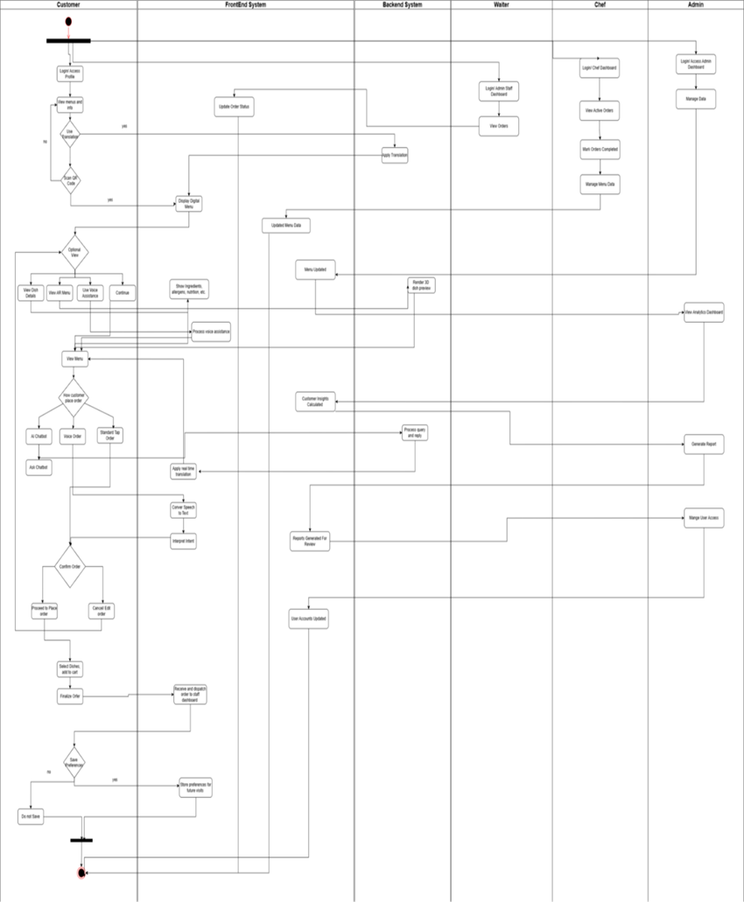

Traceability Matrix
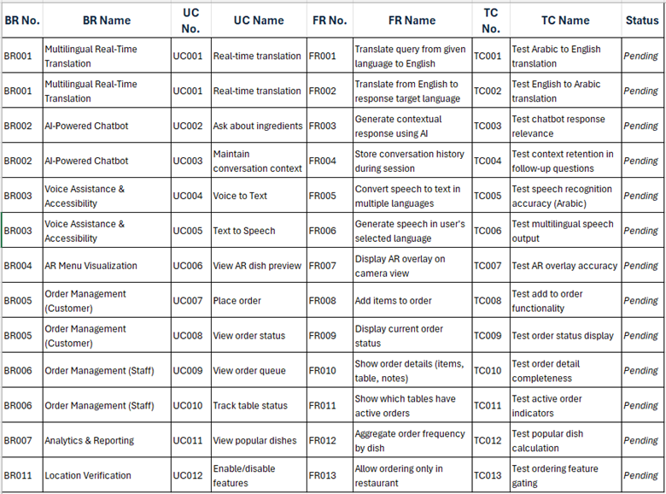

Note: Detailed test cases will be defined and tracked for execution (status) during implementation and testing phases.

Key:
BR – Business Requirement
UC – Use Case
FR – Functional Requirement
TC – Test Case

Requirement Prioritization (MoSCoW):
The MoSCoW framework is being used to prioritize the various system requirements into four categories including Must Have, Should Have, Could Have, and Won’t Have (for now). This helps ensure efficient development and avoid scope-creep.
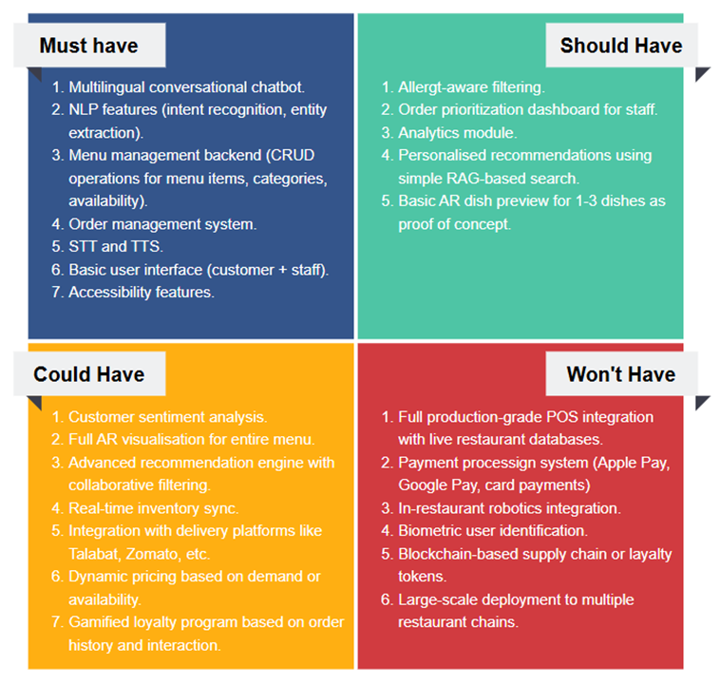

RACI Matrix
Member/Item | Saadiyah | Roshni | Manisha | Vinisha | Sadhguna | Nita | Masuma
Documentation & Weekly Reports | A | R | R | R | R | R | R
Problem & Scope Analysis | A | C | C | C | C | R | C
Competitor Analysis | C | C | C | R | C | R | A
Architecture Design | C | R | R | C | R | C | C
Staff Dashboard Frontend | C | R | C | R | C | C | R
Customer Profile Frontend | C | R | C | R | C | C | R
Backend - Database | R | C | R | C | C | C | C
Backend – Multilingual & Voice Support | R | C | C | C | R | C | C
AI Layer | R | C | R | C | R | R | C
Augmented Reality View | R | C | C | C | R | A | C
Integration | R | R | R | R | R | R | R
Testing & Deployment | R | R | R | R | R | R | R

    - Project Stakeholders
Team Members: Saadiyah, Roshni, Sadhguna, Nita, Manisha, Vinisha, Masuma
Faculty Mentors: Lecturer (Prof. Nkqubela Ruxwana) and Mentor (Prof. Obaid Ullah)

    - Report Work Distribution
Task | Member(s)
Project Preliminaries | Sadhguna, Nita, Saadiyah
Scope of the System | Manisha
Module – Customer Interface | Roshni
Module – Staff Interface | Vinisha
Module – Core Backend | Saadiyah, Vinisha
Module – AI & NLP | Sadhguna
Module – AR Visualization | Manisha
Module – Analytics | Nita
Functional & Non-functional Requirements | Masuma
System Constraints | Sadhguna, Manisha, Vinisha, Roshni, Saadiyah, Masuma
Project Matters | Nita, Masuma, Roshni
Traceability Matrix | Saadiyah
Requirement Prioritization Table | Sadhguna, Roshni

Design Document

Introduction

Purpose
This Design Document outlines the architectural vision and design decisions, as well as a description of the components that make up Gusto - an AI powered, multilingual, accessible restaurant order platform.
Gusto will provide a new level of dining by removing all language barriers using AI technology to offer real-time translation; enhancing accessibility through voice interactions and multiple input modes; and allowing customers to have confidence in their order using Augmented Reality to preview their meals. Additionally, it will provide smart recommendations and personalized support to customers.
Finally, Gusto also provides information regarding the possible allergens, and the users can customize notes according to their preferred ingredients. The purpose of this document is to provide a clear picture of how the system is designed, built, deployed, and maintained, thus enabling both technical and non-tech.

Scope
The scope of the Gusto system includes the design and development of the following:
Customer-Facing Components
- Interactive multilingual digital menu
- AI chatbot with Retrieval-Augmented Generation (RAG)
- Real-time translation (text, voice, and chat)
- Allergen & dietary filters
- Voice-based navigation and ordering assistance
- AR 3D dish visualizations
- Customer preference capture / selection builder
Backend Systems
- Microservices for translation, NLP, AR-data handling, user interaction, and menu rendering
- Secure hosting for AI models, AR assets, and application APIs
- Data pipelines for analytics
Staff-Facing Tools
- Bilingual dashboard for order insights
- Dish availability & alerts (e.g., “out of stock”)
- Basic analytics views showing operational patterns

Overview
Gusto is an adaptable, modular system that has the capability to expand its functionality. It features artificial intelligence to enhance dining experiences. By using these technologies, users are provided with a single point of access that will assist them in whatever they may need regarding dining.
Key system objectives include:
- Personalization: Tailoring suggestions based on allergens, dietary restrictions, preferences.
- Language Inclusivity: Supporting diverse languages common in multicultural hubs like the UAE.
- Operational Efficiency: Helping restaurants reduce miscommunication, order errors, and menu confusion.
- Accessibility: Supporting customers who prefer voice inputs, clear visuals, or simplified text.
- Digital Innovation: Leveraging AR and AI to modernize traditional dining.

Definitions and Acronyms

Term / Acronym | Definition
Gusto | AI-powered multilingual restaurant support platform
RAG (Retrieval-Augmented Generation) | AI technique combining LLM responses with real menu data
NLP | Natural Language Processing – AI system for understanding human language
AR | Augmented Reality – 3D/interactive dish previews
API | Application Programming Interface used for communication between system modules
Dashboard | Staff-facing interface for monitoring orders, stock, and alerts
Allergen Filters | Feature allowing customers to remove dishes with allergens (e.g., nuts, dairy)
Voice Interaction Module | Enables speech-to-text ordering and navigation
Menu Microservice | System responsible for rendering menus, translations, and AR attachments
Analytics Module | Component that shows restaurant insights like peak hours, top dishes
Multilingual Support | Ability to translate text and voice across multiple languages
Customer Selection Builder | Personalized customer preference and meal-building feature

2. System Overview

2.1 Features/Modules
Customer Interface Module
- Menu Browsing: Display dishes with images, descriptions, and prices organized by categories
- Multi-language Support: Translation of menu content using Google Translate API
- AI Chatbot: Question-answering system for dish ingredients, allergens, and recommendations
- AR Visualization: View 3D models of selected dishes using phone camera
- Order Builder: Add items to cart and show selection to waiter
Admin Portal Module
- Login System: Basic authentication for restaurant staff
- Menu Management: Add, edit, and delete menu items through forms
- Photo Upload: Upload dish images
- Allergen Tagging: Select applicable allergens for each dish
Backend API Module
- Menu CRUD API: Handle menu item operations
- Translation Integration: Call Google Translate API and cache results
- Chatbot Service: Process customer queries using OpenAI API with menu context
- Session Management: Track customer orders temporarily
- File Storage: Serve image and 3D model URLs
AR Model Module
- Restaurant uploads photo → Manual 3D model creation → Upload to cloud storage → Link in database

2.2 Design Considerations

Design Assumptions
- Customers have smartphones with internet browsers (no app download required)
- Restaurant has WiFi available for customers
- Restaurant staff can use basic web forms to update menu
- Menu items don't change daily (monthly updates are realistic)
- One person (admin) will manually create 3D models when requested

Constraints:
Technical Constraints:
- AR only works on phones with compatible browsers (Android Chrome and not iOS with the framework being used)
- Chatbot accuracy depends on how well menu data is structured
- Translation quality varies by language (better for major languages)

Budget Constraints:
- Gemini API costs money per chatbot interaction (~$0.01-0.03 per conversation)
- Google Translate charges per character translated
- Render and Vercel for deployment hosting is limited in free version
- Database hosting for NeonDB premium version

Time Constraints:
- This is a semester project with limited development time
- Cannot implement every advanced feature
- Testing will be limited to a few devices

Practical Limitations:
- AR models won't look exactly like real dishes
- Initial version will support 2-3 languages, not all languages
- Chatbot may give incorrect answers if menu data is incomplete
- System needs internet-won't work offline

System Environment
- Frontend: React app, likely hosted on free tier (Vercel/Netlify)
- Backend: FastAPI on Python, possibly AWS free tier or similar
- Database: MySQL, could use free hosting (Railway, PlanetScale) or local for testing
- Storage: AWS S3 or Cloudflare R2 for images and 3D models
- APIs: Gemini or OpenAI API (paid), Google Translate API (paid, but small usage might be free tier)

Design Methodology
This project uses a simplified full-stack web architecture suitable for an undergraduate capstone:
- Separation of Frontend and Backend: React handles what users see, FastAPI handles data and logic. They communicate via REST API (JSON over HTTP).
- API-First Development: Backend endpoints are designed first, then frontend consumes them. This allows both to develop somewhat independently.
- Basic RAG for Chatbot: Instead of training a model, we use existing menu data as context and send it to OpenAI along with the user's question. OpenAI generates answers based on this context.
- Manual AR Pipeline: Rather than automating 3D model generation (complex), the developer manually creates models using AI tools like Luma or Meshy, then uploads them. This is realistic for a prototype.
- Single Database for All Restaurants: To keep things simple, one MySQL database stores all data with a (restaurant_id )field to separate different restaurants' menus.
- Minimal Authentication: Simple username/password for admin, no complex OAuth. The customer side doesn't require login at all.

System Architecture
Gusto’s system architecture is carefully designed based on industry restaurant standards, with the focus on augmenting user experience, ensuring customers can order reliably and safely in a globalizing world.

Decomposition Description
Below is an overview of our system and the components it comprises of.

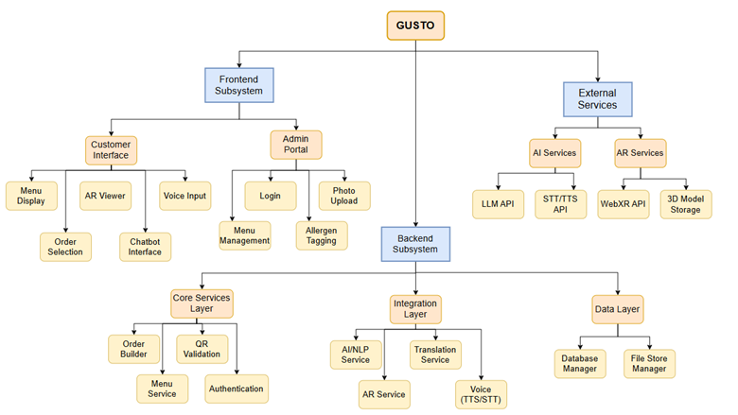

Architecture Diagram
We used multiple diagrams to depict the subsystems of Gusto, their interactions, and the use cases.

USE CASE DIAGRAM

Customer Actor
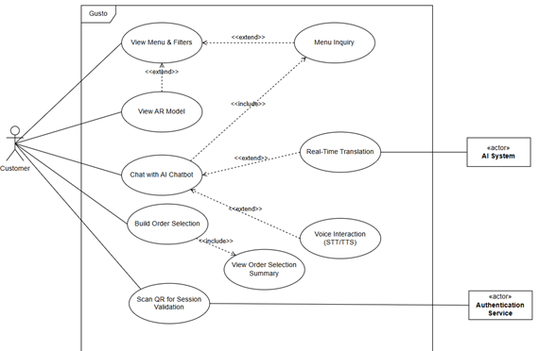

Admin Actor
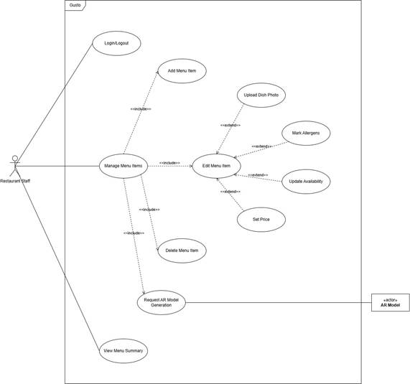

CLASS DIAGRAM
The UML Class Diagram represents Gusto’s overall system, including its domain classes, attributes, and methods. This model helps in developing an object-oriented system.

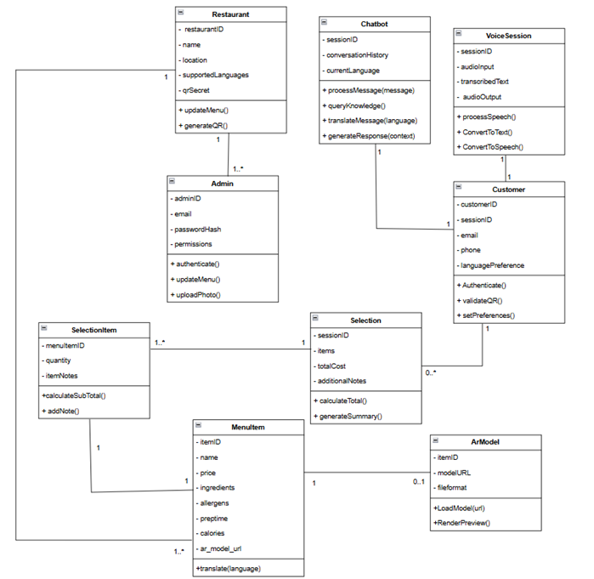

ACTIVITY DIAGRAM
The Activity Diagram of Gusto shows the user flow as well as the backend processes that run in the system from viewing menu items, interacting with chatbot through multilingual and voice support, as well as optionally viewing the AR model of a menu item. It includes swimlanes for the main actors or subsystems which are Customer, Admin, Frontend System and Backend System.
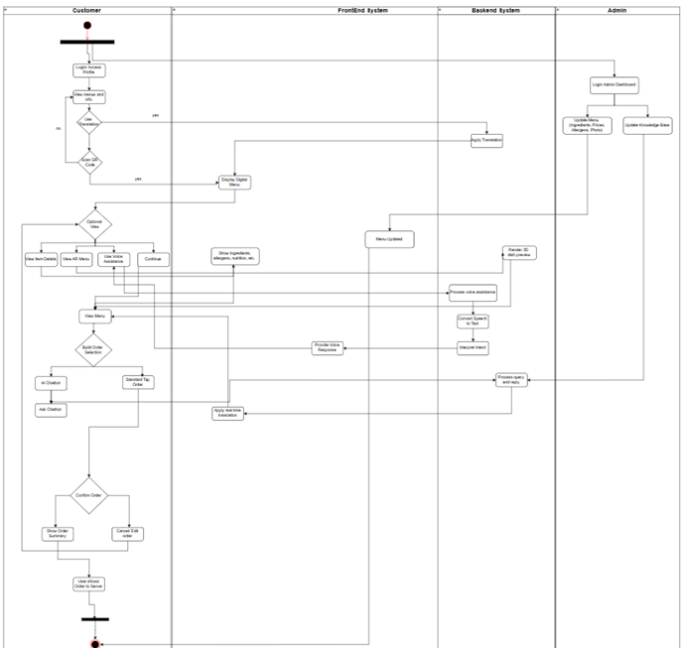

Design Rationale
We selected a three-tier architectural design (Frontend, Backend, External Services) to achieve clear separation of concerns and enable independent scaling of features, admin functions, and AI-powered services.
Initially, we considered implementing a full order management system with staff dashboards and analytics. However, we recognized most restaurants already have established POS systems and preferred workflows. By positioning our system as an intelligent menu discovery layer rather than replacing existing infrastructure, we reduce integration complexity and focus on our core innovation: multilingual AI assistance, AR visualization, and enhanced allergen awareness.
We also evaluated GPS-based location verification to restrict feature access to restaurant premises but ultimately chose renewable QR codes (30-second renewable) displayed on digital kiosks as a simpler, more reliable solution that avoids browser permission issues and works consistently across all devices. This modular architecture allows restaurants to adopt our platform immediately without disrupting their current operations, while the API-ready backend design enables future integration with POS systems for establishments seeking better integration. The decision to pre-translate and cache menu content rather than translating in real-time balances performance with cost efficiency, ensuring fast response times while managing API expenses at scale

Data Design

Data Description
The Gusto system is based on a relational data model that supports multiple languages and enables easy order sessions for all employees of Gusto Restaurant. The data architecture of the Gusto system consists of two main parts:
Restaurant Data and Menu Data: The restaurant data provides a strong foundation to the Gusto system as it stores all the restaurant profiles, menus and menu items. Because of the multiple languages supported within this model, each language is taken into consideration with respective separate columns for each language (i.e. name_en, name_ar, description_fr). This allows the Gusto user interface to present content in the language selected without requiring real time translation for static content.
Orders and Session Data: To provide customers with a seamless experience when ordering through the Gusto system, order sessions are utilized. The session table holds anonymous customers and their cart items. This design provides customers with an easy way to create their meal selections without creating an account to do so. The completed order is passed to the waiter using QR code or summary screen display.
The data travels from the front end of the Gusto system using restful APIs to the backend to retrieve menu items and update carts, as well as facilitate interactions with our AI chatbot through third-party APIs.

Data Dictionary

Restaurant:
Attribute | Data Type | Description | Constraints
ID | INT | Unique identifier for the restaurant | Primary key
Name | VARCHAR | The name of the restaurant | Not null
Location | VARCHAR | Physical address of the restaurant | Nullable

Menu_items:
Attribute | Data type | Descrption | Constraints
id | INT | Unique identifier for the menu items | Primary key
Restaurant_id | INT | Reference to the owning restaurant | Not null
Name_en | VARCHAR | Item name in english | Not null
Name_ar | VARCHAR | Item name in arabic | Not null
Description_en | VARCHAR | Item description in english | Nullable
Price | INT | Item price | Not Null
Ingredients | VARCHAR | List of the main ingredients | Nullable
Allergens | VARCHAR | Allergens (eg: dairy, gluten) | Nullable
Image_url | VARCHAR | Url to the dish | Nullable
Ar_model | VARCHAR | Url to the 3D model file for the AR view | Nullable

Sessions:

Attribute | Data type | Description | Constraints
Id | INT | Unique identifier for customer session | Primary key
Language | VARCHAR | The customers selected language | Not null
Cart_items | VARCHAR | Stores selected menu items and quantities | Nullable
Created_at | Timestamp | Time when session was started | Not null

Component Design

This section expands on the components part of the architecture. For the sake of clarity and dealing with dependencies between modules, the system has been divided overall into 5 modules for describing it diagrammatically. We used detailed class diagrams for each component and depicted each module with a diagram that is relevant to it for showing a clear design.

Customer Interface

Component Diagram
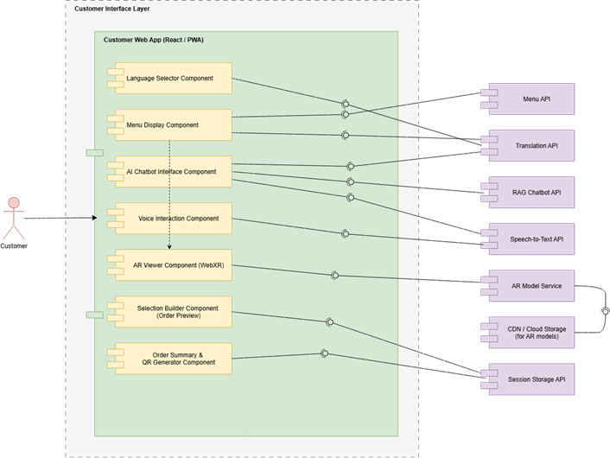

Class Diagram
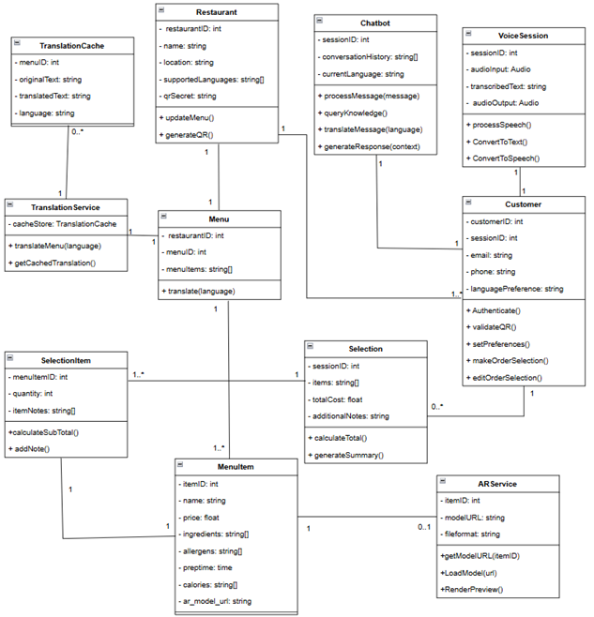

Admin Portal Interface

Use Case Diagram

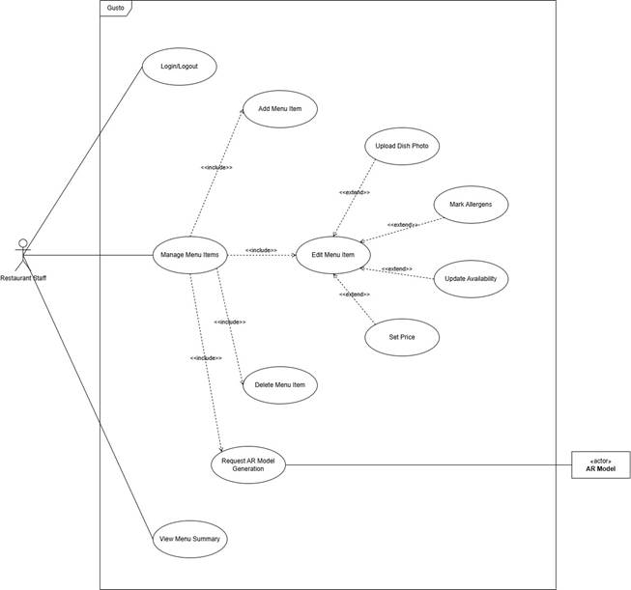

Class Diagram
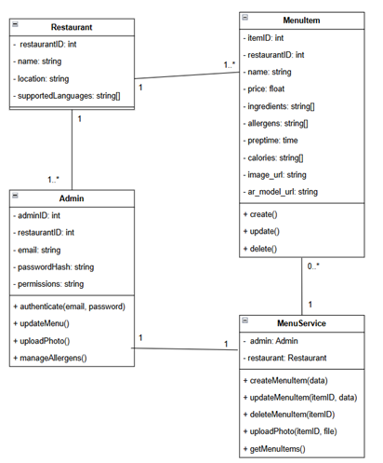

Backend Services
Class Diagram:
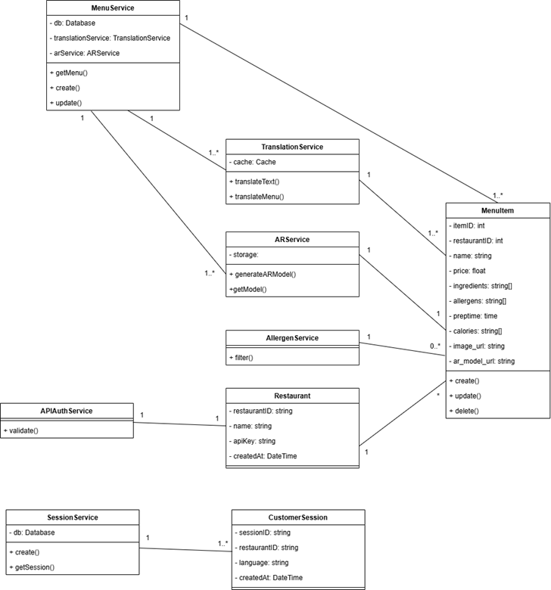

Use Case Diagram:
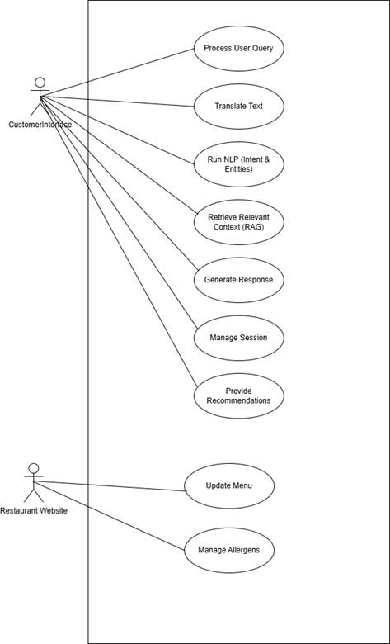

AI/NLP Services

Class Diagram:
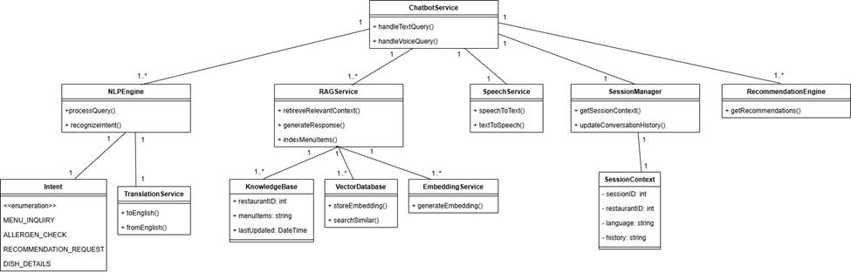

Sequence Diagram:
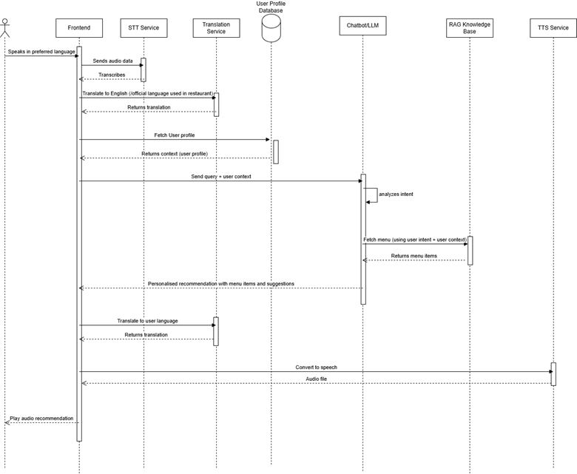

AR Visualization

Component Diagram

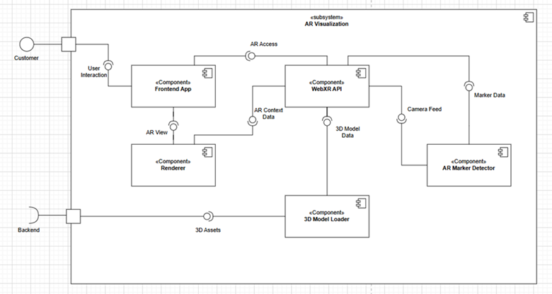

Class Diagram

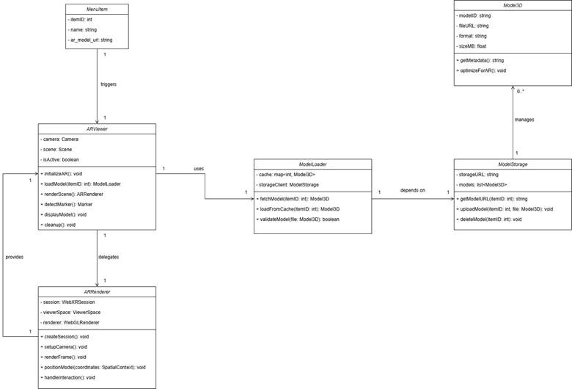

Human Interface Design
The user Interfaces are divided into two parts Customer – Interface and the Staff Interface. The Customer Interface lets users filter the menu, view the dish in AR, interact with a chatbot, make item selection, and add notes. The Staff interface mainly lets the staff view the dishes, add, update, or delete the dishes. And can put potential allergens in the dish.

Customer Interface:

Welcome Screen:


This is the first screen the user sees.
Objects:
- Restaurant logo (top center)
- Button: “Login”
- Button: “Skip for Now”
Actions:
- Login: Allows returning customers to access personalized features (like saved selections).
- Skip for Now: Lets new or guest users go directly to menu browsing without logging in.
Login Screen:
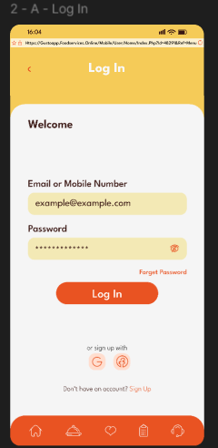
This screen is for returning users who want to login to get more customized features.
Object:
- Input field for email /mobile no. and password
- Sign Up page button
Actions:
- Input fields: users can input their mail ID or mobile no. and input their password for loginig in.
- Sign Up button: New users can sign up for customized views.

Sign Up Page:
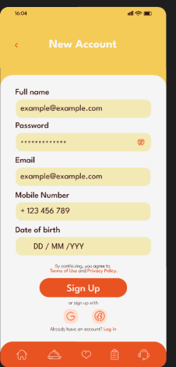
This screen is where new users can sign up.
Objects:
- Input Feilds
- Log In button
- Navigation bar at the bottom with icons/buttons for:
- Menu
- Chat
- AR Viewer
- Profile/Other pages

Actions:
- Input Feilds: There are input feilds for name, password, email, number and DOB.
- Log In button: For users who want to go back to login screen.
- Nav Bar: For easy access of the screens.

Language Selection Screen:
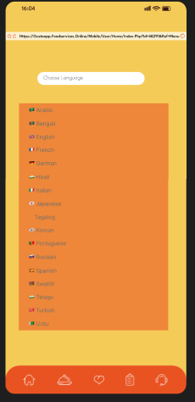

This is the screen the users see after logining in or once they click on “skip for now” button.

Objects:
- List of available languages
- Navigation bar at the bottom with icons/buttons for:
- Menu
- Chat
- AR Viewer
- Profile/Other pages
Actions:
- Language selection: Selecting a language automatically updates the interface text to the chosen language.
- Navigation bar: Allows quick access to different sections of the app.

Menu Screen:
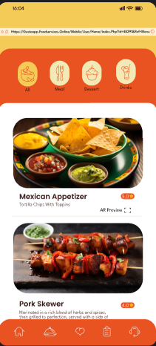
This screen shows a list of all items in a scrollable pattern. With rating anf a breif description of each items.

Objects:
- Items
- Filters
- AR Preview
- Nav Bar

Actions:
- Items: They show a brief description of the dish.
- Filters: Users can filter the type of dish they want to view (eg. Main Course, Desserts, etc.)
- AR Preview: Users can see exactly how the dish is going to be presented.
- Navigation bar: Allows quick access to different sections of the app.

AR Preview Screen:
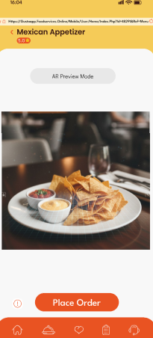
This screen shows the AR preview of the dish for better visualization.

Objects:
- Place Order
- Nav Bar
- More Information:

Actions:
- The place order button will add the item into the cart.
- The navigation button allows quick access to different sections of the app.
- The more Information button allows users to see the ingredients in the dish.

More Information Screen:

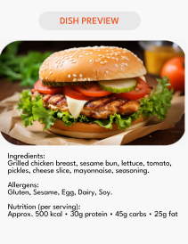
More information will display ingredients in this format.

Chat Bot Screen:
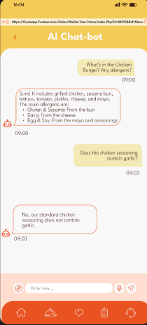
This screen is where users can interact with the bot for more information about the dish, etc.

Objects:
- Chat Field
- Nav Bar
- Voice Input

Actions:
- Chat Field: users can input text for chat in this area
- The navigation button allows quick access to different sections of the app.
- Voice Input: Users can use voice-based commands for communicating with the bot.

Place Order Screen
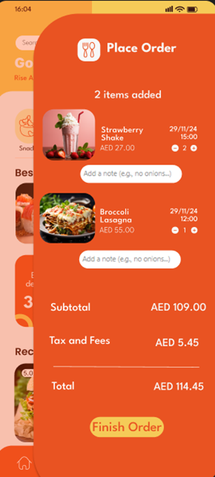

This screen is where the users can add items to their chart and finalize their orders.

Objects:
- Add a note
- + or -
- Finish order

Actions:
- Add a note: users can add notes for each dish and ask for specific changes
- + or – is used to add another or remove the item
- Finish order: clicking this will take the users to the finalize order screen to confirm the items added.

Finalize Order:
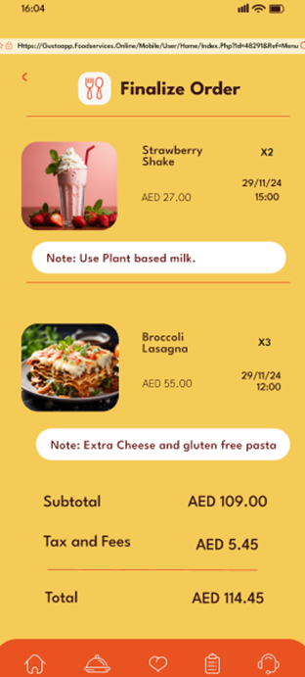
This is the final screen where the users finalize their order before confirming their order with the restaurant staff .

Staff – Interface:
Log In Interface:
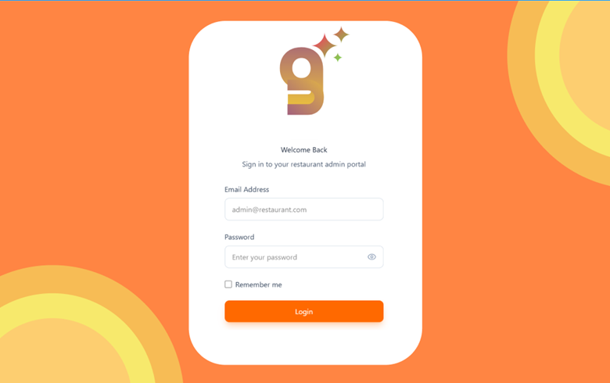This is the first screen for the staff where they can input their login details.

Objects:
- Text Field
- Check Box

Actions:
- Text field is where the staff inputs their mail if and password for login in.
- Check Box: Remember me button to make the login process smoother.

Dashboard:
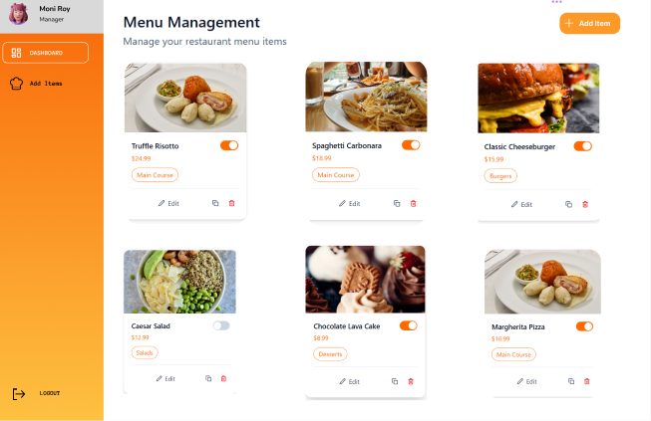Main Dashboard where the staff can view the menu and make changes.

Objects:
- Nav Bar
- Add Item
- Edit Item
- Delete Item
- Toggle button
- Logout button

Actions:
- Nav Bar: For quick access to different pages.
- Add Item: Users are taken to the add item page where they can add the details of the new dish.
- Edit Item: Users are taken to the edit item page where they can edit the details of the dish.
- Delete Item: Dishes can be deleted once the user selects the delete button they will be taken to pop up for further confirmation for the deletion.
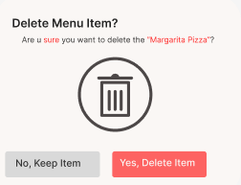

- Toggle button: Allows users to remove the dish from view if the dish is out of availability.
- Logout button: This button will take users back to the Login screen.

Add Items Screen:
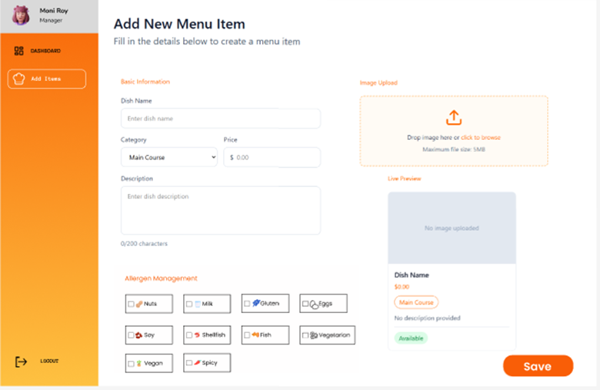 In this screen, the staff can add a new item, which will then be added to the menu based on the category.

Objects:
- Text Fields
- Price Fields
- Allergen Boxes
- Image Upload
- Nav Bar

Actions:
- Text Fields: Users can add details for the dish (eg. Description abot the dish, name, etc.)
- Price Fields: Users can add price for the dish in this area.
- Allergen Boxes: Staff can select allergens in the dish.
- Image Upload: Staff can upload images of the dish for the AR preview and better visualize the dish.
- Nav Bar: For quick access to different pages.

Edit Dish Screen:
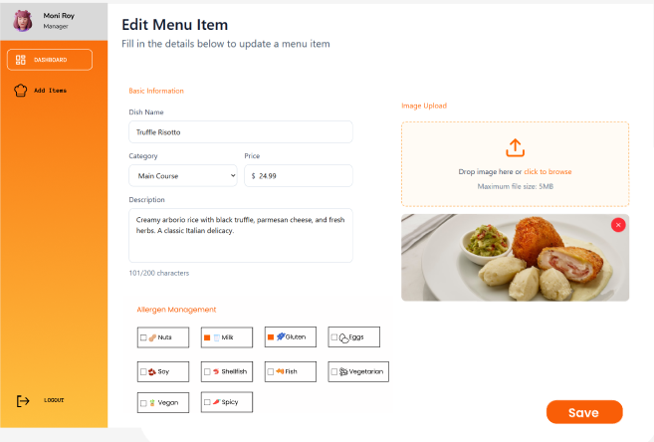In this screen, the staff can edit dishes, which will then be updated to the menu based on the category.

Objects:
- Text Fields
- Price Field's
- Allergen Boxes
- Image Upload
- Nav Bar

Actions:
- Text Fields: Users can update details for the dish (eg. Description about the dish, name, etc.)
- Price Fields: Users can update the price for the dish in this area.
- Allergen Boxes: Staff can select allergens in the dish.
- Image Upload: Staff can upload images of the dish for the AR preview and better visualize the dish.
- Nav Bar: For quick access to different pages.

Requirements Traceability Matrix

BR No. | BR Name | UC No. | UC Name | FR No. | FR Name | TC No. | TC Name | Status
BR001 | Multilingual Real-Time Translation | UC001 | Real-time translation | FR001 | Translate query from given language to English | TC001 | Test Arabic to English translation | Pending
BR001 | Multilingual Real-Time Translation | UC001 | Real-time translation | FR002 | Translate from English to response target language | TC002 | Test English to Arabic translation | Pending
BR001 | Multilingual Real-Time Translation | UC001 | Real-time translation | FR003 | Pre-translate and cache menu items | TC003 | Test cached translation retrieval | Pending
BR002 | AI-Powered Chatbot | UC002 | Ask about ingredients | FR004 | Generate contextual response using AI | TC004 | Test chatbot response relevance | Pending
BR002 | AI-Powered Chatbot | UC003 | Maintain conversation context | FR005 | Store conversation history during session | TC005 | Test context retention in follow-up questions | Pending
BR002 | AI-Powered Chatbot | UC002 | Query knowledge base | FR006 | Retrieve menu and restaurant info via RAG | TC006 | Test RAG accuracy with menu queries | Pending
BR003 | Voice Assistance & Accessibility | UC004 | Voice to Text | FR007 | Convert speech to text in multiple languages | TC007 | Test speech recognition accuracy (Arabic) | Pending
BR003 | Voice Assistance & Accessibility | UC005 | Text to Speech | FR008 | Generate speech in user's selected language | TC008 | Test multilingual speech output | Pending
BR004 | AR Menu Visualization | UC006 | View AR dish preview | FR009 | Display AR overlay on camera view | TC009 | Test AR overlay accuracy | Pending
BR004 | AR Menu Visualization | UC006 | Load 3D model | FR010 | Fetch and render 3D dish model | TC010 | Test 3D model loading performance | Pending
BR005 | Selection Builder | UC007 | Add items to selection | FR011 | Add menu items to temporary selection | TC011 | Test add to selection functionality | Pending
BR005 | Selection Builder | UC008 | Add item notes | FR012 | Store per-item customization notes | TC012 | Test note attachment to items | Pending
BR005 | Selection Builder | UC009 | View selection summary | FR013 | Display selection with total and allergen warnings | TC013 | Test summary generation accuracy | Pending
BR005 | Selection Builder | UC010 | Generate selection QR | FR014 | Create QR code for server to scan selection | TC014 | Test QR code generation and scanning | Pending
BR006 | User Authentication | UC011 | Admin login | FR015 | Authenticate admin credentials | TC015 | Test admin login validation | Pending
BR006 | User Authentication | UC012 | Session management | FR016 | Maintain admin session securely | TC016 | Test session timeout and security | Pending
BR007 | QR Session Validation | UC013 | Scan restaurant QR | FR017 | Validate renewable QR code (valid for 30 secs) | TC017 | Test QR expiration handling | Pending
BR007 | QR Session Validation | UC014 | Create customer session | FR018 | Grant session access to features | TC018 | Test session creation and feature access | Pending
BR008 | Menu Management (Admin) | UC015 | Create menu item | FR019 | Add new menu item with details | TC019 | Test menu item creation | Pending
BR008 | Menu Management (Admin) | UC016 | Update menu item | FR020 | Edit existing menu item details | TC020 | Test menu item updates | Pending
BR008 | Menu Management (Admin) | UC017 | Delete menu item | FR021 | Remove menu item from system | TC021 | Test menu item deletion | Pending
BR008 | Menu Management (Admin) | UC018 | Upload item photo | FR022 | Store and link photo to menu item | TC022 | Test photo upload and display | Pending
BR008 | Menu Management (Admin) | UC019 | Manage allergens | FR023 | Set allergen flags for menu items | TC023 | Test allergen marking and filtering | Pending
BR008 | Menu Management (Admin) | UC020 | Set item availability | FR024 | Toggle menu item in-stock status | TC024 | Test availability toggle | Pending

SEM 2

Test Plan Document

Test Plan Overview
The Test Plan describes the approach, scope, and strategy employed to ensure that our GUSTO system is working properly, efficiently, and effectively before its deployment.
GUSTO is an AI-driven restaurant intelligence solution that aims to optimize the customer ordering process while providing restaurants with valuable analytics and revenue optimization insights. The system comprises essential functionalities such as an AI chatbot ordering assistant, multi-language support, voice ordering, allergen-aware recommendations, predictive upselling, AR preview of the dish being ordered and an analytics dashboard for restaurants. The functionalities of the system are integrated to eliminate communication barriers, improve customer safety, and provide restaurants with business intelligence insights.
This test plan ensures that the entire system, including the chatbot, recommendation engine, voice ordering system, user interface, database operations, and analytics dashboard, is working correctly and without errors. The test plan will ensure that the GUSTO system is capable of processing customer inquiries correctly, providing intelligent recommendations, supporting multiple languages, and recording conversation data for analytics. The system will also be tested for usability, performance, and robustness to ensure a smooth and professional experience for users on various devices and platforms.
In addition, this test plan aims to validate the reliability and scalability of GUSTO in a real-world setting. The system should be able to support multiple users at the same time, store and retrieve data in a secure manner, and deliver accurate analytics insights to restaurants. The test will also verify that confidential data, including customer preferences and restaurant information, is properly secured and accessible only to authorized users. Ultimately, the aim of this test plan is to verify that GUSTO is fully functional, stable, secure, and ready for a real-world deployment as a scalable restaurant intelligence solution.

Purpose
The aim of this test plan is to ensure that all aspects of the GUSTO system are working as expected and that it satisfies the project’s technical, functional, and performance specifications. The testing procedure will ensure that the AI chatbot is able to interpret customer inquiries correctly, answer them accurately, suggest appropriate menu items, and handle multiple languages and voice commands. It will also ensure that the recommendation engine is able to provide the user with relevant suggestions based on their preferences and behavior, which will enable restaurants to increase customer satisfaction and ultimately their revenue.
Another important aim of this test plan is to ensure that the GUSTO system is usable and accessible. The testing procedure will determine the ease with which users can interact with the chatbot, use the system interface, and place orders without any difficulties or delays. As GUSTO is designed to eliminate communication barriers and make the system more accessible, the testing procedure will ensure that the multilingual functionality, allergen filters, and voice ordering functionality are working properly and providing a safe ordering experience for all users.
Moreover, this test plan also ensures that the restaurant analytics dashboard is able to monitor customer conversations, order trends, and performance metrics effectively. This is a critical requirement because GUSTO can convert customer interaction data into valuable business insights that enable restaurants to optimize their menus and boost profitability. The testing procedure will also assist in resolving bugs, performance problems, or system errors, ensuring that the end result is a stable and secure system. In summary, the aim of this test plan is to provide a fully functional, efficient, and intelligent system that satisfies both customer and restaurant requirements.

Scope
The scope defines the boundaries of the software testing process for the system. It identifies which features and components will be tested and which will be excluded from the current phase. Having a clearly defined scope helps ensure that testing efforts are focused on the most important and stable parts of the system. It also prevents unnecessary testing of features that are still under development or planned for future releases. For the Gusto system, the scope ensures that the testing process supports the project’s objectives and development timeline.
Defining the scope is important for managing the testing process effectively. It provides a clear understanding of what will be evaluated, how thoroughly the system will be tested, and what limitations exist in the current testing cycle. A well-defined scope improves planning, saves time and resources, and helps produce reliable and meaningful testing results.
In Scope
The testing scope includes the main features of the Gusto system that are required for both customers and administrators. The customer interface will be tested to ensure that users can access the system through QR codes, select a preferred language, and navigate the application easily. The menu display feature will be tested to confirm that menu items are shown correctly with details such as name, price, description, ingredients, and allergen information.
Search and filtering functionalities will be tested to ensure that users can find items based on categories, dietary preferences, and allergens. Sorting options and pagination will also be tested to verify that users can browse large menus efficiently.
The augmented reality feature will be included in testing to ensure that users can activate AR mode, grant camera permissions, and view 3D models of menu items in a real-world environment. This includes testing model loading, basic interactions such as rotating and zooming, and system behaviour on devices that do not support AR.
The chatbot and voice interaction features will be tested to confirm that users can communicate with the system using both text and voice. This includes checking that the chatbot provides relevant responses, supports multiple languages, and correctly converts speech to text and text to speech.
The order selection feature will be tested to ensure that users can add items to their selection, adjust quantities, include special notes, view allergen warnings, and see the total cost. The final selection summary and QR code generation will also be validated.
The administrative portal will be tested to verify that administrators can log in securely and manage menu content. This includes adding, editing, and deleting menu items, uploading images, managing allergen information, and linking AR model URLs to menu items.
Backend services will also be tested, including API endpoints for menu management, authentication, order handling, QR validation, and AI services. Basic non-functional aspects such as error handling, input validation, security of endpoints, accessibility, and responsiveness across different devices will be included in the testing process.
Out of Scope
The features excluded from the current testing phase are mainly those planned for future development or advanced system enhancements. Fully automated AR model generation and complex AR interactions, such as real-time environment mapping and advanced object physics, are not included in this phase.
Online payment systems and integration with external payment gateways are also out of scope. Restaurant order management features are also not included as they are not the key focus of our innovation and problem statement. Advanced analytics features, such as long-term user behaviour analysis and AI-based recommendation systems, will not be tested at this stage.
In addition, enterprise-level features such as multi-restaurant support, large-scale system integrations, and full production deployment testing are considered outside the scope of the current testing cycle and will be addressed in future phases of the project.

Objectives
The primary goal of this test plan is to ensure that GUSTO works well, correctly, and efficiently on all its functionalities and elements. The testing goals are centered on the validation of the system's functionality, usability, performance, security, and reliability to ensure a smooth and professional experience for the user.

Functional Objectives
• To ensure that the AI chatbot can correctly interpret and answer customer inquiries
• To ensure that the multilingual support feature works correctly and accurately in all languages
• To ensure that the voice ordering feature can correctly interpret and process customer commands
• To ensure that the allergen filter feature works correctly and does not provide any harmful suggestions
• To ensure that the recommendation engine provides the correct menu suggestions based on customer input
• To ensure that customers can successfully navigate menus and place orders through the chatbot
• To ensure that the user profile feature can correctly store and retrieve customer preferences
• To ensure that the restaurant dashboard provides correct analytics and performance information

System Performance Objectives
• To ensure that the system reacts promptly to user inputs without any delay
• To ensure that the system supports multiple users concurrently without crashing
• To ensure that all pages, dashboards, and chatbot outputs are loaded efficiently
• To ensure that database operations such as saving and loading data are done correctly

Usability Objectives
• To ensure that the system interface is friendly and easy to use
• To ensure that users can perform ordering tasks without any difficulties
• To ensure that voice, text, and chatbot interactions are seamless
• To ensure that the system layout and functionality are consistent on all devices

Security Objectives
• To ensure that customer and restaurant information is stored safely
• To ensure that only authorized users can access restaurant analytics dashboards
• To ensure that user preferences and conversation information are private and secure

Reliability Objectives
• To ensure that the system runs without any crashes or unexpected failures
• To ensure that the chatbot and recommendation system provide consistent outputs
• To ensure that customer interaction and analytics information is tracked accurately
• To ensure that the system behaves as expected under real-world usage scenarios

Testing Methodology
GUSTO’s system testing will occur in two significant stages which are Functional Testing and Non-functional Testing. Functional testing will be aimed at checking whether each single feature works as required and in line with the requirements of the project. These include user authentication, menu browsing, AI chatbot ordering, AR visualization, Multilingual translation, order processing, and the staff dashboard modules. On the other hand, non-functional testing will be used to verify the general quality and reliability of the system. It will involve performance, security, usability, and accessibility tests to ensure that GUSTO does not only work, but it also provides an easy-to-use experience for all users. The combination of such testing methods will help in the detection of bugs, test performance, as well as check whether the platform is ready to be deployed.

Functional Testing
- GUSTO will be tested functionally to ensure that it can perform the task that is given and does it in the most effective way. The testing is focused on making sure that the behaviors of the users produce the correct responses in the system and that the data is captured, parsed, and/or displayed for usage.
- The main functions that will be tested include browsing through the menu and viewing of dishes, the artificial intelligence chatbot with voice and text-based ordering, the multiple translations of supported languages, the AR dish visualization, order placement and passing the data through an endpoint which can be integrated into restaurant POS systems or shown as a QR code which can be scanned by the cashier. It will also test the accessibility and safety of the system with regards to allergen filtering and safe recommendations.
- The admin side will be tested for menu management such as adding, editing and deleting items, uploading AR models, the analytics dashboard and menu optimization recommendations.
- Finally, realistic user scenarios that are used to perform the tests with the users to verify that GUSTO behaves in an appropriate way under realistic normal situations, and accounting for any edge cases.

Non-Functional Testing
- Non-functional testing will occur through evaluating GUSTO's performance as a system rather than feature functionality. This will ensure that the software has a high degree of reliability, security, speed, and access to everyone who uses it.
- Performance testing will measure how long it takes for the GUSTO system (both the chat bot and translation) to respond to the end user. Additionally, we are required to minimize order selection latency for users as prioritizing orders is a necessity in the restaurant and catering industry to retain and satisfy customers.
- Security testing will confirm that sensitive data is encrypted when it is at rest and in transit, and that only those authorized to access the sensitive data will be able to do so.
- Usability testing will also verify that user interface is easy for all customers to utilize regardless of their language and their device of use (i.e. desktop, laptop, smart phone). These tests will validate the overall quality of the GUSTO product and the quality of the user experience that it will provide.

Test Execution Plan
- A test execution plan provides information regarding the testing methods to be used, namely types of tests being administered, the functionality being tested, as well as tools that will be used to conduct testing. The thorough and planned approach will allow for all functional items and non-functional items in the system to be thoroughly tested.
- Testing will commence with the manual verification of the key features of the application, including login, menu navigation, chatbot ordering, and augmented reality (AR) viewing to confirm that each feature is working properly.
- Security testing will be performed on a regular basis to ensure security for personal data using Postman security testing tools. Similarly, accessibility testing will also be performed to ensure compliance (by using WAVE accessibility testing software) with international accessibility standards.
- Documentation and review of test results will occur at the end of all test execution phases, allowing verification that GUSTO complies with the project requirements prior to the deployment of the application.

Test Category | Features to test | What to check | Tool used
Functional | Authentication (Login, Register, Logout) | Correct messages and actions, JWT token generation, password hashing | Postman + pytest
Functional | Menu browsing and order placement | Correct display and workflow | Manual testing + Vitest
Functional | AI chatbot and voice ordering | Correct responses and order placement | Manual testing
Functional | Translation | Accurate multilingual content rendering | Manual testing
Functional | Customer profile management | Profile creation, update, order history retrieval | Manual testing + pytest
Functional | Admin dashboard | Restaurant/menu CRUD operations, order management, analytics viewing | Manual testing
Functional | AR visualization | Correct 3D dish display | Manual testing
Functional | Session Management | Session creation via QR, session-to-customer linking on login, cart transfer | Manual testing+ pytest
Non-Functional | Performance – API response time | Chatbot Response <3s, order API <1s | Manual Testing
Non-Functional | Security | Data protection and access control | Postman + Manual Testing
Non-Functional | Performance Database Queries | Query execution time, connection pooling, concurrent user handling | Manual testing + pytest
Non- Functional | Input Validation | SQL injection prevention, XSS prevention, input sanitization | Manual testing + pytest
Non-Functional | password security | Bcrypt hashing verification, password storage validation | Pytest
Non-Functional | Usability | UI/UX intuitiveness, mobile responsiveness, AR user experience | Manual testing
Non-Functional | Compatibility - bowser | browser functionality | Manual testing
Non-Functional | Reliability – error handling | Error messages, API failure handling, network disconnection recovery | Manual testing + pytest

Test Cases – Functional Testing

Customer Side:

Login and Authentication
Test Case ID | Test Description | Input | Steps | Expected Result | Test Result
TC-CUST-AUTH-001 | Valid customer login with correct credentials | Email: customer3@example.com / Password: password3 | 1. Navigate to the customer login page  2. Enter valid registered email address  3. Enter correct password  4. Click Login button | Customer is logged in successfully. Customer is redirected to landing page. Icon with customer name shown on top right.
TC- CUST- AUTH-002 | Login attempt with incorrect password | Email: customer3@example.com / Password: password3 | 1. Navigate to the customer login page  2. Enter valid registered email address  3. Enter an incorrect password  4. Click Login button | Login is rejected. Error message displayed. User remains on login page.
TC- CUST- AUTH-003 | Login attempt with unregistered email | Email: customer@example.com / Password: password | 1. Navigate to the customer login page  2. Enter an unregistered email  3. Enter any password  4. Click Login button | Login fails. Error message displayed. Access is denied.
TC- CUST- AUTH-004 | Login with empty email field | Email: (empty) / Password: password | 1. Navigate to the customer login page  2. Leave Email Address field blank  3. Enter a password  4. Click Login button | Validation error shown on email field. Form is not submitted. Login is blocked.
TC- CUST- AUTH-005 | Login with empty password field | Email: customer3@example.com / Password: (empty) | 1. Navigate to the customer login page  2. Enter a valid email  3. Leave Password field blank  4. Click Login button | Validation error shown on password field. Form does not submit. Login is blocked.
TC- CUST- AUTH-006 | Login with both fields empty | Email: (empty) / Password: (empty) | 1. Navigate to the customer login page  2. Leave both Email and Password blank  3. Click Login button | Validation errors shown on both fields. Form does not submit.
TC- CUST- AUTH-007 | Email field input format validation | Email:  customer123 / Password: password | 1. Navigate to the customer login page  2. Enter invalid email format (e.g. "customer123")  3. Enter any password  4. Click Login button | Validation error shown for invalid email format. Login is not attempted.
TC- CUST- AUTH-008 | Session persistence on page refresh | Active customer session | 1. Log in as a valid customer  2. Navigate to any page  3. Refresh the browser | Customer remains logged in. Page reloads correctly without requiring re-login.
TC- CUST- AUTH-009 | Valid sign-up with required fields | Name: John Smith  Email: john@example.com  Password: john1234  Phone (Optional): (empty) | 1. Navigate to the sign-up page by clicking on Sign Up.  2. Enter a valid name, email and password.  3. Leave phone number field blank.  4. Submit using sign up button. | Account is created successfully. Customer is automatically logged in via auto login and is redirected to landing page.
TC- CUST- AUTH-010 | Valid sign up with all fields | Name: John Smith  Email:  john@example.com  Password: john1234  Phone (Optional): (empty) | 1. Navigate to the sign-up page by clicking on Sign Up.  2. Enter a valid name, email, phone number and password.  3. Submit using sign up button. | Account is created successfully with all details. Customer is automatically logged in and redirected to the landing page.
TC- CUST- AUTH-011 | Sign-up with an already registered email | Email: customer3@example.com | 1. Navigate to the sign-up page by clicking on Sign Up  2. Enter an email address that’s already registered.  3. Fill in the remaining fields with valid data  4. Submit the sign-up form. | Sign up is rejected. Error message displayed. No duplicate account created. Customer remains on the sign-up page.
TC- CUST- AUTH-012 | Sign-up with missing required name/password/email | Name: John Smith/(empty)  Email: john@example.com/(empty)  Password: john1234/(empty) | 1. Navigate to sign-up page by clicking on Sign Up.  2. Leave the name/email/password field blank.  3. Fill the remaining fields with valid data.  4. Submit the sign-up form. | Validation error shown for the missing field. Form doesn’t submit. Account is not created.
TC- CUST- AUTH-013 | Customer logout functionality | Logged-in customer session | 1. Log in with valid customer credentials  2. Navigate to customer profile by clicking on the customer icon.  3. Click the Logout button in top-right corner | Session is terminated. Customer is redirected to login page. Protected pages are inaccessible without re-authentication.

Landing Preview
Test Case ID | Test Description | Input | Steps | Expected Result | Test Result
TC-LAND-001 | Verify landing page loads successfully | URL: http://localhost:5173/ | 1. Open browser  2. Enter URL  3. Press Enter | Landing page loads without errors. “Welcome To Gusto” and Search bar are visible. Restaurant section loads.
TC-LAND-002 | Verify page title/banner is displayed correctly | N/A | 1. Load landing page | Header shows “Welcome To Gusto” centered and clearly readable.
TC-LAND-003 | Verify Search bar is visible and usable | N/A | 1. Load landing page  2. Click Search field | Search field is visible. Cursor appears in field. User can type.
TC-LAND-004 | Search restaurants by valid keyword (partial match) | Keyword: nan | 1. Load landing page  2. Type nan in Search  3. Observe results | Restaurant list filters to matching restaurant names (e.g., Nando’s). Only relevant cards shown.
TC-LAND-005 | Search restaurants by full name | Keyword: PF Chang's | 1. Load landing page  2. Type restaurant name | Matching restaurant card displayed correctly.
TC-LAND-006 | Search is case-insensitive | Keyword: NANDO | 1. Load landing page  2. Type NANDO | Results match same as nando. Search is not case-sensitive.
TC-LAND-007 | Search with spaces trims correctly | Keyword: Desi | 1. Load landing page  2. Type keyword with leading/trailing spaces | Results still show “Desi Biryani” (spaces ignored/handled properly).
TC-LAND-008 | Search with no match | Keyword: xyz123 | 1. Load landing page  2. Type xyz123 | No matching restaurants shown. Page should show empty state (e.g., “No restaurants found”) OR show empty list without breaking UI.
TC-LAND-009 | Clear search restores full list | Keyword: desi then clear | 1. Type desi  2. Delete text / clear input | Full restaurant list returns immediately.
TC-LAND-010 | Verify “All Restaurants” section title appears | N/A | 1. Load landing page | “All Restaurants” heading is visible above the cards.
TC-LAND-011 | Verify restaurant cards display required info | N/A | 1. Load landing page  2. Observe any card | Each card shows: Image, Restaurant Name, Category/Cuisine label (e.g., Indian/Chinese/Grill), Rating badge (e.g., 3.9), Favorite icon (heart).
TC-LAND-012 | Verify restaurant image loads properly | N/A | 1. Load landing page  2. Observe cards | Card images load without broken image icons. Proper fit inside card container.
TC-LAND-013 | Verify rating formatting | N/A | 1. Load landing page  2. Observe rating badge | Rating displays as number (e.g., 4, 3.5, 3.9). Consistent format across cards.
TC-LAND-014 | Add restaurant to favorites (heart icon) | Select any restaurant | 1. Load landing page  2. Click heart icon on a card | Heart toggles to “selected” state (filled/active). Restaurant is marked as favorite.
TC-LAND-015 | Remove restaurant from favorites (toggle off) | Same restaurant as above | 1. Click the same heart icon again | Heart returns to “unselected” state. Favorite is removed.
TC-LAND-016 | Favorite state persists after refresh (if supported) | Favorite one restaurant | 1. Favorite a restaurant  2. Refresh page | If persistence is implemented: favorite remains selected after reload. If not implemented: system should not crash (state may reset).
TC-LAND-017 | Open restaurant details/menu from card (if clickable) | Select any restaurant card | 1. Click restaurant card/name/image | Navigates to restaurant details/menu page for selected restaurant. Correct restaurant data shown.
TC-LAND-018 | Navigation bar visible at bottom | N/A | 1. Load landing page | Bottom navigation bar is visible (Home + Cart + Chat icons).
TC-LAND-019 | Home icon returns to landing page | From another page (Cart/Chat) | 1. Navigate to Cart or Chat  2. Click Home icon | User is redirected back to landing page.
TC-LAND-020 | Cart icon opens cart page | N/A | 1. Load landing page  2. Click Cart icon | User navigates to cart page. Cart loads without error.
TC-LAND-021 | Chat icon opens chatbot page | N/A | 1. Load landing page  2. Click Chat icon | User navigates to chatbot screen. Chat UI loads correctly.
TC-LAND-022 | Language/global icon opens language options (if implemented) | N/A | 1. Load landing page  2. Click globe icon (top-right) | Language selection opens (dropdown/modal). No UI overlap or crash.
TC-LAND-023 | Landing page responsiveness (mobile view) | Screen width ≤ 390px | 1. Open DevTools 2. Set to mobile device size  3. Reload | UI remains aligned. Cards and nav bar display correctly without overlapping text/icons.
TC-LAND-024 | Loading state behavior (slow network) | Throttle network “Slow 3G” | 1. Throttle network  2. Reload page | Page shows loading indicator/skeleton OR loads gracefully without broken layout. No infinite blank screen.
TC-LAND-025 | Error handling when restaurant list API fails (if API-driven) | Simulate API failure / backend off | 1. Stop backend / break API  2. Reload landing page | Error is handled gracefully: message shown (e.g., “Unable to load restaurants”) and app does not crash.
TC-LAND-026 | Accessibility: keyboard navigation for search | Keyboard only | 1. Press Tab until search field is focused  2. Type text | Search input can be focused using keyboard. User can type and filter results.
TC-LAND-027 | Accessibility: icons have visible feedback | N/A | 1. Hover/click icons (heart/nav icons) | Icons show hover/click feedback (highlight/active) and are clearly clickable.
TC-LAND-028 | Verify no console errors on load | N/A | 1. Open DevTools Console  2. Reload page | No critical errors in console. (Warnings acceptable if documented.)

Translation
Test Case ID | Test Description | Input | Steps | Expected Result | Test Result
TC-TRANSLATION-001 | Language translation upon language selection | Language selection from dropdown | - Open landing page  - Click language selector  - Select language | Interface switches to preferred language, menu items display in preferred language.
TC-TRANSLATION-002 | Menu item translation accuracy | English menu loaded | - View menu in English  - Switch to preferred language  - Check dish names | All dish names translated correctly, food terms contextually accurate
TC-TRANSLATION-003 | Allergen label translation | Menu with allergens | - Set preferred language  - View menu items with allergens | Allergen labels (dairy, nuts, gluten) display in preferred language
TC-TRANSLATION-004 | Real-time language switch | Mid-session language change | - Add items to cart  - Switch to another language  - Check cart contents | Cart items update to the new language, quantities remain intact
TC-TRANSLATION-005 | Translation cache performance | Repeated language switches | - Switch to a new language from English  - Switch back to English  - Measure load time | Cached translations load <10 seconds

Menu Page
Test Case ID | Test Description | Input | Steps | Expected Result | Test Result
TC-MENU-001 | Verify menu page loads successfully | Open Menu page from restaurant card | 1. Open landing page  2. Select a restaurant  3. Navigate to Menu page | Menu page loads without crash. “Menu” title is visible. Categories and items display properly.
TC-MENU-002 | Verify category tabs are visible | N/A | 1. Load menu page | Category icons/tabs are visible: All, Mains, Sides, Dessert, Drinks.
TC-MENU-003 | Default category is “All” | N/A | 1. Load menu page | “All” category is selected by default and items from multiple categories are shown.
TC-MENU-004 | Filter items by “Mains” category | Click “Mains” | 1. Load menu page  2. Click “Mains” | Only items under “Mains” are displayed. Selected tab highlights/indicates active state.
TC-MENU-005 | Filter items by “Sides” category | Click “Sides” | 1. Load menu page  2. Click “Sides” | Only “Sides” items are displayed (e.g., Onion Rings).
TC-MENU-006 | Filter items by “Dessert” category | Click “Dessert” | 1. Load menu page  2. Click “Dessert” | Only “Dessert” items are displayed (e.g., Apple Pie).
TC-MENU-007 | Filter items by “Drinks” category | Click “Drinks” | 1. Load menu page  2. Click “Drinks” | Only “Drinks” items are displayed (e.g., Chocolate Shake).
TC-MENU-008 | Switch categories multiple times | Mains → Sides → All | 1. Click Mains  2. Click Sides  3. Click All | List updates correctly each time without duplicate items, layout breaks, or freezing.
TC-MENU-009 | Verify each menu item card shows required info | N/A | 1. Load menu page  2. Observe any 3 cards | Each card shows: Item image, Item name, Short description, and “AR Preview” link/icon.
TC-MENU-010 | Verify item images load properly | N/A | 1. Load menu page | No broken images. Images fit inside card container and maintain UI alignment.
TC-MENU-011 | Verify long text handling (name/description) | Use item with long name/description (if available) | 1. Scroll menu list  2. Locate long text item | Text wraps or truncates neatly without overlapping UI elements.
TC-MENU-012 | Open AR Preview from a menu item | Click “AR Preview” | 1. Load menu page  2. Click AR Preview on any item | AR Preview screen/feature opens successfully for selected item OR displays a clear message if not supported.
TC-MENU-013 | AR Preview opens correct item | Choose Item: “Apple Pie” | 1. Click AR Preview for Apple Pie | AR view (or AR page) shows Apple Pie model/preview (correct item, not another).
TC-MENU-014 | AR Preview handles missing model gracefully | Item without AR model (if exists) | 1. Click AR Preview for item missing model | System shows “AR not available for this item” (or similar) without crash.
TC-MENU-015 | Verify menu items remain visible on scroll | N/A | 1. Scroll down menu list | Items load/scroll smoothly. No flickering, overlap, or white gaps.
TC-MENU-016 | Verify category bar remains usable (sticky if implemented) | N/A | 1. Scroll down  2. Try switching category | Category bar remains accessible OR user can scroll back up easily. No UI glitch.
TC-MENU-017 | Verify bottom navigation bar is visible | N/A | 1. Load menu page | Bottom nav bar is visible with icons (Home, Cart, Chat).
TC-MENU-018 | Home icon navigates back to landing page | N/A | 1. On menu page  2. Click Home icon | User is redirected to landing page (“Welcome To Gusto”).
TC-MENU-019 | Cart icon navigates to cart page | N/A | 1. On menu page  2. Click Cart icon | Cart page opens successfully without errors.
TC-MENU-020 | Chat icon navigates to chatbot page | N/A | 1. On menu page  2. Click Chat icon | Chatbot page opens successfully without errors.
TC-MENU-021 | Verify language icon is clickable | N/A | 1. On menu page  2. Click globe icon (top-right) | Language selection opens (dropdown/modal) OR triggers language switch correctly.
TC-MENU-022 | Verify responsiveness (mobile view) | Screen width ≤ 390px | 1. Open DevTools  2. Switch to mobile resolution  3. Reload | UI remains clean: cards align properly, nav bar fixed, category bar fits screen.
TC-MENU-023 | Verify loading behavior on slow network | Throttle “Slow 3G” | 1. Enable slow network  2. Reload menu page | Page shows loading state/skeleton OR loads progressively without breaking layout.
TC-MENU-024 | Verify error handling when menu API fails (if API-driven) | Backend/API off | 1. Stop backend  2. Reload menu page | System shows a friendly error (e.g., “Failed to load menu items”) and does not crash.
TC-MENU-025 | Verify no console errors on menu page load | N/A | 1. Open DevTools Console  2. Reload menu page | No critical errors in console.

Chatbot
Test Case ID | Test Description | Input | Steps | Expected Result | Test Result
TC-CHAT-001 | Basic text chatbot query | Chatbot query, for example: “I want something spicy” | - Open chatbot  - Type query  - View response | Chatbot responds. Eg: Chatbot lists 3-5 spicy dishes with prices
TC-CHAT-002 | Response to voice input | Voice input | - Click microphone icon  - Speak in preferred language  - Wait for response | Voice converts to text, bot responds in voice through preferred language
TC-CHAT-003 | Intent: inquiry (no order) | Ask the chatbot an inquiry. Eg: “Does this have dairy?” | - Ask question about item  - Check cart | Chatbot answers questions, does NOT add to cart
TC-CHAT-004 | Intent: Order confirmation | Ask the chatbot to add to cart. Eg: “Yes, add it” | - Chatbot recommends item  - User confirms  - Check cart | Item added to chatbot_orders table
TC-CHAT-005 | Allergen filtering | Add allergy. Eg: “Allergic to peanuts. What can I eat” | - Give chatbot allergen preference  - Ask chatbot for options  - Check recommendations | ONLY allergen-free (peanut-free) items recommended
TC-CHAT-006 | Multi-turn conversation context | Multi-turn conversations. Eg: “Show vegetarian options” “Tell me about the first one” | - Ask question  - Ask follow-up question  - Check response | Chatbot remembers previous context
TC-CHAT-007 | AI upsell recommendation | Order from customer. Eg: order chicken tikka | - Confirm (Chicken Tikka) order  - View chatbot response | Chatbot suggests recommendations for upsell. Eg: “Garlic Naan – 87% also ordered”
TC-CHAT-008 | Voice with background noise | Voice input while there is background noise/cafe music | - Play background noise  - Speak into microphone  - Check response | Voice accuracy > 85% with moderate noise
TC-CHAT-009 | Chatbot response time (text) | Any text query | - Send message  - Measure response time | Response delivered in less than 5 seconds
TC-CHAT-010 | Chatbot response time (text) | Any text query | - Send message  - Measure response time | Response delivered in less than 5 seconds

Order selection and Cart Management
Test Case ID | Test Description | Input | Steps | Expected Result | Test Result
TC-ORDCART-001 | Open item customization page from menu | Select item: Chocolate Shake | 1. Go to Menu page 2. Click a menu item card | Customization page opens for selected item. Item name, image, price, category are displayed.
TC-ORDCART-002 | Verify item details displayed correctly on customization page | N/A | 1. Open customization page | Item name, description, price (e.g., $5.99), and category label (e.g., drinks) are visible and correct.
TC-ORDCART-003 | Verify allergen information is displayed | Item: Chocolate Shake | 1. Open customization page | Allergen info is shown (e.g., “Allergens: Dairy”).
TC-ORDCART-004 | Increase quantity on customization page | Quantity + | 1. Open customization page 2. Click “+” once | Quantity increases by 1 (e.g., 1 → 2).
TC-ORDCART-005 | Decrease quantity on customization page (not below minimum) | Quantity - | 1. Set quantity to 1 2. Click “-” | Quantity does not go below 1 (stays at 1) OR item removal behavior happens if designed (must not crash).
TC-ORDCART-006 | Add special instructions (valid) | Text: “No ice” | 1. Open customization page 2. Type “No ice” in Special Instructions 3. Click Add to Cart | Item is added to cart with the special instructions saved/attached to the item.
TC-ORDCART-007 | Add to Cart with empty special instructions | Leave blank | 1. Open customization page 2. Leave Special Instructions empty 3. Click Add to Cart | Item is added to cart successfully. No error shown.
TC-ORDCART-008 | Add to Cart with multiple quantity | Qty: 3 | 1. Set quantity to 3 2. Click Add to Cart | Cart reflects correct quantity (3). Total price updates accordingly (3 × item price).
TC-ORDCART-009 | Add multiple different items to cart | Chocolate Shake + Classic Burger | 1. Add Chocolate Shake to cart 2. Navigate to another item 3. Add Classic Burger | Cart contains both items as separate entries with correct quantities and prices.
TC-ORDCART-010 | Navigate to cart page from customization page | Click cart icon | 1. On customization page 2. Click bottom Cart icon | Cart page opens successfully and shows cart items.
TC-ORDCART-011 | Verify cart page displays item details correctly | N/A | 1. Open cart page | Each cart item shows: image, item name, unit price (“each”), quantity controls, item total price, delete icon.
TC-ORDCART-012 | Increase quantity from cart page | Click “+” on an item | 1. Open cart page 2. Click “+” for an item | Quantity increases by 1 and the item total updates correctly.
TC-ORDCART-013 | Decrease quantity from cart page | Click “-” on an item | 1. Open cart page 2. Click “-” for an item | Quantity decreases by 1 (not below minimum). Item total updates correctly.
TC-ORDCART-014 | Remove item from cart using delete icon | Click trash icon | 1. Open cart page 2. Click delete icon for one item | Item is removed from cart. Subtotal, item count, and total update correctly.
TC-ORDCART-015 | Verify subtotal calculation | Example: Shake($5.99×2) + Burger($11.99×1) | 1. Open cart page with listed quantities | Subtotal equals sum of each item totals. (e.g., 11.98 + 11.99 = 23.97).
TC-ORDCART-016 | Verify “Items” count is correct | N/A | 1. Open cart page | Items count matches number of distinct items in cart OR total quantity (based on system design). Must be consistent.
TC-ORDCART-017 | Verify total displayed matches subtotal (if no taxes/fees) | N/A | 1. Open cart page | Total equals subtotal when no additional fees/taxes exist. (e.g., Total = $23.97).
TC-ORDCART-018 | Cart empty state handling | Remove all items | 1. Remove all items using delete | Cart shows empty state message (e.g., “Your cart is empty”) and totals become $0.00. Checkout button disabled/handled safely.
TC-ORDCART-019 | “Proceed to Checkout” button visibility and click | N/A | 1. Ensure cart has items 2. Click Proceed to Checkout | User is navigated to checkout flow/page OR next step (payment/address). No crash.
TC-ORDCART-020 | Checkout button behavior when cart is empty | Cart empty | 1. Empty cart 2. Click Proceed to Checkout | Button is disabled OR user receives message “Add items to cart first.” No navigation to checkout with empty cart.
TC-ORDCART-021 | Back navigation from cart page | Click back arrow | 1. On cart page 2. Click back arrow (top left) | User navigates to previous page (menu/customize). Cart state remains saved.
TC-ORDCART-022 | Cart persistence after refresh (if implemented) | Refresh page | 1. Add items to cart 2. Refresh browser | If persistence implemented: items remain in cart. If not: cart resets but app must not crash (document behavior).
TC-ORDCART-023 | Validate UI does not break for large quantity | Qty: 20 | 1. Increase item quantity to 20 in cart | UI stays aligned, totals update correctly, no overflow/overlap.
TC-ORDCART-024 | Special instructions length/edge case | 200+ characters | 1. Enter long instructions 2. Add to cart | System accepts within limit OR shows proper validation message. No crash or layout break.
TC-ORDCART-025 | Verify “Added by chatbot” note (if feature enabled) | Add item via chatbot | 1. Add item using chatbot flow 2. Open cart | Cart item shows note “Added by chatbot” for chatbot-added items (as shown).

Order Finalization
Test Case ID | Test Description | Input | Steps | Expected Result | Test Result
TC-ORD-FIN-001 | Successful order finalization | Active cart with items | 1. Add items to cart  2. Proceed to checkout  3. View the Order Summary page. | Order Placed! Header shown with QR code, Order ID, item count, time and total price.
TC-ORD-FIN-002 | Loading state during finalization | Active cart with items | 1. Proceed to checkout.  2. Observe the screen while the order is being processed. | Spinner and “Finalizing your order...” text displayed till order is confirmed.
TC-ORD-FIN-003 | QR code displayed on order summary | Successfully finalized order | 1. Proceed to checkout.  2. View the QR code on the Order Summary page. | QR code image is displayed under “Scan to Confirm Order.
TC-ORD-FIN-004 | QR code encodes correct order data | Successfully finalized order | 1. Proceed to checkout.  2. Scan the QR code displayed on the Order Summary page. | QR code shows a string string containing selection id, restaurant id, total price, item count, finalized at, and items list (name, quantity, price, item total and notes)
TC-ORD-FIN-005 | Correct Order ID shown | Order ID: #62 | 1. Proceed to checkout  2. Check the Order ID field. | Order ID is displayed as #62, matching selection ID from the finalized order.
TC-ORD-FIN-006 | Correct item count shown | Items: 2 | 1. Add a known number of items to cart.  2. Proceed to checkout.  3. Check the items field. | Item field shows 2 matching the number of items ordered.
TC-ORD-FIN-007 | Ordered at time shown correctly | Ordered at 03:42 | 1. Note the current time.  2. Proceed to checkout.  3. Check the Ordered at field. | Ordered at shows the correct time in HH:MM format.
TC-ORD-FIN-008 | Total price shown correctly | Cart Items: 2  Chocolate Shake ($5.99),  Classic Burger ($11.99) | 1. Add items to cart and note their prices.  2. Proceed to checkout.  3. Check the total field. | Total displayed as 17.98 matching the cart total.
TC-ORD-FIN-009 | Error during finalization redirects to cart. | Network failure or server error. | 1. Simulate a server error.  2. Proceed to checkout.  3. Observe the result | Error alert shown with failure message. User is redirected back to cart page.
TC-ORD-FIN-010 | Start new order creates new session. | Completed Order Summary page | 1. View the Order Summary page  2. Click Start New Order | Session is cleared and user is navigated to menu page to begin a new order.
TC-ORD-FIN-011 | Back to Menu preserves Session | Completed Order Summary page | 1. View the Order Summary page  2. Click Back to Menu | User is navigated back to menu page, session is preserved.

Augmented Reality (AR) View
Functional Test Cases
Test Case ID | Test Scenario | Precondition | Test Steps | Expected Result
AR-TC-01 | Launch AR Viewer from menu item | User is on menu page and item has AR model | 1. Select a menu item. 2. Click “View in AR” button. | AR viewer opens and requests camera permission.
AR-TC-02 | Camera permission granted | User clicks “View in AR” | 1. Allow camera access when prompted. | Camera feed is displayed and AR session starts successfully.
AR-TC-03 | Camera permission denied | User denies camera access | 1. Click “Deny” on camera prompt. | System displays error message indicating camera access is required.
AR-TC-04 | Load 3D model | AR session is active | 1. Launch AR view. 2. Wait for model to load. | Correct 3D model loads and appears on detected surface.
AR-TC-05 | Invalid model URL | Menu item has broken AR model URL | 1. Launch AR view. | Error message displayed and fallback UI shown.
AR-TC-06 | Rotate model | 3D model is loaded | 1. Use touch gesture to rotate model. | Model rotates smoothly according to user gesture.
AR-TC-07 | Zoom model | 3D model is loaded | 1. Use pinch gesture to zoom. | Model scales in/out correctly.
AR-TC-08 | Unsupported device | Device does not support WebXR | 1. Click “View in AR”. | System shows fallback message: “AR not supported on this device”.
AR-TC-09 | Exit AR mode | AR viewer active | 1. Click Exit AR button. | AR session ends and user returns to menu page.
AR-TC-10 | Loading state | Slow network | 1. Open AR view. | Loading spinner shown until model loads.
AR-TC-11 | Model without surface | Flat surface not detected | 1. Launch AR view in low-texture area. | System prompts user to move device to find surface.
AR-TC-12 | Multiple launches | User opens AR repeatedly | 1. Open and close AR view multiple times. | No crashes, memory leaks, or abnormal behaviour.
AR-TC-13 | Orientation change | AR active on mobile | 1. Rotate device (portrait → landscape). | AR view adapts without breaking session.
AR-TC-14 | Network disconnect | AR model loading | 1. Disable internet during load. | Error message shown and retry option available.

Non-Functional Test Cases
Test Case ID | Scenario | Expected Result
AR-NF-01 | AR model load time | Model loads within acceptable time (e.g., < 5 seconds on good network).
AR-NF-02 | Usability | Users can easily understand gestures without instructions.
AR-NF-03 | Accessibility | AR button is clearly labelled and reachable.
AR-NF-04 | Stability | No application crash during AR usage.
AR-NF-05 | Cross-device compatibility | AR works on supported Android and iOS devices.

Customer Profile
Test Case ID | Test Description | Input | Steps | Expected Result | Test Result
TC-CUST-PROF-001 | Profile page displays customer information | Logged in customer | 1. Log in as customer.  2. Navigate to the My Profile page by clicking on the customer icon/name. | Customer name, email and phone number are displayed correctly.
TC-CUST-PROF-002 | Allergen and dietary preferences displayed on profile | Customer with saved allergens and dietary preferences | 1. Navigate to the My Profile page by clicking on the customer icon/name.  2. View the Allergen Preferences section.  3. View the Dietary Preferences Section | Saved allergens and dietary preferences are displayed as tags.
TC-CUST-PROF-003 | All allergen options shown in edit mode | Customer clicks on Edit in allergen preferences | 1. Navigate to the My Profile page by clicking on the customer icon/name.  2. Click on Edit in the Allergen Preferences section. | All 11 allergen options are shown:  Nuts, Peanuts, Dairy, Gluten, Shellfish, Soy, Eggs, Fish, Wheat, Sesame, Mustard.
TC-CUST-PROF-004 | Customer can add an allergen and save | Customer clicks on Edit in allergen preferences | 1. Click on Edit in the Allergen Preferences section.  2. Select Eggs.  3. Click on Save. | Eggs is added and displayed as a tag in the Allergen Preferences section.
TC-CUST-PROF-005 | Customer can remove an allergen and save | Customer clicks on Edit in allergen preferences | 1. Click on Edit in the Allergen Preferences section.  2. Deselect Dairy.  3. Click on Save. | Dairy tag is no longer displayed in the Allergen Preferences Section.
TC-CUST-PROF-006 | Customer can update allergen preferences and save | Customer clicks on Edit in allergen preferences | 1. Click on Edit in the Allergen Preferences section.  2. Select Peanuts, Dairy  3. Deselect Eggs.  3. Click on Save. | Eggs tag is no longer displayed. Peanuts and Dairy tags are displayed in the Allergen Preferences section.
TC-CUST-PROF-007 | Cancelling allergen edit restores original selection | Changes made in allergen edit mode | 1. Click on Edit in the Allergen Preferences section.  2. Toggle several allergens.  3. Click on Cancel. | Edit mode closes and the original allergen selection remains unchanged.
TC-CUST-PROF-008 | All dietary options shown in edit mode | Customer clicks on Edit in dietary  preferences | 1. Navigate to the My Profile page by clicking on the customer icon/name.  2. Click on Edit in the Dietary Preferences section. | All 10 allergen options are shown:  Vegetarian, Vegan, Gluten-Free, Dairy-Free, Nut-Free, Halal, Kosher, Pescatarian, Paleo, Keto.
TC-CUST-PROF-009 | Customer can add a dietary preference and save | Customer clicks on Edit in dietary preferences | 1. Click on Edit in the Dietary Preferences section.  2. Select Vegan.  3. Click on Save. | Vegan is added and displayed as a tag in the Dietary Preferences section.
TC-CUST-PROF-010 | Customer can remove a dietary preference and save | Customer clicks on Edit in dietary  preferences | 1. Click on Edit in the Dietary Preferences section.  2. Deselect Vegan.  3. Click on Save. | Vegan tag is no longer displayed in the Dietary  Preferences Section.
TC-CUST-PROF-011 | Customer can update dietary preferences and save | Customer clicks on Edit in dietary preferences | 1. Click on Edit in the Dietary Preferences section.  2. Select Vegan, Keto  3. Deselect Vegetarian.  3. Click on Save. | Vegetarian tag is no longer displayed. Vegan and Keto tags are displayed in the Dietary Preferences section.
TC-CUST-PROF-012 | Cancelling dietary preferences edit restores original selection | Changes made in dietary preferences edit mode | 1. Click on Edit in the Dietary Preferences section.  2. Toggle several dietary preferences.  3. Click on Cancel. | Edit mode closes and the original dietary preferences selection remain unchanged.
TC-CUST-PROF-013 | Order history displays past orders | Customer with past orders. | 1. Navigate to the My Profile page by clicking on the customer icon/name.  2. View the Order History section. | Past orders are listed showing order number, date, order items, total price and finalized status.
TC-CUST-PROF-014 | Empty allergen/  dietary preference state shows message | No allergens/  dietary preferences selected. | 1. Click on Edit in Allergen/Dietary Preferences section.  2. Deselect all allergens or dietary preferences.  3. Click save. | “No allergens selected/No dietary preferences selected” message is displayed.
TC-CUST-PROF-015 | Empty order history shows message | Customer with no past orders | 1. Navigate to the My Profile page by clicking on the customer icon/name.  2. View the Order History section. | “No orders yet” message is displayed.

Admin Side:

Login & Authentication:
Test Case ID | Test Description | Input | Steps | Expected Result | Test Result
TC-AUTH-001 | Valid admin login with correct credentials | Email: admin1@gusto.com / Password: pass1 | 1. Navigate to the admin login page  2. Enter valid email in Email Address field  3. Enter correct password  4. Click Login button | Admin is redirected to the Menu Management dashboard. Logged-in email shown in top-right.
TC-AUTH-002 | Attempt logging in with incorrect password | Email: admin1@gusto.com / Password: admin | 1. Navigate to the admin login page  2. Enter valid email  3. Enter an incorrect password  4. Click Login button | Login is rejected. Error message displayed. User remains on login page.
TC-AUTH-003 | Attempt logging in with unregistered email | Email:  Admin@test.com/ Password: admin | 1. Navigate to the admin login page  2. Enter an unregistered email  3. Enter any password  4. Click Login button | Login fails. Error message displayed. Access to admin portal is denied.
TC-AUTH-004 | Attempt logging in with empty email field | Email: (empty) / Password: admin | 1. Navigate to the admin login page  2. Leave Email Address field blank  3. Enter a password  4. Click Login button | Validation error shown on email field. Form is not submitted. Login is blocked.
TC-AUTH-005 | Attempt logging in with empty password field | Email: admin1@gusto.com / Password: (empty) | 1. Navigate to the admin login page  2. Enter a valid email  3. Leave Password field blank  4. Click Login button | Validation error shown on password field. Form does not submit. Login is blocked.
TC-AUTH-006 | Attempt logging in with both fields empty | Email: (empty) / Password: (empty) | 1. Navigate to the admin login page  2. Leave both Email and Password blank  3. Click Login button | Validation errors shown on both fields. Form does not submit.
TC-AUTH-007 | Admin logout functionality | Logged-in admin session | 1. Log in as a valid admin  2. Verify dashboard is visible with logged-in email  3. Click the Logout button in top-right corner | Session is terminated. Admin is redirected to login page. Protected pages are inaccessible without re-authentication.
TC-AUTH-008 | Session persistence on page refresh | Active admin session | 1. Log in as a valid admin  2. Navigate to the menu management page  3. Refresh the browser | Admin remains logged in. Dashboard displays without requiring re-login.
TC-AUTH-009 | Prevent non-admin access to admin portal | Non-admin or customer credentials | 1. Attempt to navigate directly to the admin URL  2. Enter customer-level credentials on the login page  3. Click Login | Access is denied. Error message shown or user is redirected to login page. Admin dashboard is not accessible.
TC-AUTH-010 | Email field input format validation | Email:  admin123 / Password: admin | 1. Navigate to the admin login page  2. Enter invalid email format (e.g. "notanemail")  3. Enter any password  4. Click Login button | Validation error shown for invalid email format. Login is not attempted.

Admin Menu Management:
Test Case ID | Test Description | Input | Steps | Expected Result | Test Result
TC-MENU-001 | Menu dashboard loads with correct item counts per category | Admin logged in with existing menu data | 1. Log in as admin  2. View the summary cards on the menu management page | Summary cards show correct counts for Mains, Sides, Dessert, and Drinks matching actual menu items.
TC-MENU-002 | All menu items are displayed on the dashboard | Admin logged in with 6 existing menu items | 1. Log in as admin  2. View the menu item grid | All menu items displayed as cards with name, description, price, category badge, availability, and allergen info.
TC-MENU-003 | Filter menu items by Mains category | Filter selection: Mains | 1. Log in as admin  2. Click the "Mains" filter button in the filter bar | Only Mains items displayed. Other categories hidden. Mains button is highlighted/active.
TC-MENU-004 | Filter menu items by Sides category | Filter selection: Sides | 1. Log in as admin  2. Click the "Sides" filter button | Only Sides items displayed. Other categories hidden. Sides button is highlighted.
TC-MENU-005 | Filter menu items by Dessert category | Filter selection: Dessert | 1. Log in as admin  2. Click the "Dessert" filter button | Only Dessert items shown. Correct count of displayed items.
TC-MENU-006 | Filter menu items by Drinks category | Filter selection: Drinks | 1. Log in as admin  2. Click the "Drinks" filter button | Only Drinks items displayed.
TC-MENU-007 | Filter resets to all items when "All" is selected | Currently filtered to Mains | 1. Apply a category filter (e.g. Mains)  2. Click the "All" filter button | All menu items across all categories displayed. "All" button is highlighted.
TC-MENU-008 | Search for a menu item by name | Search query: "Burger" | 1. Log in as admin  2. Type "Burger" into the search bar | Only items whose name contains "Burger" are displayed (e.g. Classic Burger). Non-matching items are hidden.
TC-MENU-009 | Search with no matching results | Search query: "xyz123" | 1. Log in as admin  2. Type "xyz123" into the search bar | No menu items shown. An empty state message is displayed (e.g. "No items found").
TC-MENU-010 | Clear search restores full menu list | Search input cleared after a search | 1. Type a search query 2. Clear the search input field | All menu items restored and displayed in the grid.

- Add Menu Item
Test Case ID | Test Description | Input | Steps | Expected Result | Test Result
TC-ADD-001 | Add a new menu item with all required fields | Name: Margherita Pizza / Price: 12.99 / Category: Mains | 1. Click "+ Add Item" button 2. Enter name: Margherita Pizza 3. Enter price: 12.99 4. Select category: Mains 5. Click Save | New item saved and appears in the menu grid under Mains. Mains summary count increments by 1.
TC-ADD-002 | Add item with all optional fields populated | All fields filled including description, allergens, Image URL, AR Model URL | 1. Click "+ Add Item" 2. Fill all fields including description, allergens, image URL, and AR model URL 3. Ensure "Item is available" is checked 4. Click Save | Item created with all details visible on card: image, description, price, allergens, availability status.
TC-ADD-003 | Prevent add with empty required Name field | Name: (empty) / Price: 9.99 / Category: Sides | 1. Click "+ Add Item" 2. Leave Name field blank 3. Enter price and category 4. Click Save | Validation error shown on Name field. Item not created. Modal remains open.
TC-ADD-004 | Prevent add with empty required Price field | Name: Garlic Bread / Price: (empty) / Category: Sides | 1. Click "+ Add Item" 2. Enter item name 3. Leave Price field empty 4. Select a category 5. Click Save | Validation error shown on Price field. Item is not saved.
TC-ADD-005 | Prevent add with a negative price value | Name: Test Item / Price: -5.00 / Category: Mains | 1. Click "+ Add Item" 2. Enter a name 3. Enter -5.00 in the Price field 4. Click Save | Validation error shown. Negative prices not accepted. Item is not saved.
TC-ADD-006 | Add item with invalid Image URL format | Image URL: "not-a-url" | 1. Click "+ Add Item" 2. Fill required fields 3. Enter "not-a-url" in Image URL field 4. Click Save | Validation error for invalid URL format OR image fails to load and a placeholder is shown on the card.
TC-ADD-007 | Add item with valid AR Model URL | AR Model URL: https://example.com/model.glb | 1. Click "+ Add Item" 2. Fill required fields 3. Enter a valid AR model URL 4. Click Save | Item saved with AR model URL stored. Item reflects AR model availability for the customer-facing view.
TC-ADD-008 | Add item with "Item is available" unchecked | Item is available: unchecked | 1. Click "+ Add Item" 2. Fill required fields 3. Uncheck "Item is available" checkbox 4. Click Save | Item created and visible in grid but marked as unavailable (no green "Available" tick shown).
TC-ADD-009 | Cancel adding a new item | Partially filled modal form | 1. Click "+ Add Item" 2. Enter some data in the form fields 3. Click "Cancel" or close (X) icon | Modal closes. No item is saved. Menu grid is unchanged.
TC-ADD-010 | Category summary card updates after adding item | Adding new item to Drinks category | 1. Note current Drinks count in summary card 2. Click "+ Add Item" 3. Create a new Drinks item and save | Drinks summary card count increments by 1 after saving.

- Edit Menu Item
Test Case ID | Test Description | Input | Steps | Expected Result | Test Result
TC-EDIT-001 | Open edit modal pre-populated for existing item | Existing menu item: Chocolate Shake | 1. Log in as admin 2. Locate "Chocolate Shake" in menu grid 3. Click the edit (pencil) icon on the card | Edit modal opens pre-filled with all existing values: name, description, price, category, allergens, image URL, AR Model URL.
TC-EDIT-002 | Edit item name and save successfully | Update name to "Double Chocolate Shake" | 1. Open edit modal for "Chocolate Shake" 2. Clear name field and enter "Double Chocolate Shake" 3. Click "Update" | Item saved with updated name. Menu grid reflects "Double Chocolate Shake".
TC-EDIT-003 | Edit item price and save successfully | Update price from 5.99 to 6.49 | 1. Open edit modal for any menu item 2. Clear price and enter 6.49 3. Click "Update" | Item price updated. Card displays $6.49.
TC-EDIT-004 | Edit item category and verify counts update | Change category from "Drinks" to "Dessert" | 1. Open edit modal for "Chocolate Shake" 2. Change Category dropdown from Drinks to Dessert 3. Click "Update" | Item now appears under Dessert. Drinks count decreases by 1; Dessert count increases by 1.
TC-EDIT-005 | Edit allergen information on a menu item | Update allergens from "Dairy" to "Dairy, Nuts" | 1. Open edit modal for item 2. Update Allergens field to "Dairy, Nuts" 3. Click "Update" | Item card displays updated allergen info: "Allergens: Dairy, Nuts".
TC-EDIT-006 | Remove image URL and save | Clear the Image URL field | 1. Open edit modal for item with image 2. Clear Image URL field 3. Click "Update" | Item saved without image. A default placeholder is shown on the card.
TC-EDIT-007 | Prevent save with empty required Name field | Name field cleared in edit modal | 1. Open edit modal for any item 2. Clear the Name field completely 3. Click "Update" | Validation error shown. Update blocked. Modal remains open. Original data preserved.
TC-EDIT-008 | Toggle availability from Available to Unavailable | Item currently marked as available | 1. Open edit modal for an "Available" item 2. Uncheck "Item is available" checkbox 3. Click "Update" | Item updated. Card no longer shows the green "Available" tick.
TC-EDIT-009 | Toggle availability from Unavailable to Available | Item currently marked as unavailable | 1. Open edit modal for an unavailable item 2. Check the "Item is available" checkbox 3. Click "Update" | Item updated. Card now shows green tick and "Available" status.
TC-EDIT-010 | Cancel editing without saving changes | Changes made in edit modal but not saved | 1. Open edit modal for any item 2. Modify one or more fields 3. Click "Cancel" button | Modal closes. All original item data preserved. No changes saved to menu.
TC-EDIT-011 | Add AR Model URL to an existing item | AR Model URL: https://models.example.com/burger.glb | 1. Open edit modal for "Classic Burger" 2. Enter valid AR model URL in AR Model URL field 3. Click "Update" | AR model URL saved. Item reflects AR availability for the customer-facing menu view.

- Delete Menu Item
Test Case ID | Test Description | Input | Steps | Expected Result | Test Result
TC-DEL-001 | Delete a menu item with confirmation | Existing menu item: French Fries | 1. Log in as admin 2. Locate "French Fries" in menu grid 3. Click the delete (trash) icon 4. Click "OK" in the confirmation dialog | "French Fries" is permanently removed from menu grid. Sides category count decrements by 1.
TC-DEL-002 | Cancel delete when confirmation dialog appears | Delete triggered on "Onion Rings" | 1. Click the delete icon on "Onion Rings" card 2. When confirmation dialog appears, click "Cancel" | Dialog closes. "Onion Rings" remains in menu grid. No data is deleted.
TC-DEL-003 | Confirmation dialog displays correct message | Delete triggered on any item | 1. Click the delete icon on any menu item 2. Observe the confirmation dialog message | Dialog displays: "Are you sure you want to delete this item?" with OK and Cancel buttons.
TC-DEL-004 | Category summary count updates after deletion | Delete a Mains item | 1. Note current count in Mains summary card 2. Click delete on a Mains item and confirm OK | Mains category count decrements by 1 immediately after deletion.
TC-DEL-005 | Delete the last item in a category | Only one Dessert item exists | 1. Ensure only one Dessert item exists 2. Click delete on that item 3. Confirm with "OK" | Item deleted. Dessert summary card shows 0. No items appear when Dessert filter is applied.
TC-DEL-006 | Deleted item does not reappear on page refresh | Item recently deleted from menu | 1. Delete a menu item and confirm 2. Refresh the browser page | Deleted item does not reappear. Deletion is persisted correctly in the database.

Analytics
Test Case ID | Test Description | Input | Steps | Expected Result | Test Result
TC-ANA-001 | Analytics Dashboard loads successfully from menu page | Admin navigates to Analytics | 1. Log in as admin 2. Click the "Analytics" button in the top navigation | Analytics Dashboard loads. KPI cards visible: Total Conversations, Total Orders, Conversion Rate, Avg Order Value.
TC-ANA-002 | Total Conversations KPI displays correct value | Known conversation count in database | 1. Open Analytics Dashboard 2. Observe "Total Conversations" KPI card | Total Conversations shows the correct count of all AI chatbot conversations for the selected period.
TC-ANA-003 | Total Orders KPI displays correct value | Known order data (e.g. 16 orders) | 1. Open Analytics Dashboard 2. Observe "Total Orders" KPI card | Total Orders displays the accurate number of completed orders (e.g. 16).
TC-ANA-004 | Conversion Rate is calculated correctly | Conversations: 0, Orders: 16 | 1. Open Analytics Dashboard 2. Observe the "Conversion Rate" KPI card | Conversion Rate calculated as (Orders / Conversations) x 100%. Displays 0% when conversations = 0.
TC-ANA-005 | Average Order Value KPI displays correctly with comparison | Known order totals (avg $14.44) | 1. Open Analytics Dashboard 2. Observe "Avg Order Value" KPI card | Avg Order Value shows correct mean value and percentage comparison vs baseline (e.g. -65.6% vs baseline).
TC-ANA-006 | Switch time period to Last 7 Days | Time filter: Last 7 Days | 1. Open Analytics Dashboard 2. Click the "Last 7 Days" button in top-right | All KPI cards and Conversation & Order Timeline update to reflect data from the last 7 days only.
TC-ANA-007 | Switch time period to Last 30 Days (default) | Time filter: Last 30 Days | 1. Open Analytics Dashboard 2. Click the "Last 30 Days" button | All KPI cards and timeline display data from the last 30 days. "Last 30 Days" button is highlighted.
TC-ANA-008 | Conversation & Order Timeline renders correctly | Order history across multiple dates | 1. Open Analytics Dashboard 2. Scroll to Conversation & Order Timeline 3. Observe bars for each date | Timeline renders a bar per date showing conversation and order counts. Dates and values match database records.
TC-ANA-009 | Language Distribution chart shows accurate breakdown | Customer sessions in English and other languages | 1. Open Analytics Dashboard 2. Observe Language Distribution panel on the right | Language Distribution shows a bar per language with accurate percentage (e.g. English 100.0%). All languages sum to 100%.
TC-ANA-010 | Top Customer Questions populates when data exists | Customer conversation history with recorded questions | 1. Ensure AI chatbot conversation data exists 2. Open Analytics Dashboard 3. Scroll to "Top Customer Questions" | Most frequently asked customer questions listed and ranked by frequency.
TC-ANA-011 | Top Customer Questions shows empty state with no data | No conversation data exists | 1. Open Analytics Dashboard with no conversation history 2. Observe "Top Customer Questions" section | Panel displays empty state message: "No questions yet".
TC-ANA-012 | Navigate back from Analytics to Menu Management | Admin currently on Analytics Dashboard | 1. Open Analytics Dashboard 2. Click the back arrow ( < ) next to "Analytics Dashboard" heading | Admin returned to Menu Management dashboard. Menu items and category counts are visible.
TC-ANA-013 | Analytics data updates to reflect new orders | New order placed on customer side | 1. Note current Total Orders count on Analytics 2. Place a new order from the customer-facing interface 3. Refresh or re-open the Analytics Dashboard | Total Orders count increases by 1 to reflect the newly placed order.

Test Cases – Non-Functional Testing

Accessibility
The primary purpose of this accessibility testing is to verify whether Gusto meets accessibility standards and is usable by all users including those with disabilities. The testing will ensure that Gusto can be used on various devices including computers, and smartphones, and that using any of them should be intuitive and not confusing. The testing will be completed using the WCAG (Web Content Accessibility Guidelines).
WCAG Test Plan Table
Type | Test description | Expected result
Perceivable | - Check that all images of dishes, AR icons and all menu items have alternative text.  - Make sure allergen warnings can be clearly identified visually | A screen reader will be able to narrate all elements of a page. Contrast ratios must be at least 4:5:1 for regular size text and at least 3:1 for large size text. The allergen warning must be legible
Operable | - Using only the keyboard, check the accessibility of each page. Make sure that all interactive elements can be reached using only the Tab key.  - This includes alternatives like the QR code scanner, AR viewer, voice button, language selector, and cart. Check for the presence of audio files that play automatically, and flashing elements. | All interactive elements can be operated on from the keyboard only. No AR visualizations or transitional page content will cause seizures.
Understandable | - Examine each form element on the login, chatbot, and order pages for a proper label. Ensure that each error message contains clear, easily understood content.  - Verify that the translations provided for each of the supported languages maintain a consistent overall meaning. | All labels will communicate their intended purpose. Users can easily identify what they need to do by the error messages when correcting their input and translate correctly both in terms of accuracy and meaning.
Robust | - Perform browser testing using Chrome, Firefox, Safari, and Edge as well as desktop, tablet, and smartphone while testing with NVDA and JAWS screen readers. | Browser type, Operating Systems & Devices support the same set of features and screens and can be navigated by screen readers through the menus of the website until an order is completed.

Security
Test case ID | Test description | Input | Steps | Expected Results | Pass/Fail
TC-SEC-001 | Password hashing is implemented correctly | Customer/Admin credentials | Register new user  Check database for password storage  Verify password is hashed with bcrypt | Passwords stored as hashed values using bcrypt, not plaintext.
TC-SEC-002 | JWT token authentication works correctly | Valid login credentials | Login as customer  Receive JWT token  Use token to access protected endpoint  Test with expired token | Valid token grants access. The expired token is rejected with 401 error.
TC-SEC-003 | Admin routes are protected from customer access | Customer account credentials | Login as customer  Attempt to access /api/admin endpoints  Verify access is denied | Customer accounts cannot access admin-only routes. Returns 403 Forbidden.
TC-SEC-004 | Database connections use SSL/TLS encryption | Access database | Check Neon DB connection settings  Verify SSL/TLS is enforced  Attempt unencrypted connection | All database connections use SSL/TLS. Unencrypted connections are rejected.
TC-SEC-005 | Environment variables protect sensitive data | Access codebase | Check if .env file is in .gitignore  Verify SECRET_KEY and DATABASE_URL not in code  Check browser console for exposed keys | Credentials stored in. env only. Not visible in browser or version control.
TC-SEC-006 | inactive users cannot access system | Disabled user account | Set user is_active flag to False in database  Attempt login with that account | Login is denied. System checks is_active flag before granting access.
TC-SEC-007 | Session management is secure | Customer login and cart | Add items to cart as anonymous user  Login as customer  Verify cart transfers securely  Logout and verify session ends | Cart transfers correctly. Session data isolated. Token invalidated on logout.

Backup & Recovery
Test Case ID | Test Description | Input | Steps | Expected Result | Test Result
TC-BACKUP-001 | Daily Database backup | Automatic backup trigger | - Wait for the scheduled backup timing. Eg: Midnight  - Check the backup file created  - Verify the file size | Backup file created has the correct file size. Eg: <500MB for 1000 orders
TC-BACKUP-002 | Session recovery after expiry | Expired session (30+ min) | - Let the active session expire  - Scan the order items QR code again  - Check the cart | New session is created, and the old cart and its items are NOT recovered
TC-BACKUP-003 | Recovery of order data | DB failure simulation during order | - Place an order  - Simulate a failure (connection drop), before the QR is generated  - Restore from backup | Order is saved to selections, and it is recoverable
TC-BACKUP-004 | Menu item restoration | Accidentally deleted menu item | - Admin deletes a menu item  - Restore the database from backup  - Check the menu again | Menu item is restored with all the necessary data (price, image, allergens)
TC-BACKUP-005 | Preservation of analytics data | Chat history corruption | - Corrupt the chat_history table  - Restore from backup  - Check the analytics dashboard | There is no data loss, and the conversation counts are accurate
TC-BACKUP-006 | Neon Point-in-Time Recovery Verification | Access to neon console | - Login to Neon console  - Navigate to the Restore tab  - Check the PITR options that are available | PITR displays the restore points for the last 7 days

Performance & Optimization Testing
Test Case ID | Test Description | Input | Steps | Expected Result | Test Result
TC-PEROPT-001 | Customer login is reliable and fast | Customer email and password | - Open customer login page  - Sign up with new email  - Enter wrong email and password  - Enter correct email and password | Wrong credentials should prevent access. Customer can login reliably with low latency.
TC-PEROPT-002 | Admin login is reliable and fast | Admin email and password | - Open admin login page  - Enter wrong email and password  - Enter correct email and password | Wrong credentials should prevent access. Admin can login reliably with latency.
TC-PEROPT-003 | Website can handle multiple concurrent users (minimum 5 for MVP Load Testing) | Access website from multiple devices | - 5 users open the website from their respective devices.  - Each user tries a different route – search on landing page, view menu items, order from cart, finalize cart, switch language  - Measure latency | All users face consistent load and response times within the target time.
TC-PEROPT-004 | Gusto Home Page items load with reasonable latency | Access Gusto Home page | - Run backend and frontend server  - Open website landing page  - Check if all items have been loaded with images | All items load with <5 sec latency and renders images with  < 7 sec latency.
TC-PEROPT-005 | Menu Page items load with <5 sec latency and renders images with < 7 sec latency. | Access Menu Page | - Run backend and frontend server  - Open website landing page  - Click on a restaurant  - Check if all menu items have been loaded  - Filter by different categories | All items load with <5 sec latency and renders images with  < 7 sec latency. Items are filtered accurately.
TC-PEROPT-006 | Menu Cart Page – editing cart quantity | Add menu items to cart | - Click on restaurant to get menu page  - Click on menu item  - Select ‘Place Order’  - Change quantity, add notes  - Select ‘Add to cart’ | Items added to cart reflect correctly in selections database with notes and quantity.
TC-PEROPT-007 | Orders are correctly finalized from cart page | Finalize items from cart | - Click on Cart page  - Edit quantity of items from the cart page  - Click ‘Proceed to Checkout’  - View finalized cart page and scan QR Code  - Check if order is correct | Items added to cart reflect correctly in database and show status to ‘Finalized’. Scan QR code – order is correct.
TC-PEROPT-008 | Chatbot text response is accurate and within tolerable latency for non-English language | Query chatbot, for e.g., ‘What’s on the menu?’ | - Click on a restaurant and go to Chatbot  - Enter a query in any language other than English  - Ask follow-up questions to check accuracy of chatbot. | Chatbot text response should be accurate, understand context, and respond from actual menu knowledge.
TC-PEROPT-009 | Chatbot voice response is accurate and within tolerable latency for non-English language | Ask chatbot for e.g., ‘What’s on the menu?’ | - Click on a restaurant and go to Chatbot  - Click on microphone  - Ask in any language other than English  - Ask follow-up questions to check accuracy of chatbot. | Chatbot replies in the same language with voice and later followed by text with context.
TC-PEROPT-010 | Admin edits menu items (add/delete/edit) and it reflects in the database | Add a new menu item for your restaurant as the admin | - Login as admin  - Add a new menu item with image, AR model and allergens  - Click Save  - It should update in database and customer side menu | Admin can edit or add menu items with low latency and reflect reliably in database.
TC-PEROPT-011 | Analytics load accurately and within tolerable latency | View analytics dashboard as the admin | - Login as admin  - Click on analytics dashboard  - View analytics | Admin can view analytics

Usability & UI/UX Testing
Test Case ID | Test Description | Input | Steps | Expected Result | Test Result
TC-UIUX-001 | User email and password is mandatory in login | User email and password | - Navigate to login page  - Try submitting without a mandatory field  - Submit with all mandatory fields filled | Users can understand which fields are mandatory
TC-UIUX-002 | User can view restaurants in the home page | Navigate to Home page | - Open Gusto landing home page  - View restaurants | Restaurant interface is easy to navigate
TC-UIUX-003 | User can navigate to the restaurant’s menu | Navigate to the Restaurant’s menu | - Open Landing page  - Click on a restaurant and open menu | Menu interface is easy to navigate
TC-UIUX-004 | User can access cart per restaurant | Navigate to Cart Page | - Open landing page  - Click on a restaurant and open menu  - Click on cart page | Cart page can only be accessed once within a restaurant
TC-UIUX-005 | User can access chatbot per restaurant | Navigate to Chatbot page | - Open landing page  - Click on a restaurant and open menu  - Click on chatbot page | Chatbot page can only be accessed once within a restaurant
TC-UIUX-006 | User can switch between languages from multiple pages | Switch to a new language from default for e.g. ‘Arabic’ | - Open landing page  - Switch language to Arabic  - Click on a restaurant  - Switch language to English | Switching languages are intuitive from the icon
TC-UIUX-007 | User can filter menu by categories | Filter menu for a restaurant by category | - Open landing page  - Click on a restaurant and open menu  - Filter by categories like ‘Mains’, ‘Dessert’, ‘Drinks’ | User should be able to switch between categories easily
TC-UIUX-008 | Chatbot voice interaction is easy to start and stop | Interact with voice to chatbot | - Open landing page  - Navigate to restaurant menu  - Open chatbot  - Click on mic to start and stop speaking | Users find it intuitive and easy to interact with chatbot by voice
TC-UIUX-009 | The user ordering flow is understandable | Add order to cart and finalize | - Open landing page  - Navigate to restaurant menu  - Click on menu items and place order  - Go to cart and proceed to checkout | Adding, deleting, editing menu items to cart should be intuitive and give proper feedback to user
TC-UIUX-010 | Admin can only edit menu of their restaurant | Admin adds menu item | - Login as admin  - Navigate to dashboard  - Edit menu item quantity and image  - Save changes | Editing menu items should be intuitive and give proper feedback to admin
TC-UIUX-011 | Admin can access analytics | Admin views analytics | - Login as Admin  - Navigate to analytics page  - View and interact with analytics | Analytics should be interactive and responsive

Test Environment
A test environment refers to a system or setup designed to closely mimic the production environment in which GUSTO will be released. This is done so the system can be evaluated under specific conditions to assess their functionality, performance, and reliability, before releasing into production. In the section below, we will be defining the key components – hardware infrastructure, software configuration, network setup, testing data, and tools to perform comprehensive testing.
- Hardware infrastructure: Laptops with Intel core i5 processor and 8 GB RAM minimum. Samsung and iPhone mobile devices with AR support (ARKit or ARCore).

- Software configuration: Windows 10 or 11 Operating Systems, Smartphone with Android version 14 (A35) or iPhone 16.

- Testing tools: These involve both automated and manual user testing.
Backend Testing
- Python 3.10.11 or any later stable version
- pytest (for unit & integration testing)
- pytest-asyncio (for FastAPI async endpoints)
- Postman & Swagger UI (API testing)
Frontend Testing
- Node.js & npm (using `npm run build` to mirror production environments)
- Vitest (unit testing)
- React Testing Library (component testing)
- Chrome DevTools (debugging & network inspection)
Database
- PostgreSQL supported platform - Neon DB cloud instance for testing with seed data scripts for testing
Version Control & CI
- Git & GitHub
- GitHub Issues (bug tracking)
Browsers
- Edge and Chrome
Visual Studio Code IDE
- Qodo (AI-assisted test generation and code review)
- Prettier (code formatting and consistency)
- ESLint (JavaScript/React code linting)
- Pylance (type checking)

- Network setup: 5G and 2.4G Wi-Fi or Mobile data (4G LTE)
- Authentication using JWT
The goal is to ensure the GUSTO system works for typical environments where it will be used in production by restaurant admins and customer users.

Entry & Exit Criteria

Entry Criteria
The development of GUSTO involves minimal testing after development of each feature before moving on to the next deliverable.
Testing for the entire system and each of its features in detail will be initiated once the code has been completed for all the main modules. The environment for testing must be stable and setup so that it mirrors the production environment. All test cases must be written and reviewed prior to the testing phase as it will guide the entire process. All main modules have been mentioned in the Scope section above.
The schedule for testing must be clearly defined with goals and objectives to be achieved at every checkpoint. Roles must be allocated to each team member such as:
- QA Lead – Leading and reviewing the test plan and coordination between teams
- Test Engineer – Executing manual and automated tests with relevance to the features and tools available, and reporting defects
- Dev Support (optional) – Helping setup the environment and debug any technical issues
Prior to assigning these roles, each developer must ensure they have developed unit tests for the feature they worked on. Following that, roles will be distributed to perform testing.
Documentation and standup meetings led by the QA Lead are key to ensuring all modules have been tested through unit and integration tests as well as non-functional tests such as performance and security testing. The Dev Support ensures testers have access to all the tools and sample data required to have consistent testing.

Exit Criteria
Testing exit criteria involves achieving the target code coverage and having no critical issues. 95% of tests for each module should be passed successfully in order to move on to the next module.
Low-priority issues identified must be documented for improvement once the entire system is tested. High-priority issues must be first reported to the QA Lead and then fixed to achieve target success percentage. Then, it should be retested and adhered to all exit criteria before conclusion. Each module code and test should be peer-reviewed or approved by the QA Lead after testing by the Test Engineer assigned.
The end goal is for the features and underlying services to work consistently, securely, and with tolerable latency. Each test case should be documented with details such as pass or fail, testing process, issues found, and approach taken to fix the issue.

Risks and Mitigation
Risks are unavoidable at any phase of a project. However, through identifying risks beforehand that can arise while executing the Test Plan, we can set measures to prevent and handle them. This can help ensure that GUSTO is built as a robust and reliable system. Below is a list of possible key risks that can arise along with its impact and suggested mitigation strategy.

Affects | Risk | Impact | Mitigation
Testing Process | Insufficient test coverage, ignoring edge cases | High | Mandatory coverage target, automated checks, peer review
Testing Process | Poor quality tests | High | Code review, automated testing
Testing Process | Time constraints | Medium | Assign roles clearly, create a realistic schedule, prioritize critical test cases
Testing Process | Limited device or browser coverage | Medium | Use cloud testing platforms
Security | Database structure is altered or production data is affected | High | Separate test data from production data or limit database access
Functionality | Improper error handling, failure to identify root cause of issues | Medium | Implement comprehensive error handling and logging
Functionality | Scope creep when fixing bugs due to unclear module scope | Low | Ensure all members communicate and have a clear idea of system scope and functionality.
Deployment | Version control conflicts while fixing bugs | Low | Use branches and Git workflows, QA Lead approves changes

Test Deliverables
The test deliverables are a set of documents, records, and artifacts generated during the software testing process. They play a fundamental role in building systems on a quality codebase, ensuring transparency and accountability, and communicating progress to stakeholders.
Below is a list of deliverables produced at every phase of the software testing lifecycle. For Gusto, the Test Plan includes some of the reports highlighted below as a unified document. Similarly, the Test Execution Report and Test Summary report serve as a central document including all deliverables of their respective phase.
- Planning and Design Phase
- Test Plan – a detailed document that outlines scope, objectives, resources and schedule for testing.
- Test Environment setup – a ReadME file along with the codebase outlining the hardware, software, network and tool requirements to replicate testing.
- Test data – data seed scripts provided with the repository for testing purposes.
- Test Strategy – defines the testing approach according to the system, types of testing, and tools used.
- Test Cases – serves as a blueprint for testing execution such as preconditions, inputs, execution steps and expectations.

- Testing Execution Phase
- Test Execution Report – it logs execution of test cases, and whether test cases have failed or passed. It can also include code coverage metrics and potential risks found during the testing process.
- Defect Report – identifies issues discovered during testing with priority and severity to facilitate resolution of bugs.

- Post-Testing Phase
- Test Summary Report – it consolidates the results of all testing activities and provides overall results, including pass/fail rates and defect analysis to identify recurring issues.

Test Schedule
Below is the tentative schedule set by the team to ensure efficiency in testing and continuous integration of the system.
Task / Testing Activity | Start Date | End Date | Description / Objective | Person Responsible
Functional Testing – Customer Interface (Menu, AR, Chatbot, Order Selection) | Week 9 | Week 10 | Execute manual functional test cases to verify menu display, AR viewer functionality, chatbot interactions, voice features, and order selection processes to ensure correct system behaviour and validation. | All members of the team
Functional Testing – Admin Portal & Backend APIs | Week 9 | Week 10 | Test admin authentication, menu CRUD operations, allergen management, AR model linking, and backend API endpoints to ensure data accuracy, security, and system stability. | All members of the team
Non-Functional Testing – Performance & Compatibility | Week 9 | Week 10 | Evaluate system response time, AR model loading performance, API performance, and compatibility across supported devices and browsers. | All members of the team
Non-Functional Testing – Usability & Accessibility | Week 9 | Week 10 | Assess user interface clarity, responsiveness across screen sizes, basic accessibility compliance, and ease of navigation for both customers and administrators. | All members of the team
Debugging & Issue Resolution | Week 11 | Week 11 | Identify, analyse, and fix defects found during testing. Retest corrected functionalities and ensure system stability through regression testing. | All members of the team
Final Test Summary & Documentation | Week 11 | Week 11 | Compile all test results, document findings, summarise defect resolutions, and finalise the testing report for submission. | All members of the team

Conclusion
This testing plan is essential to ensure that the Gusto system is functional, stable, and ready for deployment. By executing the planned test cases, key components which include menu management, the AR viewer, chatbot and voice interactions, order selection, and the administrative portal, are verified against the specified requirements. Early detection of defects, performance issues, and usability concerns help reduce risks and improve system reliability. Non-functional testing also evaluates efficiency, security, accessibility, and responsiveness across different devices. Through thorough testing and debugging, the Gusto system becomes more robust, user-friendly, and reliable, supporting an improved dining experience with AR visualization and AI-driven assistance for both customers and administrators.

Change Report

Introduction

Previous Topic Summary
Gusto was originally conceived as an AI-powered restaurant ordering platform designed to address communication and operational challenges in the UAE's diverse, multicultural hospitality sector. The original Semester 1 scope encompassed the following core features:
- Real-Time Bi-Directional Translation – enabling customers to interact in their preferred language
- AR Menu Previews – allowing customers to visualize dishes in augmented reality before ordering
- Analytics Dashboard – providing restaurant managers with actionable business insights
- Order Management – providing staff admins optimized order processing and management
- Menu and Allergen-Aware Chatbot – powered by RAG to answer menu and dietary queries
- Voice Interaction – enabling complete hands-free ordering and navigation by speech
- Menu Optimization – AI-driven recommendations to help restaurants refine their offerings

The system targeted a multi-restaurant customer interface, an admin portal, a backend API layer, and an AR model module, built to serve the UAE's 200+ nationalities through a browser-based, app-download-free experience.

Updated Topic Summary
In Semester 2, the Gusto platform retained all features from the original scope which aligned with the key focus of our problem statement while reducing scope creep according to feasibility given our resources. We also introduced one significant addition: Smart Group Planning. This feature extends the chatbot's capabilities to handle group dining scenarios, where a customer can input the preferences, dietary restrictions, and budget constraints of multiple people and receive dish recommendations and ranking restaurants that satisfy the group as a whole.

The complete Semester 2 feature set is as follows:
- Real-Time Bi-Directional Translation (retained)
- AR Menu Previews (retained, simplified implementation)
- Analytics Dashboard (retained, basic implementation)
- Menu and Allergen-Aware Chatbot (retained)
- Voice Interaction (retained)
- Menu Optimization (retained)
- Smart Group Planning (new in Semester 2)

Scope & Requirements Changes
The following section documents the changes between the final Semester 1 design and the Semester 2 implementation. These changes reflect practical constraints, revised priorities, and architectural decisions made during the development phase.

Features Removed
The following features were planned in Semester 1 but were not carried forward into Semester 2:
- Bilingual Staff Dashboard
- Waiter & Chef Separate Role Dashboards
- Real-Time Order Tracking (pending/preparing/ready/served)
- WebSocket Real-Time Updates for Kitchen/Waiter
- Customer Feedback & Ratings System

Features Simplified
The following features were retained but implemented at a reduced scope compared to the original design:
- Database changed from MySQL to PostgreSQL via Neon DB
- Language support reduced from 10+ languages to 6 (Arabic, English, Hindi, Urdu, French, Spanish)
- AR simplified from photogrammetry models to basic pre-loaded GLB models via WebXR
- Analytics simplified from real-time ML predictions to a basic dashboard
- Chatbot simplified from full RAG personalization to menu-context responses with RAG concepts for filtering for efficient and relevant menu retrieval
- QR code on order finalization replaced with plain Order Summary screen
Features Added
The following features were added in Semester 2:
- Smart Group Planning – chatbot recommends dishes based on combined group preferences, dietary restrictions and budget in a single conversation
- Expanded Customer Profile – now includes allergen preferences, dietary preferences and order history

Functional Requirements

User interface
User Requirements
- The QR scan was updated from a session validation based scan to a simpler direct menu access scan.
- Guest access was simplified, removing the need for account creation to browse and place orders.

System Requirements
- The chatbot was updated from OpenAI API and LangChain to Gemini API for contextual real-time responses.

Admin interface
User Requirements
- The staff interface was simplified from three separate role dashboards for Waiter, Chef and Admin to a single Admin dashboard.
- The Waiter role and its order viewing and status update features were removed as Gusto ends at Order Summary shown to the waiter or sent to the restaurant’s existing PoS system where they view all orders.
- The Chef role and its kitchen order queue view were removed as Gusto does not provide order management.
System Requirements
- The role based dashboard was simplified from three roles to a single Admin role.
- Real time order status updates were removed as order management is now handled manually by restaurant staff.
- Generate Reports feature was removed from the Admin dashboard scope.

Core backend Services
System Requirements
- The database was updated from MySQL to NeonDB (PostgreSQL) with Alembic handling migrations.
- The AI integration was updated from OpenAI API to Gemini API.
- Location based order validation was removed as it was not necessary from a business and logic perspective, as observed from existing multi-restaurant platforms. Instead, an option was added on checkout for users to add their location at the restaurant or for home-delivery.

AI & NLP
User Requirements
- Menu translation was updated from OpenAI to Gemini and Google Translate API.
- Preference based personalization included both allergen restrictions and dietary preferences, and guest logins handled personalization through session-based context.
System Requirements
- The STT and TTS services were updated from Whisper to Google Cloud Speech API.
- The LLM was updated from OpenAI GPT-4 to Gemini API.
- The Order Prioritization Engine powered by ML models was removed as it was out of scope.

AR Visualization
System Requirements
- AR marker detection was updated to flat surface detection using WebXR hit testing.
- AR model management was simplified, admin pastes a pre-uploaded URL instead of a full file upload system.

Analytics
System Requirements
- The database was updated from MySQL to NeonDB (PostgreSQL) with Alembic for schema migrations.
- Machine learning based predictions were confirmed as out of scope for the current implementation.

Updated Target Audience & Personas
The target audience for Gusto remains unchanged from Semester 1, continuing to focus on three primary user groups in the UAE: international tourists, expat residents, and restaurant administrators. The UAE's unique demographic composition with over 200 nationalities — makes it an ideal market for a multilingual, allergen-aware restaurant platform for safe and accessible dining.

The following personas have been updated to reflect the Semester 2 feature set, including the new Smart Group Planning capability.

Persona 1 – The Adventurous Foodie
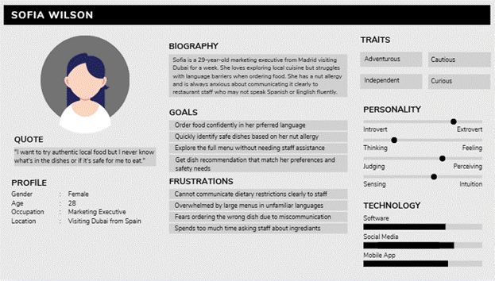

Persona 2 – The Busy Parent
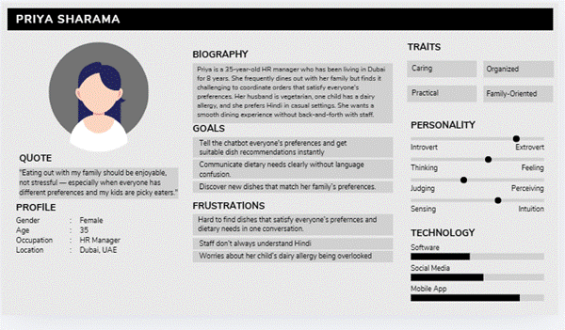

Persona 3 – The Operations Manager
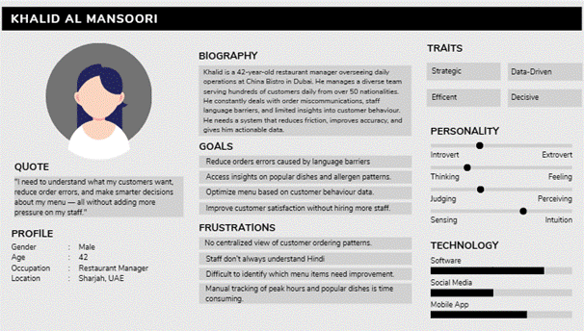

Updated SWOT Analysis
The following SWOT analysis reflects the current state of Gusto following Semester 2 development, incorporating lessons learned and changes made during implementation.

STRENGTHS | WEAKNESSES
- Multilingual support in 6 languages (Arabic, English, Hindi, Urdu, French, Spanish)  - Allergen-aware chatbot reduces food safety risks  - AR menu previews enhance customer decision making  - Analytics dashboard provides actionable business insights  - Group-aware chatbot recommends dishes based on combined group preferences and dietary needs  - No competitor combines all these features in one platform  - Fully browser-based — no app download required  - Modular architecture allows easy future updates | - Bilingual staff dashboard not implemented  - AR models must be manually created and uploaded  - Chatbot accuracy depends on quality of restaurant menu data  - Dependent on third-party APIs — if they go down, system breaks  - No payment gateway or POS integration  - Single restaurant branch support only currently  - Basic authentication
OPPORTUNITIES | THREATS
- UAE has 200+ nationalities — huge market for multilingual dining solutions  - Growing demand for AI-powered restaurant technology  - Group dining culture in UAE creates strong demand for AI that can handle multiple preferences in one conversation  - Potential to expand to other multicultural cities like Singapore, Qatar, Malaysia  - Growing awareness of food allergies increases demand for allergen tracking  - Payment gateway integration as a future revenue stream | - Competitors could quickly replicate similar AI features  - Dependence on third-party APIs — price increases or outages directly impact the system  - Restaurants may resist adopting new technology due to training requirements  - Data privacy regulations in UAE could restrict customer data handling  - AR feature limited to WebXR-compatible devices only

Updated diagrams
Fig 1: customer side
Use case diagram
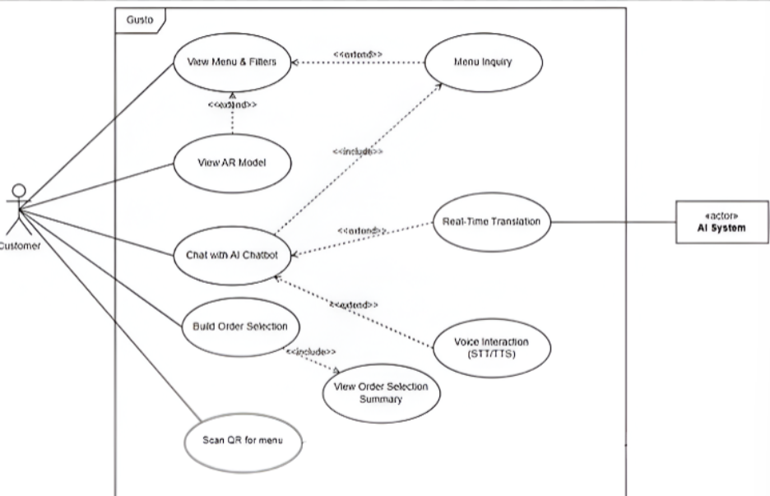

- Scan QR for Session Validation to Scan QR for Menu - The QR code now simply gives the customer access to the menu rather than creating a validated session
- Remove Authentication Service actor - Customer login is now optional, so a dedicated authentication service actor is no longer needed

Fig 2: Admin side
Use case diagram
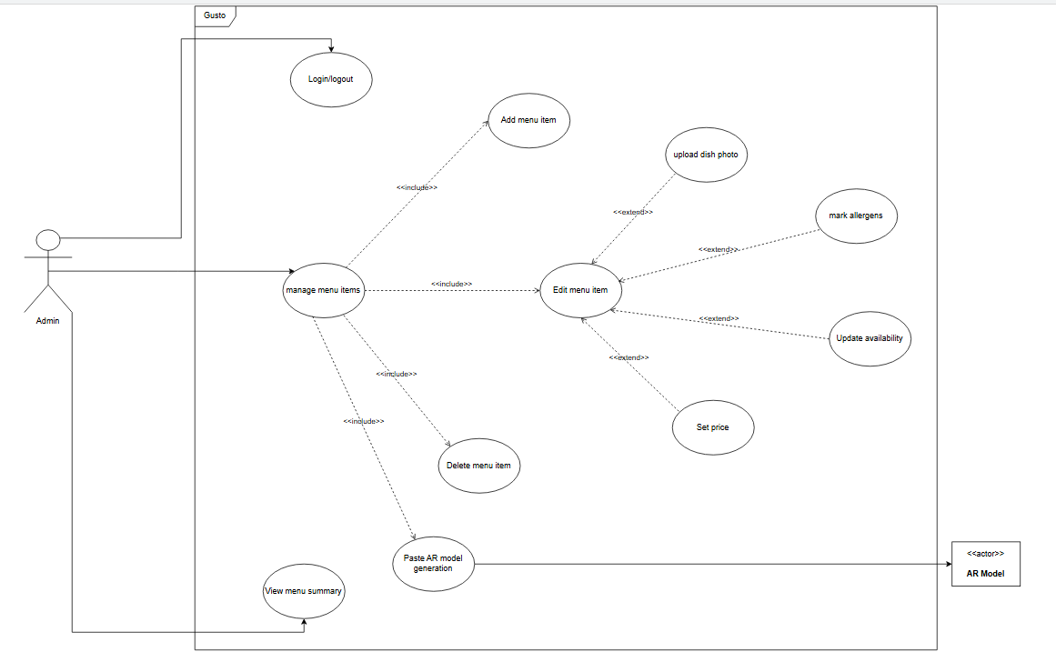

- Restaurant Staff to Admin -The actor was renamed to Admin to better reflect the single role managing the system
- Request AR Model Generation to Paste AR Model URL - AR models are no longer auto generated, the admin manually pastes a pre-uploaded URL

Fig 3: System architecture
Decomposition diagram
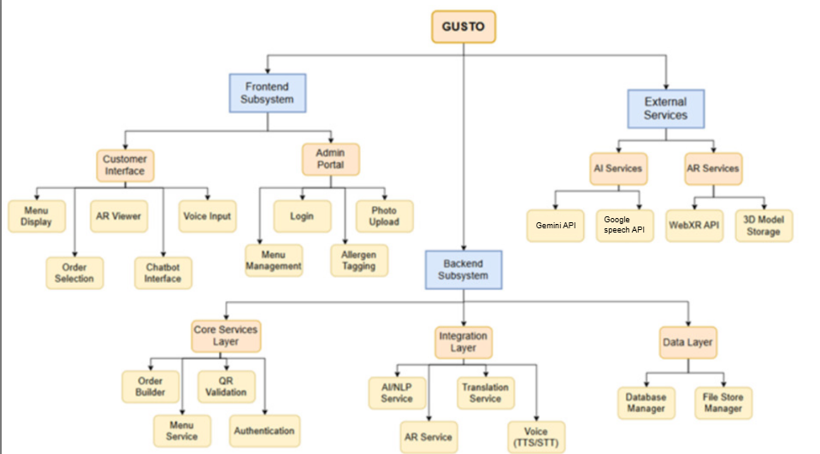
- LLM API to Gemini API - The project switched from OpenAI GPT-4 to Google's Gemini as the large language model for the chatbot
- STT/TTS API to Google Speech API - Speech to text and text to speech is now handled by Google Speech API instead of Whisper

Fig 4:AR visualization
Class diagram
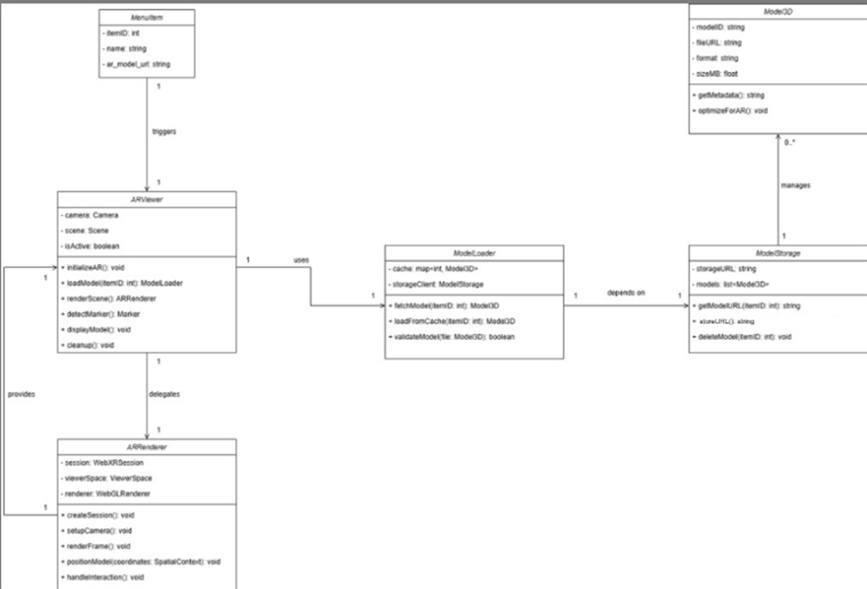

- uploadModel() to storeURL: string - Since AR models are not directly uploaded by the admin, this method was changed to store a pre-uploaded URL instead

Fig 5: customer interface
Component diagram
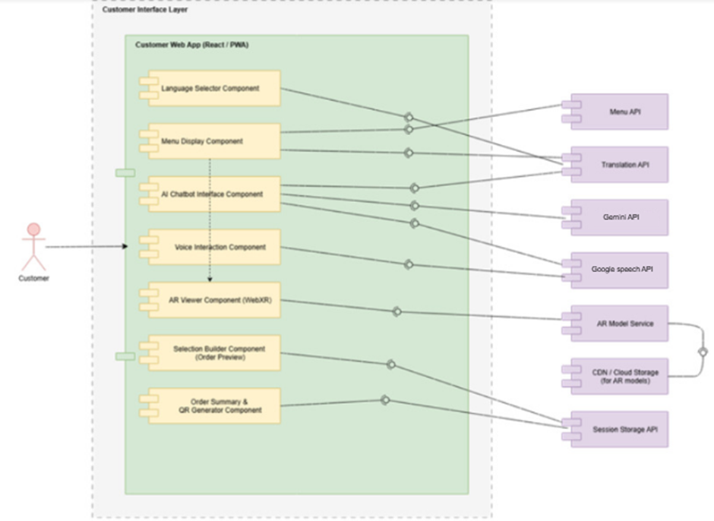

- RAG chatbot API to Gemini API - The project switched from OpenAI GPT-4 to Google's Gemini as the large language model for the chatbot
- Speech to text API to Google Speech API - Speech to text and text to speech is now handled by Google Speech API instead of Whisper

Gantt Chart
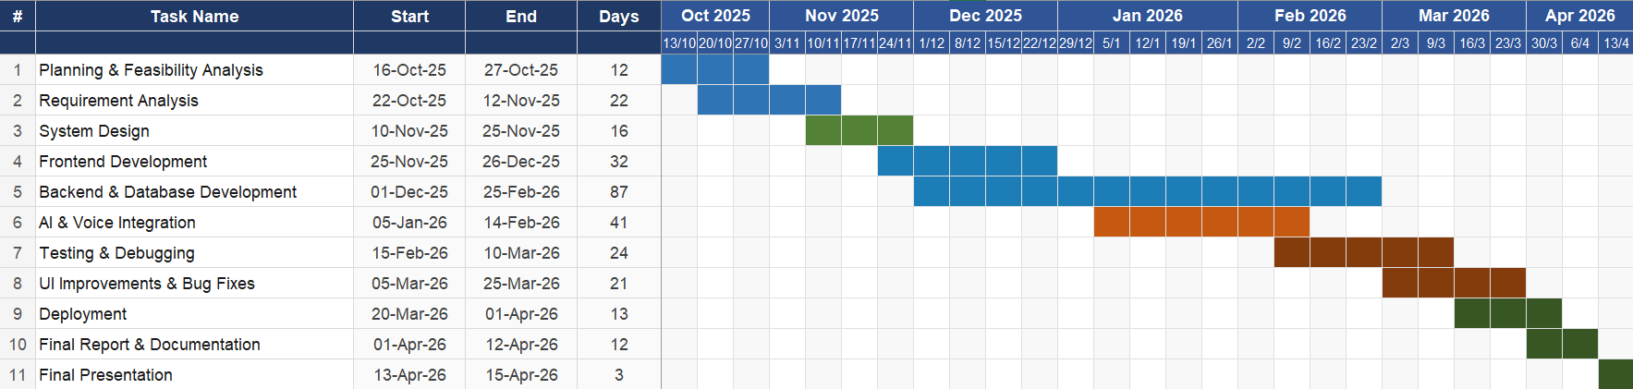

Test Results
The following section presents the test execution results for the customer-facing modules of the Gusto platform. Tests were conducted manually against a live development build of the system. Each test case was executed as specified in the Semester 1 Test Plan.

Login and Authentication
Test Case ID | Test Description | Input | Steps | Expected Result | Test Result
TC-CUST-AUTH-001 | Valid customer login with correct credentials | Email: customer3@example.com / Password: password3 | 1. Navigate to the customer login page  2. Enter valid registered email address  3. Enter correct password  4. Click Login button | Customer logged in successfully. Redirected to landing page. Icon with customer name shown on top right. | Pass
TC-CUST-AUTH-002 | Login attempt with incorrect password | Email: customer3@example.com / Password: (wrong password) | 1. Navigate to the customer login page  2. Enter valid registered email address  3. Enter an incorrect password  4. Click Login button | Login is rejected. Error message displayed. User remains on login page. | Pass
TC-CUST-AUTH-003 | Login attempt with unregistered email | Email: customer@example.com / Password: password | 1. Navigate to the customer login page  2. Enter an unregistered email  3. Enter any password  4. Click Login button | Login fails. Error message displayed. Access is denied. | Pass
TC-CUST-AUTH-004 | Login with empty email field | Email: (empty) / Password: password | 1. Navigate to the customer login page  2. Leave Email Address field blank  3. Enter a password  4. Click Login button | Validation error shown on email field. Form is not submitted. Login is blocked. | Pass
TC-CUST-AUTH-005 | Login with empty password field | Email: customer3@example.com / Password: (empty) | 1. Navigate to the customer login page  2. Enter a valid email  3. Leave Password field blank  4. Click Login button | Validation error shown on password field. Form does not submit. Login is blocked. | Pass
TC-CUST-AUTH-006 | Login with both fields empty | Email: (empty) / Password: (empty) | 1. Navigate to the customer login page  2. Leave both Email and Password blank  3. Click Login button | Validation errors shown on both fields. Form does not submit. | Pass
TC-CUST-AUTH-007 | Email field input format validation | Email: customer123 / Password: password | 1. Navigate to the customer login page  2. Enter invalid email format (e.g. customer123)  3. Enter any password  4. Click Login button | Validation error shown for invalid email format. Login is not attempted. | Pass
TC-CUST-AUTH-008 | Session persistence on page refresh | Active customer session | 1. Log in with valid customer credentials  2. Navigate to any page  3. Refresh the browser | Customer remains logged in. Page reloads correctly without requiring re-login. | Pass
TC-CUST-AUTH-009 | Valid sign-up with required fields only (phone left blank) | Name: John Smith / Email: john@example.com / Password: john1234 / Phone: (empty) | 1. Navigate to sign-up page  2. Enter valid name, email and password  3. Leave phone number field blank  4. Submit using sign up button | Account created successfully. Customer automatically logged in and redirected to landing page. | Pass
TC-CUST-AUTH-010 | Valid sign-up with all fields | Name: John Smith / Email: john@example.com / Password: john1234 / Phone: (filled) | 1. Navigate to sign-up page  2. Enter valid name, email, phone number and password  3. Submit using sign up button | Account created successfully. Customer automatically logged in and redirected to landing page. | Pass
TC-CUST-AUTH-011 | Sign-up with already registered email | Email: customer3@example.com | 1. Navigate to sign-up page  2. Enter an email address already registered  3. Fill in remaining fields with valid data  4. Submit the sign-up form | Sign up is rejected. Error message displayed. No duplicate account created. | Pass
TC-CUST-AUTH-012 | Sign-up with missing required fields | Name/Email/Password: (empty), remaining fields valid | 1. Navigate to sign-up page  2. Leave the name/email/password field blank  3. Fill remaining fields with valid data  4. Submit the sign-up form | Validation error shown for the missing field. Form does not submit. Account is not created. | Pass
TC-CUST-AUTH-013 | Customer logout functionality | Logged-in customer session | 1. Log in with valid customer credentials  2. Navigate to customer profile by clicking on the customer icon  3. Click the Logout button | Session terminated. Customer redirected to login page. Protected pages inaccessible without re-authentication. | Pass

Landing Page
Test Case ID | Test Description | Input | Steps | Expected Result | Test Result
TC-LAND-001 | Landing page loads successfully | URL: http://localhost:5173/ | 1. Open browser  2. Enter URL  3. Press Enter | Landing page loads without errors. 'Welcome To Gusto' and search bar visible. Restaurant section loads. | Pass
TC-LAND-002 | Page title/banner displayed correctly | N/A | 1. Load landing page | Header shows 'Welcome To Gusto' centered and clearly readable. | Pass
TC-LAND-003 | Search bar is visible and usable | N/A | 1. Load landing page  2. Click Search field | Search field is visible. Cursor appears in field. User can type. | Pass
TC-LAND-004 | Search restaurants by valid keyword (partial match) | Keyword: nan | 1. Load landing page  2. Type 'nan' in Search  3. Observe results | Restaurant list filters to matching names. Only relevant cards shown. | Pass
TC-LAND-005 | Search restaurants by full name | Keyword: PF Chang's | 1. Load landing page  2. Type restaurant full name | Matching restaurant card displayed correctly. | Pass
TC-LAND-006 | Search is case-insensitive | Keyword: NANDO | 1. Load landing page  2. Type NANDO in uppercase | Results match same as lowercase. Search is not case-sensitive. | Pass
TC-LAND-007 | Search with spaces trims correctly | Keyword: ' Desi' (with leading space) | 1. Load landing page  2. Type keyword with leading and trailing spaces | Results still show matching restaurant. Spaces ignored/handled properly. | Pass
TC-LAND-008 | Search with no match | Keyword: xyz123 | 1. Load landing page  2. Type xyz123 | No matching restaurants shown. Empty state displayed without breaking UI. | Pass
TC-LAND-009 | Clear search restores full list | Keyword: desi then cleared | 1. Type desi  2. Delete text / clear input | Full restaurant list returns immediately. | Pass
TC-LAND-010 | 'All Restaurants' section title appears | N/A | 1. Load landing page | 'All Restaurants' heading is visible above the cards. | Pass
TC-LAND-011 | Restaurant cards display required info | N/A | 1. Load landing page  2. Observe any card | Each card shows: Image, Restaurant Name, Category/Cuisine label, Rating badge, Favourite icon. | Pass
TC-LAND-012 | Restaurant image loads properly | N/A | 1. Load landing page  2. Observe cards | Card images load without broken icons. Proper fit inside card container. | Pass
TC-LAND-013 | Rating formatting | N/A | 1. Load landing page  2. Observe rating badge | Rating displays as number (e.g. 4, 3.5, 3.9). Consistent format across cards. | Pass
TC-LAND-017 | Open restaurant details/menu from card | N/A | 1. Click restaurant card/name/image | Navigates to menu page for selected restaurant. Correct restaurant data shown. | Pass
TC-LAND-018 | Navigation bar visible at bottom | N/A | 1. Load landing page | Bottom navigation bar visible with Home, Cart, and Chat icons. | Pass
TC-LAND-019 | Home icon returns to landing page | From Cart or Chat page | 1. Navigate to Cart or Chat  2. Click Home icon | User redirected back to landing page. | Pass
TC-LAND-020 | Cart icon opens cart page | N/A | 1. Load landing page  2. Click Cart icon | User navigates to cart page. Cart loads without error. | Pass
TC-LAND-021 | Chat icon opens chatbot page | N/A | 1. Load landing page  2. Click Chat icon | User navigates to chatbot screen. Chat UI loads correctly. | Pass
TC-LAND-022 | Language/globe icon opens language options | N/A | 1. Load landing page  2. Click globe icon (top-right) | Language selection opens without UI overlap or crash. | Pass
TC-LAND-023 | Landing page responsiveness (mobile view) | Screen width: 390px | 1. Open DevTools  2. Set to mobile device size (390px)  3. Reload | UI remains aligned. Cards and nav bar display correctly without overlapping text/icons. | Pass
TC-LAND-024 | Loading state behavior (slow network) | Network throttle: 3G | 1. Open DevTools  2. Go to Network tab  3. Select 3G throttling  4. Reload page | Page shows loading state or loads gracefully. No infinite blank screen. | Pass
TC-LAND-025 | Error handling when restaurant list API fails | Backend server stopped | 1. Stop backend server  2. Reload landing page | Error handled gracefully. Message shown and app does not crash. | Pass
TC-LAND-026 | Accessibility: keyboard navigation for search | Keyboard only | 1. Press Tab until search field is focused  2. Type text in the search field | Search input can be focused using keyboard. User can type and filter results. | Pass
TC-LAND-027 | Accessibility: icons have visible feedback | N/A | 1. Hover over icons  2. Click icons | Icons show hover/click feedback and are clearly clickable. | Pass
TC-LAND-028 | No console errors on load | N/A | 1. Open DevTools (F12)  2. Click Console tab  3. Reload page | No critical errors in console. | Pass

Menu Page
Test Case ID | Test Description | Input | Steps | Expected Result | Test Result
TC-MENU-001 | Menu page loads successfully | Selected restaurant from landing page | 1. Open landing page  2. Select a restaurant  3. Navigate to Menu page | Menu page loads without crash. 'Menu' title visible. Categories and items display properly. | Pass
TC-MENU-002 | Category tabs are visible | N/A | 1. Load menu page | Category tabs visible: All, Mains, Sides, Dessert, Drinks. | Pass
TC-MENU-003 | Default category is 'All' | N/A | 1. Load menu page | 'All' category selected by default. Items from multiple categories shown. | Pass
TC-MENU-004 | Filter items by 'Mains' category | Category: Mains | 1. Load menu page  2. Click 'Mains' | Only Mains items displayed. Selected tab highlights active state. | Pass
TC-MENU-005 | Filter items by 'Sides' category | Category: Sides | 1. Load menu page  2. Click 'Sides' | Only Sides items displayed (e.g. Onion Rings). | Pass
TC-MENU-006 | Filter items by 'Dessert' category | Category: Dessert | 1. Load menu page  2. Click 'Dessert' | Only Dessert items displayed (e.g. Apple Pie). | Pass
TC-MENU-007 | Filter items by 'Drinks' category | Category: Drinks | 1. Load menu page  2. Click 'Drinks' | Only Drinks items displayed (e.g. Chocolate Shake). | Pass
TC-MENU-008 | Switch categories multiple times | Mains → Sides → All | 1. Click Mains  2. Click Sides  3. Click All | List updates correctly each time without duplicate items, layout breaks, or freezing. | Pass
TC-MENU-009 | Each menu item card shows required info | N/A | 1. Load menu page  2. Observe any 3 cards | Each card shows: Item image, Item name, Short description, and AR Preview link. | Pass
TC-MENU-010 | Item images load properly | N/A | 1. Load menu page | No broken images. Images fit inside card container and maintain UI alignment. | Pass
TC-MENU-011 | Long text handling (name/description) | Item with long name/description | 1. Scroll menu list  2. Locate long text item | Text wraps or truncates neatly without overlapping UI elements. | Pass
TC-MENU-012 | Open AR Preview from a menu item | AR Preview clicked on any item | 1. Load menu page  2. Click AR Preview on any item | AR Preview screen opens successfully for selected item. | Pass
TC-MENU-013 | AR Preview opens correct item | Item: Apple Pie | 1. Click AR Preview for Apple Pie | AR view shows correct Apple Pie model/preview. | Pass
TC-MENU-014 | AR Preview handles missing model gracefully | Item without AR model | 1. Click AR Preview for item missing model | System shows 'AR not available for this item' or similar without crash. | Pass
TC-MENU-015 | Menu items remain visible on scroll | N/A | 1. Scroll down menu list | Items load/scroll smoothly. No flickering, overlap, or white gaps. | Pass
TC-MENU-016 | Category bar remains usable on scroll | N/A | 1. Scroll down  2. Try switching category | Category bar remains accessible. No UI glitch. | Pass
TC-MENU-017 | Navigation bar is visible | N/A | 1. Load menu page | Nav bar visible with icons (Home, Restaurants, About, Login). | Pass
TC-MENU-018 | Home icon navigates back to landing page | N/A | 1. On menu page  2. Click Home icon | User redirected to landing page ('Welcome To Gusto'). | Pass
TC-MENU-019 | Cart icon navigates to cart page | N/A | 1. On menu page  2. Click Cart icon | Cart page opens successfully without errors. | Pass
TC-MENU-020 | Chat icon navigates to chatbot page | N/A | 1. On menu page  2. Click Chat icon | Chatbot page opens successfully without errors. | Pass
TC-MENU-021 | Language icon is clickable | Globe icon top-right | 1. On menu page  2. Click globe icon | Language selection opens correctly. No UI overlap or crash. | Pass
TC-MENU-022 | Responsiveness (mobile view) | Screen width: 390px | 1. Open DevTools (F12)  2. Switch to mobile resolution (390px)  3. Reload | UI remains clean. Cards align, nav bar fixed, category bar fits screen. | Pass
TC-MENU-023 | Loading behavior on slow network | Network throttle: 3G | 1. Open DevTools  2. Select 3G throttling  3. Reload menu page | Page shows loading state or loads progressively without breaking layout. | Pass
TC-MENU-024 | Error handling when menu API fails | Backend server stopped | 1. Stop backend  2. Reload menu page | System shows friendly error and does not crash. | Pass
TC-MENU-025 | No console errors on menu page load | N/A | 1. Open DevTools (F12)  2. Click Console tab  3. Reload menu page | No critical errors in console. | Pass

Order Selection & Cart
Test Case ID | Test Description | Input | Steps | Expected Result | Test Result
TC-ORDCART-001 | Open item customization page from menu | Item: Chocolate Shake | 1. Go to Menu page  2. Click a menu item card | Customization page opens. Item name, image, price, and category displayed. | Pass
TC-ORDCART-002 | Item details displayed correctly on customization page | N/A | 1. Open customization page | Item name, description, price (e.g. $5.99), and category label visible and correct. | Pass
TC-ORDCART-003 | Allergen information is displayed | Item: Chocolate Shake | 1. Open customization page | Allergen info shown (e.g. 'Allergens: Dairy'). | Pass
TC-ORDCART-004 | Increase quantity on customization page | Quantity: + | 1. Open customization page  2. Click '+' once | Quantity increases by 1 (e.g. 1 → 2). | Pass
TC-ORDCART-005 | Decrease quantity on customization page (not below minimum) | Quantity set to 1, then click - | 1. Set quantity to 1  2. Click '-' | Quantity does not go below 1. Must not crash. | Pass
TC-ORDCART-006 | Add special instructions (valid) | Instructions: 'No ice' | 1. Open customization page  2. Type 'No ice' in Special Instructions  3. Click Add to Cart | Item added to cart with special instructions saved. | Pass
TC-ORDCART-007 | Add to Cart with empty special instructions | Special Instructions: (empty) | 1. Open customization page  2. Leave Special Instructions empty  3. Click Add to Cart | Item added to cart successfully. No error shown. | Pass
TC-ORDCART-008 | Add to Cart with multiple quantity | Quantity: 3 | 1. Set quantity to 3  2. Click Add to Cart | Cart reflects correct quantity (3). Total price updates accordingly. | Pass
TC-ORDCART-009 | Add multiple different items to cart | Chocolate Shake + Classic Burger | 1. Add Chocolate Shake to cart  2. Navigate to another item  3. Add Classic Burger | Cart contains both items as separate entries with correct quantities and prices. | Pass
TC-ORDCART-010 | Navigate to cart page from customization page | Cart icon clicked | 1. On customization page  2. Click bottom Cart icon | Cart page opens successfully and shows cart items. | Pass
TC-ORDCART-011 | Cart page displays item details correctly | N/A | 1. Open cart page | Each cart item shows: image, item name, unit price, quantity controls, item total, delete icon. | Pass
TC-ORDCART-012 | Increase quantity from cart page | Click + on an item | 1. Open cart page  2. Click '+' for an item | Quantity increases by 1 and item total updates correctly. | Pass
TC-ORDCART-013 | Decrease quantity from cart page | Click - on an item | 1. Open cart page  2. Click '-' for an item | Quantity decreases by 1 (not below minimum). Item total updates correctly. | Pass
TC-ORDCART-014 | Remove item from cart using delete icon | Trash icon clicked | 1. Open cart page  2. Click delete icon for one item | Item removed from cart. Subtotal, item count, and total update correctly. | Pass
TC-ORDCART-015 | Verify subtotal calculation | Shake ($5.99×2) + Burger ($11.99×1) | 1. Open cart page with listed quantities | Subtotal equals sum of each item total (e.g. 11.98 + 11.99 = 23.97). | Pass
TC-ORDCART-016 | Items count is correct | Chocolate Shake×3 (17.97 AED) + Classic Burger×1 (11.99 AED) | 1. Open cart page | Items count matches number of distinct items. Total = 29.96 AED / 2 items. | Pass
TC-ORDCART-017 | Total displayed matches subtotal (no taxes/fees) | N/A | 1. Open cart page | Total equals subtotal when no additional fees/taxes exist. | Pass
TC-ORDCART-018 | Cart empty state handling | All items removed | 1. Remove all items using delete | Cart shows empty state message and totals become 0.00. Checkout button handled safely. | Pass
TC-ORDCART-019 | 'Proceed to Checkout' button visibility and click | Cart with items | 1. Ensure cart has items  2. Click Proceed to Checkout | User navigated to checkout flow. No crash. | Pass
TC-ORDCART-020 | Checkout button behavior when cart is empty | Empty cart | 1. Empty cart  2. Click Proceed to Checkout | Button disabled or message shown. No navigation to checkout with empty cart. | Pass
TC-ORDCART-021 | Back navigation from cart page | Back arrow clicked | 1. On cart page  2. Click back arrow (top left) | User navigates to previous page. Cart state remains saved. | Pass
TC-ORDCART-022 | Cart persistence after refresh | Items in cart, then page refreshed | 1. Add items to cart  2. Refresh browser | Items remain in cart after refresh. App must not crash. | Pass
TC-ORDCART-023 | UI does not break for large quantity | Quantity: 20 | 1. Increase item quantity to 20 in cart | UI stays aligned. Totals update correctly. No overflow or overlap. | Pass
TC-ORDCART-024 | Special instructions length/edge case | 210-character instructions string | 1. Enter long instructions (210+ characters)  2. Add to cart | System accepts within limit or shows proper validation. No crash or layout break. | Pass
TC-ORDCART-025 | 'Added by chatbot' note (if feature enabled) | Item added via chatbot flow | 1. Add item using chatbot flow  2. Open cart | Cart item shows note 'Added by chatbot' for chatbot-added items. | Pass

Order Finalization
Test Case ID | Test Description | Input | Steps | Expected Result | Test Result
TC-ORD-FIN-001 | Successful order finalization | Active cart with items | 1. Add items to cart  2. Proceed to checkout  3. View the Order Summary page | 'Order Placed!' header shown with Order ID, item count, time and total price on Order Summary page. | Pass
TC-ORD-FIN-002 | Order Summary displays correct items | N/A | 1. Place order  2. View Order Summary | All items from cart listed correctly with quantities and prices. | Pass
TC-ORD-FIN-005 | Place order with single item | Single item in cart | 1. Add one item to cart  2. Proceed to checkout | Order placed successfully with 1 item. Summary shows correct details. | Pass
TC-ORD-FIN-006 | Place order with multiple items | Multiple items in cart | 1. Add multiple items  2. Proceed to checkout | All items appear in summary. Total is correct. | Pass
TC-ORD-FIN-007 | Order total matches cart total | N/A | 1. Compare cart total with Order Summary total | Total on Order Summary matches what was shown in the cart. | Pass
TC-ORD-FIN-008 | Back navigation after order placed | Back button after order placed | 1. Place order  2. Click back | User redirected to landing page or safe page. No crash. | Pass
TC-ORD-FIN-009 | Place new order after completing one | N/A | 1. Complete one order  2. Add items and place another | Cart resets. User can add items and place another order successfully. | Pass
TC-ORD-FIN-010 | Order finalization on slow network | Network throttle: 3G | 1. Throttle to 3G  2. Place order | Order processes successfully or shows loading state. No crash. | Pass
TC-ORD-FIN-011 | No console errors on order placement | N/A | 1. Open DevTools Console  2. Place order | No critical errors in console. | Pass

Admin Side

Login and authentication
Test Case ID | Test Description | Input | Steps | Expected Result | Test Result
TC-AUTH-001 | Valid admin login with correct credentials | Email: admin1@gusto.com / Password: pass1 | 1. Navigate to the admin login page  2. Enter valid email in Email Address field  3. Enter correct password  4. Click Login button | Admin is redirected to the Menu Management dashboard. Logged-in email shown in top-right. | Pass
TC-AUTH-002 | Attempt logging in with incorrect password | Email: admin1@gusto.com / Password: admin | 1. Navigate to the admin login page  2. Enter valid email  3. Enter an incorrect password  4. Click Login button | Login is rejected. Error message displayed. User remains on login page. | pass
TC-AUTH-003 | Attempt logging in with unregistered email | Email:  Admin@test.com/ Password: admin | 1. Navigate to the admin login page  2. Enter an unregistered email  3. Enter any password  4. Click Login button | Login fails. Error message displayed. Access to admin portal is denied. | pass
TC-AUTH-004 | Attempt logging in with empty email field | Email: (empty) / Password: admin | 1. Navigate to the admin login page  2. Leave Email Address field blank  3. Enter a password  4. Click Login button | Validation error shown on email field. Form is not submitted. Login is blocked. | pass
TC-AUTH-005 | Attempt logging in with empty password field | Email: admin1@gusto.com / Password: (empty) | 1. Navigate to the admin login page  2. Enter a valid email  3. Leave Password field blank  4. Click Login button | Validation error shown on password field. Form does not submit. Login is blocked. | pass
TC-AUTH-006 | Attempt logging in with both fields empty | Email: (empty) / Password: (empty) | 1. Navigate to the admin login page  2. Leave both Email and Password blank  3. Click Login button | Validation errors shown on both fields. Form does not submit. | pass
TC-AUTH-007 | Admin logout functionality | Logged-in admin session | 1. Log in as a valid admin  2. Verify dashboard is visible with logged-in email  3. Click the Logout button in top-right corner | Session is terminated. Admin is redirected to login page. Protected pages are inaccessible without re-authentication. | pass
TC-AUTH-008 | Session persistence on page refresh | Active admin session | 1. Log in as a valid admin  2. Navigate to the menu management page  3. Refresh the browser | Admin remains logged in. Dashboard displays without requiring re-login. | pass
TC-AUTH-009 | Prevent non-admin access to admin portal | Non-admin or customer credentials | 1. Attempt to navigate directly to the admin URL  2. Enter customer-level credentials on the login page  3. Click Login | Access is denied. Error message shown or user is redirected to login page. Admin dashboard is not accessible. | pass
TC-AUTH-010 | Email field input format validation | Email:  admin123 / Password: admin | 1. Navigate to the admin login page  2. Enter invalid email format (e.g. "notanemail")  3. Enter any password  4. Click Login button | Validation error shown for invalid email format. Login is not attempted. | pass

Admin menu management
Test Case ID | Test Description | Input | Steps | Expected Result | Test Result
TC-MENU-001 | Menu dashboard loads with correct item counts per category | Admin logged in with existing menu data | 1. Log in as admin  2. View the summary cards on the menu management page | Summary cards show correct counts for Mains, Sides, Dessert, and Drinks matching actual menu items. | pass
TC-MENU-002 | All menu items are displayed on the dashboard | Admin logged in with 6 existing menu items | 1. Log in as admin  2. View the menu item grid | All menu items displayed as cards with name, description, price, category badge, availability, and allergen info. | pass
TC-MENU-003 | Filter menu items by Mains category | Filter selection: Mains | 1. Log in as admin  2. Click the "Mains" filter button in the filter bar | Only Mains items displayed. Other categories hidden. Mains button is highlighted/active. | pass
TC-MENU-004 | Filter menu items by Sides category | Filter selection: Sides | 1. Log in as admin  2. Click the "Sides" filter button | Only Sides items displayed. Other categories hidden. Sides button is highlighted. | pass
TC-MENU-005 | Filter menu items by Dessert category | Filter selection: Dessert | 1. Log in as admin  2. Click the "Dessert" filter button | Only Dessert items shown. Correct count of displayed items. | pass
TC-MENU-006 | Filter menu items by Drinks category | Filter selection: Drinks | 1. Log in as admin  2. Click the "Drinks" filter button | Only Drinks items displayed. | pass
TC-MENU-007 | Filter resets to all items when "All" is selected | Currently filtered to Mains | 1. Apply a category filter (e.g. Mains)  2. Click the "All" filter button | All menu items across all categories displayed. "All" button is highlighted. | pass
TC-MENU-008 | Search for a menu item by name | Search query: "Burger" | 1. Log in as admin  2. Type "Burger" into the search bar | Only items whose name contains "Burger" are displayed (e.g. Classic Burger). Non-matching items are hidden. | pass
TC-MENU-009 | Search with no matching results | Search query: "xyz123" | 1. Log in as admin  2. Type "xyz123" into the search bar | No menu items shown. An empty state message is displayed (e.g. "No items found"). | pass
TC-MENU-010 | Clear search restores full menu list | Search input cleared after a search | 1. Type a search query 2. Clear the search input field | All menu items restored and displayed in the grid. | pass

Add menu item
Test Case ID | Test Description | Input | Steps | Expected Result | Test Result
TC-ADD-001 | Add a new menu item with all required fields | Name: Margherita Pizza / Price: 12.99 / Category: Mains | 1. Click "+ Add Item" button 2. Enter name: Margherita Pizza 3. Enter price: 12.99 4. Select category: Mains 5. Click Save | New item saved and appears in the menu grid under Mains. Mains summary count increments by 1. | pass
TC-ADD-002 | Add item with all optional fields populated | All fields filled including description, allergens, Image URL, AR Model URL | 1. Click "+ Add Item" 2. Fill all fields including description, allergens, image URL, and AR model URL 3. Ensure "Item is available" is checked 4. Click Save | Item created with all details visible on card: image, description, price, allergens, availability status. | pass
TC-ADD-003 | Prevent add with empty required Name field | Name: (empty) / Price: 9.99 / Category: Sides | 1. Click "+ Add Item" 2. Leave Name field blank 3. Enter price and category 4. Click Save | Validation error shown on Name field. Item not created. Modal remains open. | pass
TC-ADD-004 | Prevent add with empty required Price field | Name: Garlic Bread / Price: (empty) / Category: Sides | 1. Click "+ Add Item" 2. Enter item name 3. Leave Price field empty 4. Select a category 5. Click Save | Validation error shown on Price field. Item is not saved. | pass
TC-ADD-005 | Prevent add with a negative price value | Name: Test Item / Price: -5.00 / Category: Mains | 1. Click "+ Add Item" 2. Enter a name 3. Enter -5.00 in the Price field 4. Click Save | Validation error shown. Negative prices not accepted. Item is not saved. | pass
TC-ADD-006 | Add item with invalid Image URL format | Image URL: "not-a-url" | 1. Click "+ Add Item" 2. Fill required fields 3. Enter "not-a-url" in Image URL field 4. Click Save | Validation error for invalid URL format OR image fails to load and a placeholder is shown on the card. | pass
TC-ADD-007 | Add item with valid AR Model URL | AR Model URL: https://example.com/model.glb | 1. Click "+ Add Item" 2. Fill required fields 3. Enter a valid AR model URL 4. Click Save | Item saved with AR model URL stored. Item reflects AR model availability for the customer-facing view. | pass
TC-ADD-008 | Add item with "Item is available" unchecked | Item is available: unchecked | 1. Click "+ Add Item" 2. Fill required fields 3. Uncheck "Item is available" checkbox 4. Click Save | Item created and visible in grid but marked as unavailable (no green "Available" tick shown). | pass
TC-ADD-009 | Cancel adding a new item | Partially filled modal form | 1. Click "+ Add Item" 2. Enter some data in the form fields 3. Click "Cancel" or close (X) icon | Modal closes. No item is saved. Menu grid is unchanged. | pass
TC-ADD-010 | Category summary card updates after adding item | Adding new item to Drinks category | 1. Note current Drinks count in summary card 2. Click "+ Add Item" 3. Create a new Drinks item and save | Drinks summary card count increments by 1 after saving. | pass

Edit menu item
Test Case ID | Test Description | Input | Steps | Expected Result | Test Result
TC-EDIT-001 | Open edit modal pre-populated for existing item | Existing menu item: Chocolate Shake | 1. Log in as admin 2. Locate "Chocolate Shake" in menu grid 3. Click the edit (pencil) icon on the card | Edit modal opens pre-filled with all existing values: name, description, price, category, allergens, image URL, AR Model URL. | pass
TC-EDIT-002 | Edit item name and save successfully | Update name to "Double Chocolate Shake" | 1. Open edit modal for "Chocolate Shake" 2. Clear name field and enter "Double Chocolate Shake" 3. Click "Update" | Item saved with updated name. Menu grid reflects "Double Chocolate Shake". | pass
TC-EDIT-003 | Edit item price and save successfully | Update price from 5.99 to 6.49 | 1. Open edit modal for any menu item 2. Clear price and enter 6.49 3. Click "Update" | Item price updated. Card displays $6.49. | pass
TC-EDIT-004 | Edit item category and verify counts update | Change category from "Drinks" to "Dessert" | 1. Open edit modal for "Chocolate Shake" 2. Change Category dropdown from Drinks to Dessert 3. Click "Update" | Item now appears under Dessert. Drinks count decreases by 1; Dessert count increases by 1. | pass
TC-EDIT-005 | Edit allergen information on a menu item | Update allergens from "Dairy" to "Dairy, Nuts" | 1. Open edit modal for item 2. Update Allergens field to "Dairy, Nuts" 3. Click "Update" | Item card displays updated allergen info: "Allergens: Dairy, Nuts". | pass
TC-EDIT-006 | Remove image URL and save | Clear the Image URL field | 1. Open edit modal for item with image 2. Clear Image URL field 3. Click "Update" | Item saved without image. A default placeholder is shown on the card. | pass
TC-EDIT-007 | Prevent save with empty required Name field | Name field cleared in edit modal | 1. Open edit modal for any item 2. Clear the Name field completely 3. Click "Update" | Validation error shown. Update blocked. Modal remains open. Original data preserved. | pass
TC-EDIT-008 | Toggle availability from Available to Unavailable | Item currently marked as available | 1. Open edit modal for an "Available" item 2. Uncheck "Item is available" checkbox 3. Click "Update" | Item updated. Card no longer shows the green "Available" tick. | pass
TC-EDIT-009 | Toggle availability from Unavailable to Available | Item currently marked as unavailable | 1. Open edit modal for an unavailable item 2. Check the "Item is available" checkbox 3. Click "Update" | Item updated. Card now shows green tick and "Available" status. | pass
TC-EDIT-010 | Cancel editing without saving changes | Changes made in edit modal but not saved | 1. Open edit modal for any item 2. Modify one or more fields 3. Click "Cancel" button | Modal closes. All original item data preserved. No changes saved to menu. | pass
TC-EDIT-011 | Add AR Model URL to an existing item | AR Model URL: https://models.example.com/burger.glb | 1. Open edit modal for "Classic Burger" 2. Enter valid AR model URL in AR Model URL field 3. Click "Update" | AR model URL saved. Item reflects AR availability for the customer-facing menu view. | pass

Delete menu item
Test Case ID | Test Description | Input | Steps | Expected Result | Test Result
TC-DEL-001 | Delete a menu item with confirmation | Existing menu item: French Fries | 1. Log in as admin 2. Locate "French Fries" in menu grid 3. Click the delete (trash) icon 4. Click "OK" in the confirmation dialog | "French Fries" is permanently removed from menu grid. Sides category count decrements by 1. | pass
TC-DEL-002 | Cancel delete when confirmation dialog appears | Delete triggered on "Onion Rings" | 1. Click the delete icon on "Onion Rings" card 2. When confirmation dialog appears, click "Cancel" | Dialog closes. "Onion Rings" remains in menu grid. No data is deleted. | pass
TC-DEL-003 | Confirmation dialog displays correct message | Delete triggered on any item | 1. Click the delete icon on any menu item 2. Observe the confirmation dialog message | Dialog displays: "Are you sure you want to delete this item?" with OK and Cancel buttons. | pass
TC-DEL-004 | Category summary count updates after deletion | Delete a Mains item | 1. Note current count in Mains summary card 2. Click delete on a Mains item and confirm OK | Mains category count decrements by 1 immediately after deletion. | pass
TC-DEL-005 | Delete the last item in a category | Only one Dessert item exists | 1. Ensure only one Dessert item exists 2. Click delete on that item 3. Confirm with "OK" | Item deleted. Dessert summary card shows 0. No items appear when Dessert filter is applied. | pass
TC-DEL-006 | Deleted item does not reappear on page refresh | Item recently deleted from menu | 1. Delete a menu item and confirm 2. Refresh the browser page | Deleted item does not reappear. Deletion is persisted correctly in the database. | pass

Analytics

Test Case ID | Test Description | Input | Steps | Expected Result | Test Result
TC-ANA-001 | Analytics Dashboard loads successfully from menu page | Admin navigates to Analytics | 1. Log in as admin 2. Click the "Analytics" button in the top navigation | Analytics Dashboard loads. KPI cards visible: Total Conversations, Total Orders, Conversion Rate, Avg Order Value. | pass
TC-ANA-002 | Total Conversations KPI displays correct value | Known conversation count in database | 1. Open Analytics Dashboard 2. Observe "Total Conversations" KPI card | Total Conversations shows the correct count of all AI chatbot conversations for the selected period. | pass
TC-ANA-003 | Total Orders KPI displays correct value | Known order data (e.g. 16 orders) | 1. Open Analytics Dashboard 2. Observe "Total Orders" KPI card | Total Orders displays the accurate number of completed orders (e.g. 16). | pass
TC-ANA-004 | Conversion Rate is calculated correctly | Conversations: 0, Orders: 16 | 1. Open Analytics Dashboard 2. Observe the "Conversion Rate" KPI card | Conversion Rate calculated as (Orders / Conversations) x 100%. Displays 0% when conversations = 0. | pass
TC-ANA-005 | Average Order Value KPI displays correctly with comparison | Known order totals (avg $14.44) | 1. Open Analytics Dashboard 2. Observe "Avg Order Value" KPI card | Avg Order Value shows correct mean value and percentage comparison vs baseline (e.g. -65.6% vs baseline). | pass
TC-ANA-006 | Switch time period to Last 7 Days | Time filter: Last 7 Days | 1. Open Analytics Dashboard 2. Click the "Last 7 Days" button in top-right | All KPI cards and Conversation & Order Timeline update to reflect data from the last 7 days only. | pass
TC-ANA-007 | Switch time period to Last 30 Days (default) | Time filter: Last 30 Days | 1. Open Analytics Dashboard 2. Click the "Last 30 Days" button | All KPI cards and timeline display data from the last 30 days. "Last 30 Days" button is highlighted. | pass
TC-ANA-008 | Conversation & Order Timeline renders correctly | Order history across multiple dates | 1. Open Analytics Dashboard 2. Scroll to Conversation & Order Timeline 3. Observe bars for each date | Timeline renders a bar per date showing conversation and order counts. Dates and values match database records. | pass
TC-ANA-009 | Language Distribution chart shows accurate breakdown | Customer sessions in English and other languages | 1. Open Analytics Dashboard 2. Observe Language Distribution panel on the right | Language Distribution shows a bar per language with accurate percentage (e.g. English 100.0%). All languages sum to 100%. | pass
TC-ANA-010 | Top Customer Questions populates when data exists | Customer conversation history with recorded questions | 1. Ensure AI chatbot conversation data exists 2. Open Analytics Dashboard 3. Scroll to "Top Customer Questions" | Most frequently asked customer questions listed and ranked by frequency. | pass
TC-ANA-011 | Top Customer Questions shows empty state with no data | No conversation data exists | 1. Open Analytics Dashboard with no conversation history 2. Observe "Top Customer Questions" section | Panel displays empty state message: "No questions yet". | pass
TC-ANA-012 | Navigate back from Analytics to Menu Management | Admin currently on Analytics Dashboard | 1. Open Analytics Dashboard 2. Click the back arrow ( < ) next to "Analytics Dashboard" heading | Admin returned to Menu Management dashboard. Menu items and category counts are visible. | pass
TC-ANA-013 | Analytics data updates to reflect new orders | New order placed on customer side | 1. Note current Total Orders count on Analytics 2. Place a new order from the customer-facing interface 3. Refresh or re-open the Analytics Dashboard | Total Orders count increases by 1 to reflect the newly placed order. | pass

Augmented reality (AR) view

Functional test cases

Test Case ID | Test Scenario | Precondition | Test Steps | Expected Result | Test results
AR-TC-01 | Launch AR Viewer from menu item | User is on menu page and item has AR model | 1. Select a menu item. 2. Click “View in AR” button. | AR viewer opens and requests camera permission. | pass
AR-TC-02 | Camera permission granted | User clicks “View in AR” | 1. Allow camera access when prompted. | Camera feed is displayed and AR session starts successfully. | pass
AR-TC-03 | Camera permission denied | User denies camera access | 1. Click “Deny” on camera prompt. | System displays error message indicating camera access is required. | pass
AR-TC-04 | Load 3D model | AR session is active | 1. Launch AR view. 2. Wait for model to load. | Correct 3D model loads and appears on detected surface. | pass
AR-TC-05 | Invalid model URL | Menu item has broken AR model URL | 1. Launch AR view. | Error message displayed and fallback UI shown. | pass
AR-TC-06 | Rotate model | 3D model is loaded | 1. Use touch gesture to rotate model. | Model rotates smoothly according to user gesture. | Fail
AR-TC-07 | Zoom model | 3D model is loaded | 1. Use pinch gesture to zoom. | Model scales in/out correctly. | Fail
AR-TC-08 | Unsupported device | Device does not support WebXR | 1. Click “View in AR”. | System shows fallback message: “AR not supported on this device”. | pass
AR-TC-09 | Exit AR mode | AR viewer active | 1. Click Exit AR button. | AR session ends and user returns to menu page. | pass
AR-TC-10 | Loading state | Slow network | 1. Open AR view. | Loading spinner shown until model loads. | pass
AR-TC-11 | Model without surface | Flat surface not detected | 1. Launch AR view in low-texture area. | System prompts user to move device to find surface. | pass
AR-TC-12 | Multiple launches | User opens AR repeatedly | 1. Open and close AR view multiple times. | No crashes, memory leaks, or abnormal behaviour. | pass
AR-TC-13 | Orientation change | AR active on mobile | 1. Rotate device (portrait → landscape). | AR view adapts without breaking session. | pass
AR-TC-14 | Network disconnect | AR model loading | 1. Disable internet during load. | Error message shown and retry option available. | pass

Nonfunctional test cases
Test Case ID | Scenario | Expected Result | Test results
AR-NF-01 | AR model load time | Model loads within acceptable time (e.g., < 5 seconds on good network). | pass
AR-NF-02 | Usability | Users can easily understand gestures without instructions. | pass
AR-NF-03 | Accessibility | AR button is clearly labelled and reachable. | pass
AR-NF-04 | Stability | No application crash during AR usage. | pass
AR-NF-05 | Cross-device compatibility | AR works on supported Android and iOS devices. | Fail (works only on Android)

Customer profile

Test Case ID | Test Description | Input | Steps | Expected Result | Test Result
TC-CUST-PROF-001 | Profile page displays customer information | Logged in customer | 1. Log in as customer.  2. Navigate to the My Profile page by clicking on the customer icon/name. | Customer name, email and phone number are displayed correctly. | pass
TC-CUST-PROF-002 | Allergen and dietary preferences displayed on profile | Customer with saved allergens and dietary preferences | 1. Navigate to the My Profile page by clicking on the customer icon/name.  2. View the Allergen Preferences section.  3. View the Dietary Preferences Section | Saved allergens and dietary preferences are displayed as tags. | pass
TC-CUST-PROF-003 | All allergen options shown in edit mode | Customer clicks on Edit in allergen preferences | 1. Navigate to the My Profile page by clicking on the customer icon/name.  2. Click on Edit in the Allergen Preferences section. | All 11 allergen options are shown:  Nuts, Peanuts, Dairy, Gluten, Shellfish, Soy, Eggs, Fish, Wheat, Sesame, Mustard. | pass
TC-CUST-PROF-004 | Customer can add an allergen and save | Customer clicks on Edit in allergen preferences | 1. Click on Edit in the Allergen Preferences section.  2. Select Eggs.  3. Click on Save. | Eggs is added and displayed as a tag in the Allergen Preferences section. | pass
TC-CUST-PROF-005 | Customer can remove an allergen and save | Customer clicks on Edit in allergen preferences | 1. Click on Edit in the Allergen Preferences section.  2. Deselect Dairy.  3. Click on Save. | Dairy tag is no longer displayed in the Allergen Preferences Section. | pass
TC-CUST-PROF-006 | Customer can update allergen preferences and save | Customer clicks on Edit in allergen preferences | 1. Click on Edit in the Allergen Preferences section.  2. Select Peanuts, Dairy  3. Deselect Eggs.  3. Click on Save. | Eggs tag is no longer displayed. Peanuts and Dairy tags are displayed in the Allergen Preferences section. | pass
TC-CUST-PROF-007 | Cancelling allergen edit restores original selection | Changes made in allergen edit mode | 1. Click on Edit in the Allergen Preferences section.  2. Toggle several allergens.  3. Click on Cancel. | Edit mode closes and the original allergen selection remains unchanged. | pass
TC-CUST-PROF-008 | All dietary options shown in edit mode | Customer clicks on Edit in dietary  preferences | 1. Navigate to the My Profile page by clicking on the customer icon/name.  2. Click on Edit in the Dietary Preferences section. | All 10 allergen options are shown:  Vegetarian, Vegan, Gluten-Free, Dairy-Free, Nut-Free, Halal, Kosher, Pescatarian, Paleo, Keto. | pass
TC-CUST-PROF-009 | Customer can add a dietary preference and save | Customer clicks on Edit in dietary preferences | 1. Click on Edit in the Dietary Preferences section.  2. Select Vegan.  3. Click on Save. | Vegan is added and displayed as a tag in the Dietary Preferences section. | pass
TC-CUST-PROF-010 | Customer can remove a dietary preference and save | Customer clicks on Edit in dietary  preferences | 1. Click on Edit in the Dietary Preferences section.  2. Deselect Vegan.  3. Click on Save. | Vegan tag is no longer displayed in the Dietary  Preferences Section. | pass
TC-CUST-PROF-011 | Customer can update dietary preferences and save | Customer clicks on Edit in dietary preferences | 1. Click on Edit in the Dietary Preferences section.  2. Select Vegan, Keto  3. Deselect Vegetarian.  3. Click on Save. | Vegetarian tag is no longer displayed. Vegan and Keto tags are displayed in the Dietary Preferences section. | pass
TC-CUST-PROF-012 | Cancelling dietary preferences edit restores original selection | Changes made in dietary preferences edit mode | 1. Click on Edit in the Dietary Preferences section.  2. Toggle several dietary preferences.  3. Click on Cancel. | Edit mode closes and the original dietary preferences selection remain unchanged. | pass
TC-CUST-PROF-013 | Order history displays past orders | Customer with past orders. | 1. Navigate to the My Profile page by clicking on the customer icon/name.  2. View the Order History section. | Past orders are listed showing order number, date, order items, total price and finalized status. | pass
TC-CUST-PROF-014 | Empty allergen/  dietary preference state shows message | No allergens/  dietary preferences selected. | 1. Click on Edit in Allergen/Dietary Preferences section.  2. Deselect all allergens or dietary preferences.  3. Click save. | “No allergens selected/No dietary preferences selected” message is displayed. | pass
TC-CUST-PROF-015 | Empty order history shows message | Customer with no past orders | 1. Navigate to the My Profile page by clicking on the customer icon/name.  2. View the Order History section. | “No orders yet” message is displayed. | pass

Test Cases – Non-Functional Testing

Accessibility

Type | Test description | Expected result | Test Results
Perceivable | - Check that all images of dishes, AR icons and all menu items have alternative text.  - Make sure allergen warnings can be clearly identified visually | A screen reader will be able to narrate all elements of a page. Contrast ratios must be at least 4:5:1 for regular size text and at least 3:1 for large size text. The allergen warning must be legible | Pass
Operable | - Using only the keyboard, check the accessibility of each page. Make sure that all interactive elements can be reached using only the Tab key.  - This includes alternatives like the QR code scanner, AR viewer, voice button, language selector, and cart. Check for the presence of audio files that play automatically, and flashing elements. | All interactive elements can be operated on from the keyboard only. No AR visualizations or transitional page content will cause seizures. | Pass
Understandable | - Examine each form element on the login, chatbot, and order pages for a proper label. Ensure that each error message contains clear, easily understood content.  - Verify that the translations provided for each of the supported languages maintain a consistent overall meaning. | All labels will communicate their intended purpose. Users can easily identify what they need to do by the error messages when correcting their input and translate correctly both in terms of accuracy and meaning. | Pass
Robust | - Perform browser testing using Chrome, Firefox, Safari, and Edge as well as desktop, tablet, and smartphone while testing with NVDA and JAWS screen readers. | Browser type, Operating Systems & Devices support the same set of features and screens and can be navigated by screen readers through the menus of the website until an order is completed. | Pass

Security

Test case ID | Test description | Input | Steps | Expected Results | Test results
TC-SEC-001 | Password hashing is implemented correctly | Customer/Admin credentials | Register new user  Check database for password storage  Verify password is hashed with bcrypt | Passwords stored as hashed values using bcrypt, not plaintext. | Pass
TC-SEC-002 | JWT token authentication works correctly | Valid login credentials | Login as customer  Receive JWT token  Use token to access protected endpoint  Test with expired token | Valid token grants access. The expired token is rejected with 401 error. | Pass
TC-SEC-003 | Admin routes are protected from customer access | Customer account credentials | Login as customer  Attempt to access /api/admin endpoints  Verify access is denied | Customer accounts cannot access admin-only routes. Returns 403 Forbidden. | Pass
TC-SEC-004 | Database connections use SSL/TLS encryption | Access database | Check Neon DB connection settings  Verify SSL/TLS is enforced  Attempt unencrypted connection | All database connections use SSL/TLS. Unencrypted connections are rejected. | Pass
TC-SEC-005 | Environment variables protect sensitive data | Access codebase | Check if .env file is in .gitignore  Verify SECRET_KEY and DATABASE_URL not in code  Check browser console for exposed keys | Credentials stored in. env only. Not visible in browser or version control. | Pass
TC-SEC-006 | inactive users cannot access system | Disabled user account | Set user is_active flag to False in database  Attempt login with that account | Login is denied. System checks is_active flag before granting access. | Pass
TC-SEC-007 | Session management is secure | Customer login and cart | Add items to cart as anonymous user  Login as customer  Verify cart transfers securely  Logout and verify session ends | Cart transfers correctly. Session data isolated. Token invalidated on logout. | Pass

Backup and Recovery

Test Case ID | Test Description | Input | Steps | Expected Result | Test Result
TC-BACKUP-001 | Daily Database backup | Automatic backup trigger | - Wait for the scheduled backup timing. Eg: Midnight  - Check the backup file created  - Verify the file size | Backup file created has the correct file size. Eg: <500MB for 1000 orders | pass
TC-BACKUP-002 | Session recovery after expiry | Expired session (30+ min) | - Let the active session expire  - Scan the order items QR code again  - Check the cart | New session is created, and the old cart and its items are NOT recovered | pass
TC-BACKUP-003 | Recovery of order data | DB failure simulation during order | - Place an order  - Simulate a failure (connection drop), before the QR is generated  - Restore from backup | Order is saved to selections, and it is recoverable | pass
TC-BACKUP-004 | Menu item restoration | Accidentally deleted menu item | - Admin deletes a menu item  - Restore the database from backup  - Check the menu again | Menu item is restored with all the necessary data (price, image, allergens) | pass
TC-BACKUP-005 | Preservation of analytics data | Chat history corruption | - Corrupt the chat_history table  - Restore from backup  - Check the analytics dashboard | There is no data loss, and the conversation counts are accurate | pass
TC-BACKUP-006 | Neon Point-in-Time Recovery Verification | Access to neon console | - Login to Neon console  - Navigate to the Restore tab  - Check the PITR options that are available | PITR displays the restore points for the last 7 days | pass

Performance and optimization
Test Case ID | Test Description | Input | Steps | Expected Result | Test Result
TC-PEROPT-001 | Customer login is reliable and fast | Customer email and password | - Open customer login page  - Sign up with new email  - Enter wrong email and password  - Enter correct email and password | Wrong credentials should prevent access. Customer can login reliably with low latency. | pass
TC-PEROPT-002 | Admin login is reliable and fast | Admin email and password | - Open admin login page  - Enter wrong email and password  - Enter correct email and password | Wrong credentials should prevent access. Admin can login reliably with latency. | pass
TC-PEROPT-003 | Website can handle multiple concurrent users (minimum 5 for MVP Load Testing) | Access website from multiple devices | - 5 users open the website from their respective devices.  - Each user tries a different route – search on landing page, view menu items, order from cart, finalize cart, switch language  - Measure latency | All users face consistent load and response times within the target time. | pass
TC-PEROPT-004 | Gusto Home Page items load with reasonable latency | Access Gusto Home page | - Run backend and frontend server  - Open website landing page  - Check if all items have been loaded with images | All items load with <5 sec latency and renders images with  < 7 sec latency. | pass
TC-PEROPT-005 | Menu Page items load with <5 sec latency and renders images with < 7 sec latency. | Access Menu Page | - Run backend and frontend server  - Open website landing page  - Click on a restaurant  - Check if all menu items have been loaded  - Filter by different categories | All items load with <5 sec latency and renders images with  < 7 sec latency. Items are filtered accurately. | pass
TC-PEROPT-006 | Menu Cart Page – editing cart quantity | Add menu items to cart | - Click on restaurant to get menu page  - Click on menu item  - Select ‘Place Order’  - Change quantity, add notes  - Select ‘Add to cart’ | Items added to cart reflect correctly in selections database with notes and quantity. | pass
TC-PEROPT-007 | Orders are correctly finalized from cart page | Finalize items from cart | - Click on Cart page  - Edit quantity of items from the cart page  - Click ‘Proceed to Checkout’  - View finalized cart page and scan QR Code  - Check if order is correct | Items added to cart reflect correctly in database and show status to ‘Finalized’. Scan QR code – order is correct. | pass
TC-PEROPT-008 | Chatbot text response is accurate and within tolerable latency for non-English language | Query chatbot, for e.g., ‘What’s on the menu?’ | - Click on a restaurant and go to Chatbot  - Enter a query in any language other than English  - Ask follow-up questions to check accuracy of chatbot. | Chatbot text response should be accurate, understand context, and respond from actual menu knowledge. | pass
TC-PEROPT-009 | Chatbot voice response is accurate and within tolerable latency for non-English language | Ask chatbot for e.g., ‘What’s on the menu?’ | - Click on a restaurant and go to Chatbot  - Click on microphone  - Ask in any language other than English  - Ask follow-up questions to check accuracy of chatbot. | Chatbot replies in the same language with voice and later followed by text with context. | pass
TC-PEROPT-010 | Admin edits menu items (add/delete/edit) and it reflects in the database | Add a new menu item for your restaurant as the admin | - Login as admin  - Add a new menu item with image, AR model and allergens  - Click Save  - It should update in database and customer side menu | Admin can edit or add menu items with low latency and reflect reliably in database. | pass
TC-PEROPT-011 | Analytics load accurately and within tolerable latency | View analytics dashboard as the admin | - Login as admin  - Click on analytics dashboard  - View analytics | Admin can view analytics | pass

Usability and UI/UX testing
Test Case ID | Test Description | Input | Steps | Expected Result | Test Result
TC-UIUX-001 | User email and password is mandatory in login | User email and password | - Navigate to login page  - Try submitting without a mandatory field  - Submit with all mandatory fields filled | Users can understand which fields are mandatory | pass
TC-UIUX-002 | User can view restaurants in the home page | Navigate to Home page | - Open Gusto landing home page  - View restaurants | Restaurant interface is easy to navigate | pass
TC-UIUX-003 | User can navigate to the restaurant’s menu | Navigate to the Restaurant’s menu | - Open Landing page  - Click on a restaurant and open menu | Menu interface is easy to navigate | pass
TC-UIUX-004 | User can access cart per restaurant | Navigate to Cart Page | - Open landing page  - Click on a restaurant and open menu  - Click on cart page | Cart page can only be accessed once within a restaurant | pass
TC-UIUX-005 | User can access chatbot per restaurant | Navigate to Chatbot page | - Open landing page  - Click on a restaurant and open menu  - Click on chatbot page | Chatbot page can only be accessed once within a restaurant | pass
TC-UIUX-006 | User can switch between languages from multiple pages | Switch to a new language from default for e.g. ‘Arabic’ | - Open landing page  - Switch language to Arabic  - Click on a restaurant  - Switch language to English | Switching languages are intuitive from the icon | pass
TC-UIUX-007 | User can filter menu by categories | Filter menu for a restaurant by category | - Open landing page  - Click on a restaurant and open menu  - Filter by categories like ‘Mains’, ‘Dessert’, ‘Drinks’ | User should be able to switch between categories easily | pass
TC-UIUX-008 | Chatbot voice interaction is easy to start and stop | Interact with voice to chatbot | - Open landing page  - Navigate to restaurant menu  - Open chatbot  - Click on mic to start and stop speaking | Users find it intuitive and easy to interact with chatbot by voice | pass
TC-UIUX-009 | The user ordering flow is understandable | Add order to cart and finalize | - Open landing page  - Navigate to restaurant menu  - Click on menu items and place order  - Go to cart and proceed to checkout | Adding, deleting, editing menu items to cart should be intuitive and give proper feedback to user | pass
TC-UIUX-010 | Admin can only edit menu of their restaurant | Admin adds menu item | - Login as admin  - Navigate to dashboard  - Edit menu item quantity and image  - Save changes | Editing menu items should be intuitive and give proper feedback to admin | pass
TC-UIUX-011 | Admin can access analytics | Admin views analytics | - Login as Admin  - Navigate to analytics page  - View and interact with analytics | Analytics should be interactive and responsive | pass

Implementation Summary
The Gusto system functioned as a complete web platform which developers built as a modular system to enhance restaurant ordering through its multilingual capabilities and AI support and accessibility features and AR visualization technology and restaurant operational data. The system architecture used a three-tier design that included a React frontend and a FastAPI backend and external AI/translation services which enabled developers to separate system functions and develop new features.

Customer Interface
The customer-facing side was built as a responsive web interface accessible through a browser without requiring app installation. Customers can use the platform to search through restaurant menus which include options to filter items by category and display allergens and ingredients and show AR previews of dishes and interact with the chatbot. The menu interface was designed to work across modern browsers and mobile devices, with bottom navigation for quick access to key pages such as Home, Menu, and Chat.

Multilingual translation
The system adopted multilingual capability through a translation integration system which links to its backend system. The menu content was created to handle multiple language requirements because database fields support different languages. Translators used translation caching to enhance system performance while decreasing recurring API expenses. The system achieved a successful balance between user friendliness and fast response times and affordable operational expenses.

AI chatbot
The system uses Gemini-backed artificial intelligence services as the foundation for its chatbot which operates with menu context derived from the system's knowledge repository. Gusto implements its system using a lightweight Retrieval-Augmented Generation method instead of developing a custom model because it uses menu information as contextual data to produce accurate responses about ingredients and allergens and recommendations. The system enabled the chatbot to provide better answers to restaurant-specific inquiries because it used more precise information than what a standard chatbot could deliver.

Voice interaction
The combination of speech-to-text and chatbot processing with text-to-speech technology enabled the development of voice support as an accessibility feature. Users can use their voice to ask questions or make requests which the chatbot will process and provide them with both written and spoken answers. The designers created the feature to enhance accessibility for users who experience vision loss or have difficulties reading.

AR visualization
The team utilized WebXR-compatible browsers to develop the AR module. The project used a manual process to create 3D dish models by converting dish photos into 3D assets through external tools which were then uploaded to cloud storage and connected to menu items in the database. The development team built a functional prototype to showcase immersive dish previews while keeping development work to a minimum.

Smart group planning
The chatbot was extended in Semester 2 to support group ordering scenarios. The Smart Group Planning feature allows the chatbot to gather the dietary restrictions, allergen preferences, and budget constraints of multiple group members within a single conversation and then recommend dishes that satisfy the combined requirements. This enables tables with mixed dietary needs to receive coordinated recommendations without requiring individual lookups.

Expanded customer profile
The customer profile was expanded in Semester 2 to store allergen preferences, dietary preferences, and order history. This information is used to personalise chatbot recommendations and streamline repeat visits by surfacing relevant menu items based on the customer’s stored profile data.

Admin backend features
The backend system was developed using FastAPI which established a connection to the frontend through REST APIs. The system performs multiple functions including menu creation and update operations and user authentication and AI service integration and storage of menu and AR asset links. The database layer uses PostgreSQL hosted via Neon DB, replacing the originally planned MySQL setup. The administrative interface enables staff to control menu items while they upload images and designate allergens and access analytical data. The implementation team designed a JWT-based authentication system to provide secure access rights for administrators who require access to administrative features.

Known Issues & Resolutions
During implementation, several practical and technical limitations were identified.

Translation Accuracy Across Languages
The established problem demonstrates that translation accuracy depends on both the language used and the specific food terms which require translation. The system achieves better results with major languages, although it struggles to translate certain dish names and menu items that exist only in specific cultures. The project implemented structured menu data and translation caching as its solution, while supporting only a select group of major languages during its prototype stage.

Chatbot Accuracy Depends on Menu Data Quality
The chatbot's response quality depends on the accuracy of the system's menu items and allergen information and ingredient data which needs to be entered into the system. The chatbot will provide inaccurate answers when the menu data contains missing or inconsistent parts. The solution required us to use structured menu data which we combined with RAG-style methods to create restaurant-specific answers that did not rely on general information.

AR Device Compatibility
AR support exists only on mobile devices and web browsers which support WebXR or ARCore environments. The feature will present different performance results to different users. The practical solution required development of AR as a supplementary feature which allowed users to access the entire system even when AR remained inactive. The system is currently compatible with Android.

Internet Dependency
The system needs dependable internet connection because it operates through AI and translation services which use API technology. The system experiences operational problems because poor internet connection causes delays in chatbot functions and translation services and specific dynamic features. The solution involved creating a system which operates in restaurant settings that provide Wi-Fi and uses cached translations to minimize unnecessary repeated requests.

Backup Procedures Were Not Fully Finalized
The backup procedures for third-party API outages were identified as an area requiring improvement during Semester 1 planning. In Semester 2, the team addressed this by separating test and production data environments, establishing a stable deployment setup, and documenting recovery steps for external service failures. Full automated backup and failover was not implemented for the prototype but the groundwork for production-readiness was laid.

Limited Testing Coverage Across Devices
The project team decided to restrict testing activities to specific devices and browsers because they had limited time and available resources. The process required testing for complete production-scale compatibility with all systems. The team developed a test plan which implemented testing procedures in standard environments that included Chrome Browser and Edge Browser and Android devices and iPhone devices.

User Guide & Tutorial

Customer User Guide
- Open the Gusto web interface by scanning the restaurant QR code or opening the provided link.
- On the landing page, browse available restaurants
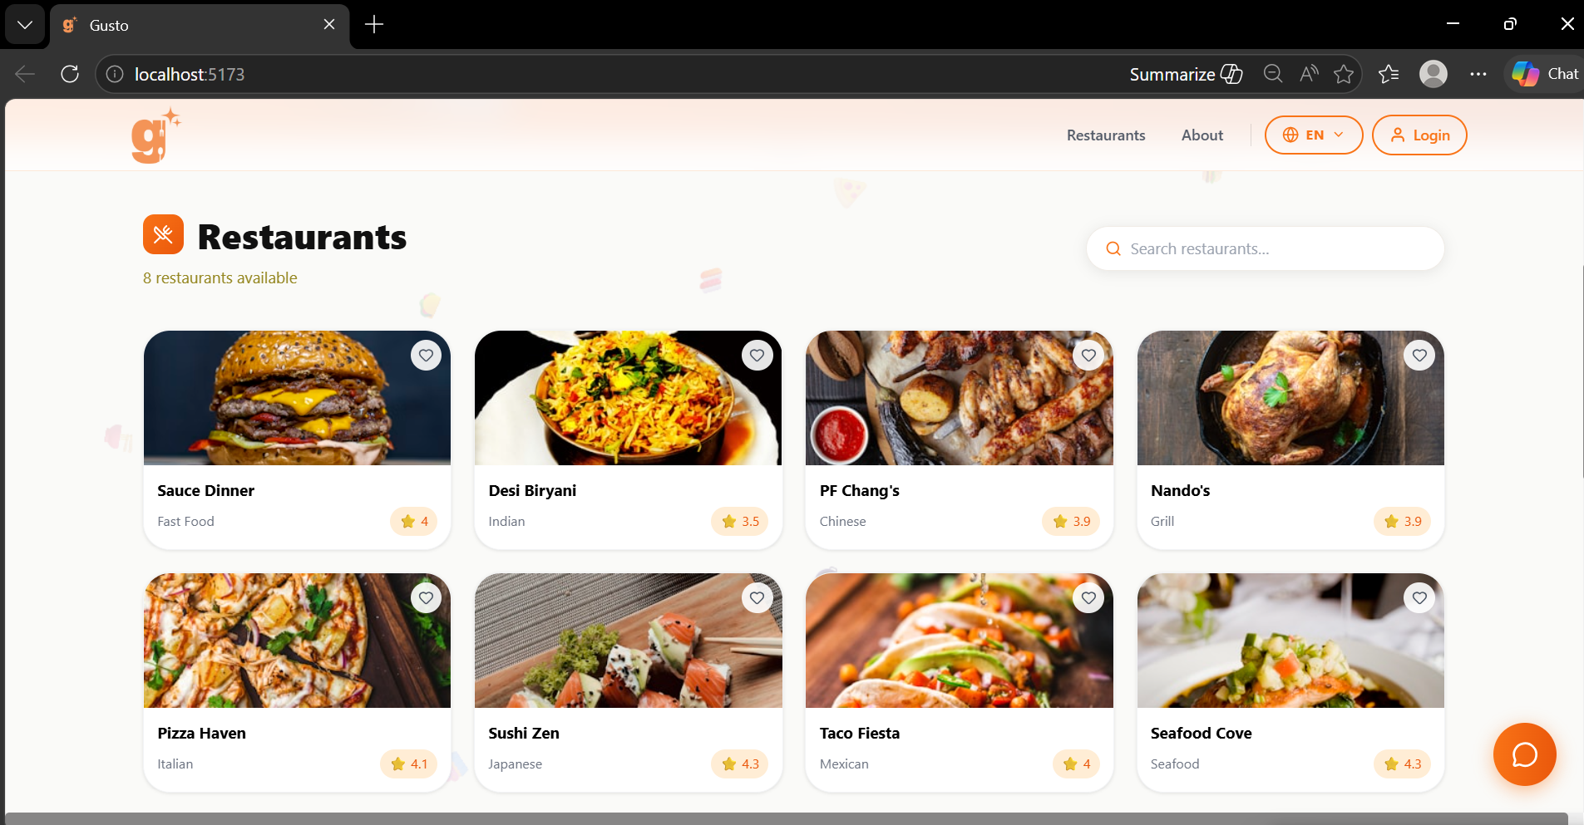
- Select your preferred language from the language selector.
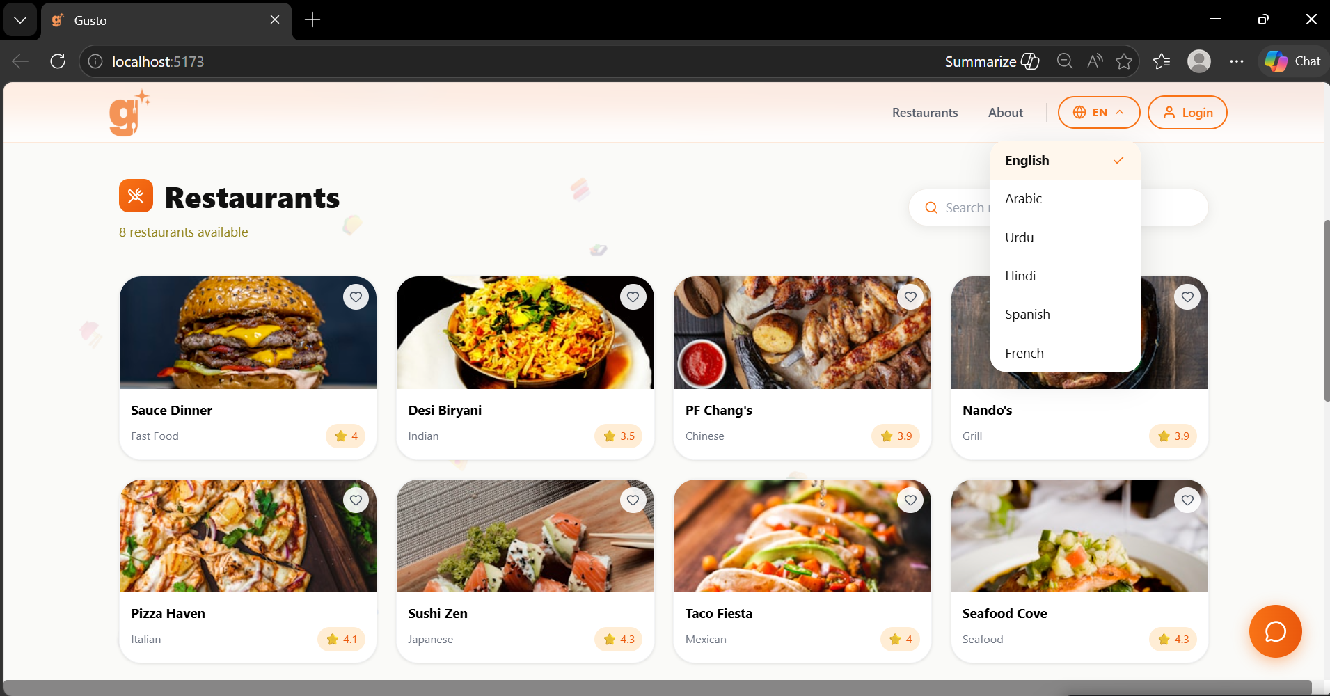
- Open the menu page to view dishes, descriptions, prices, and allergen information.
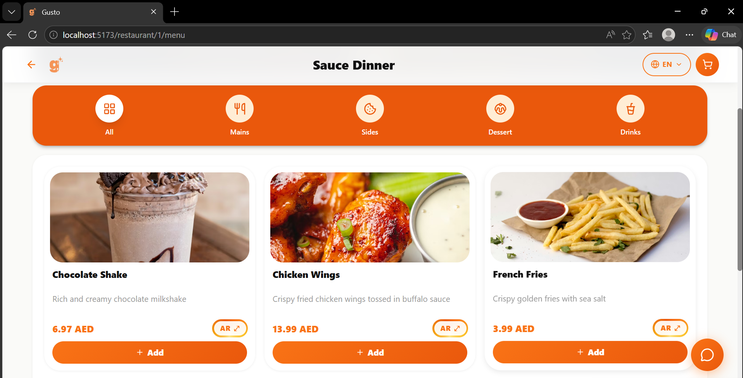
- Use category tabs such as Mains, Sides, Dessert, or Drinks to filter items.
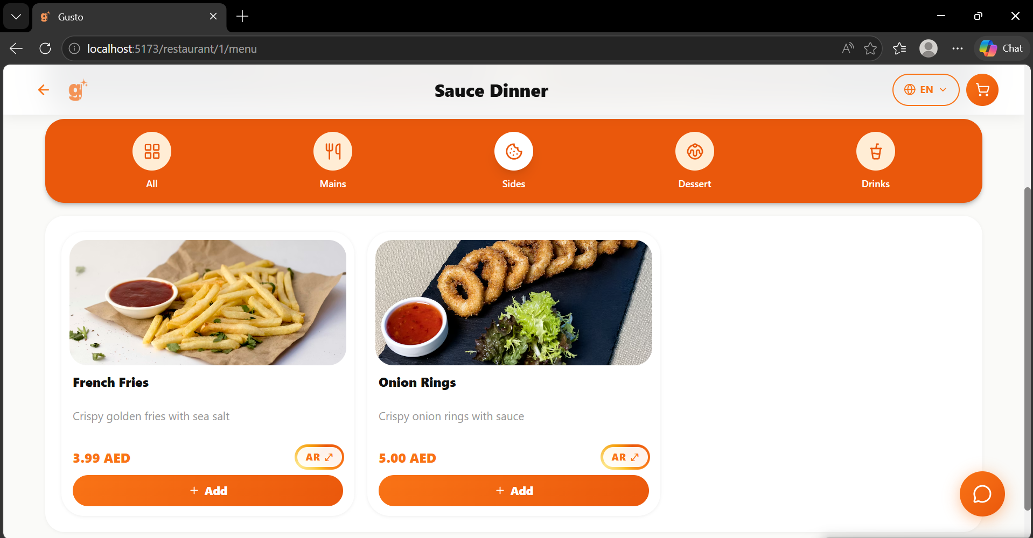
- Click the chatbot icon to ask questions about ingredients, allergens, recommendations, or translations.
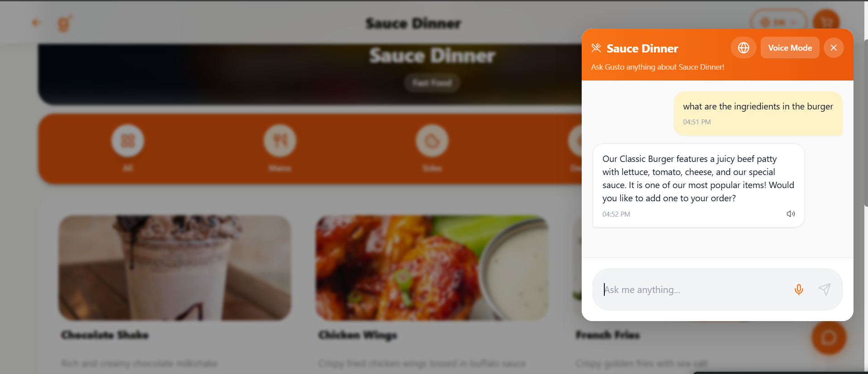
- Use voice input if supported to speak your request instead of typing.
- Add menu items to your cart or selection.
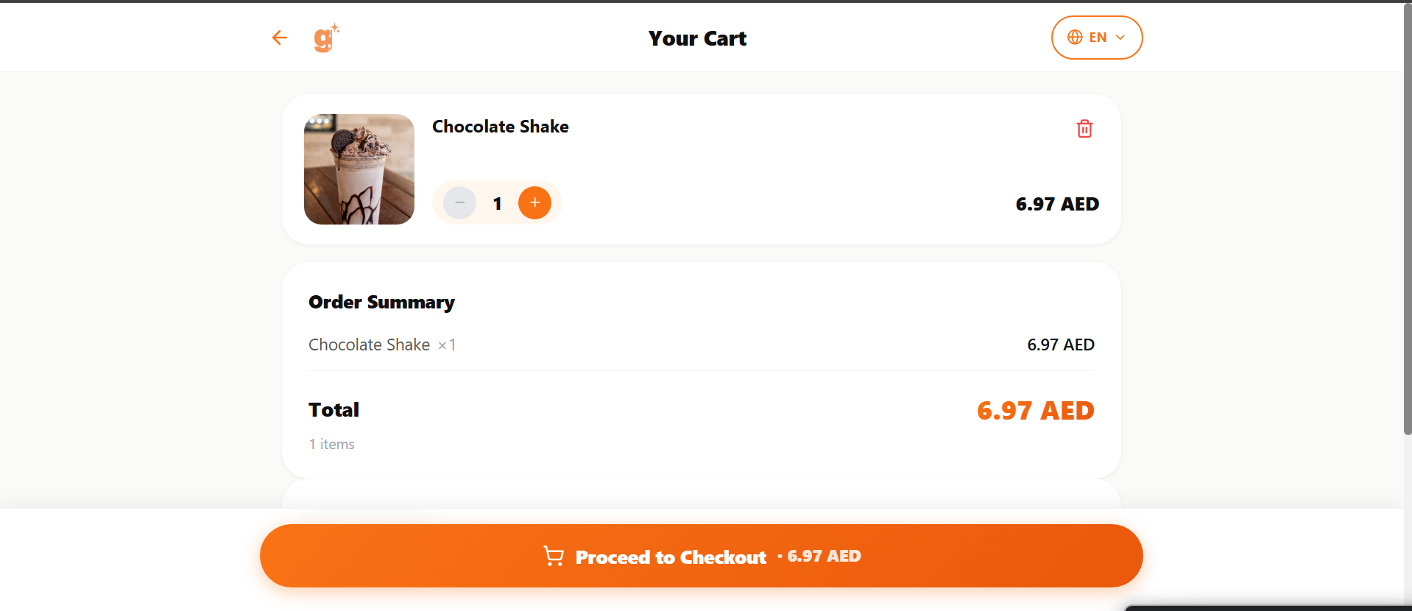
- Review the final selection summary before confirming.
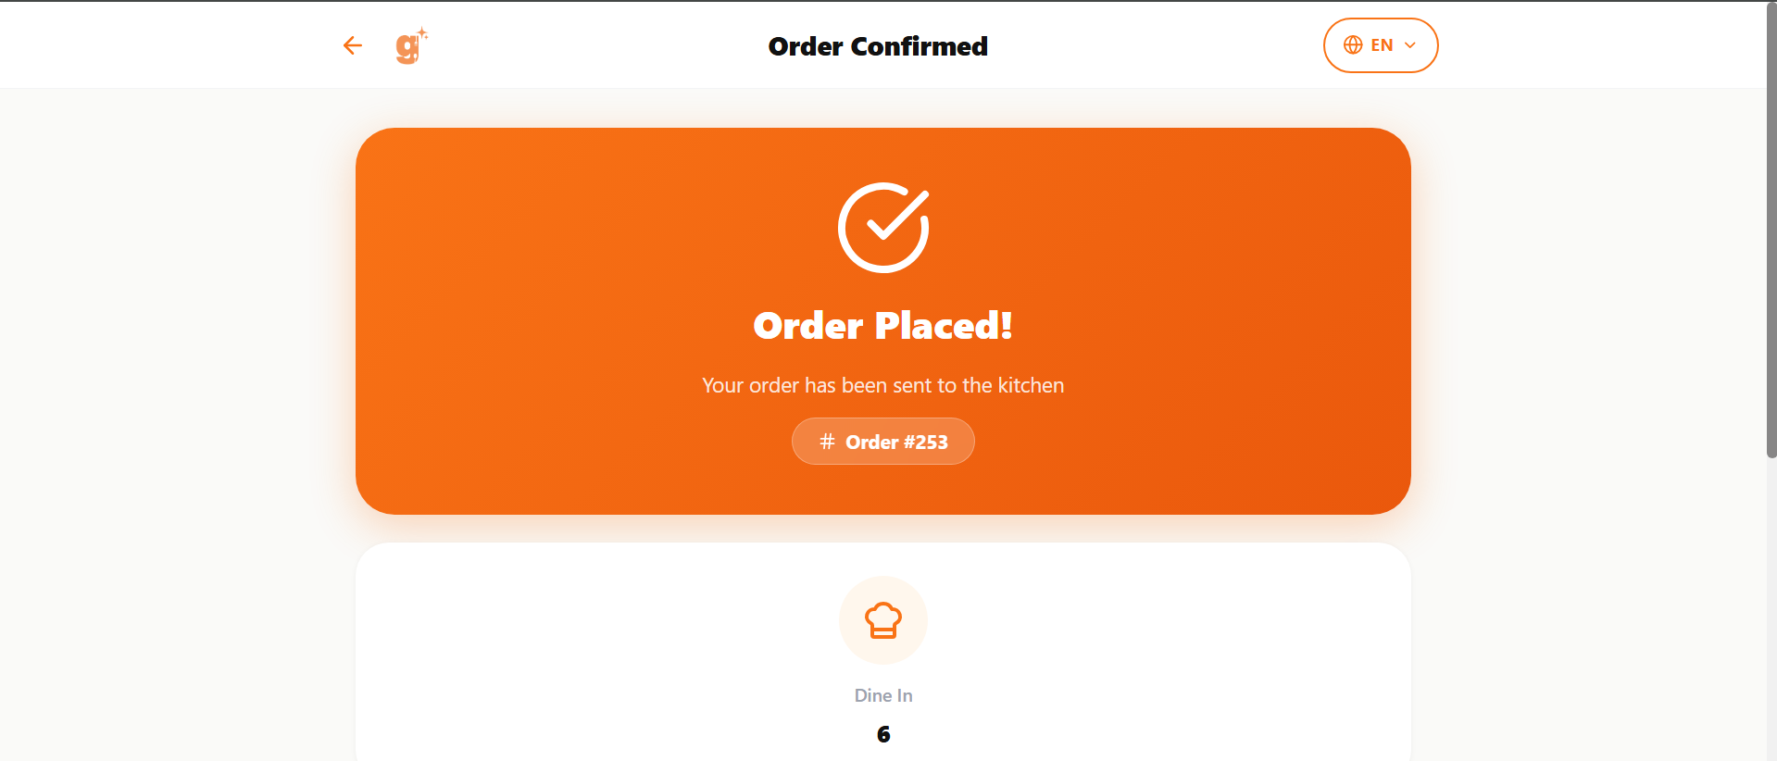
- If available, choose AR Preview to visualize the selected dish in augmented reality.
- For group dining, use the Smart Group Planning feature in the chatbot. Share each group member’s dietary restrictions, allergen preferences, and budget, and the chatbot will recommend dishes that work for the whole group in a single conversation.
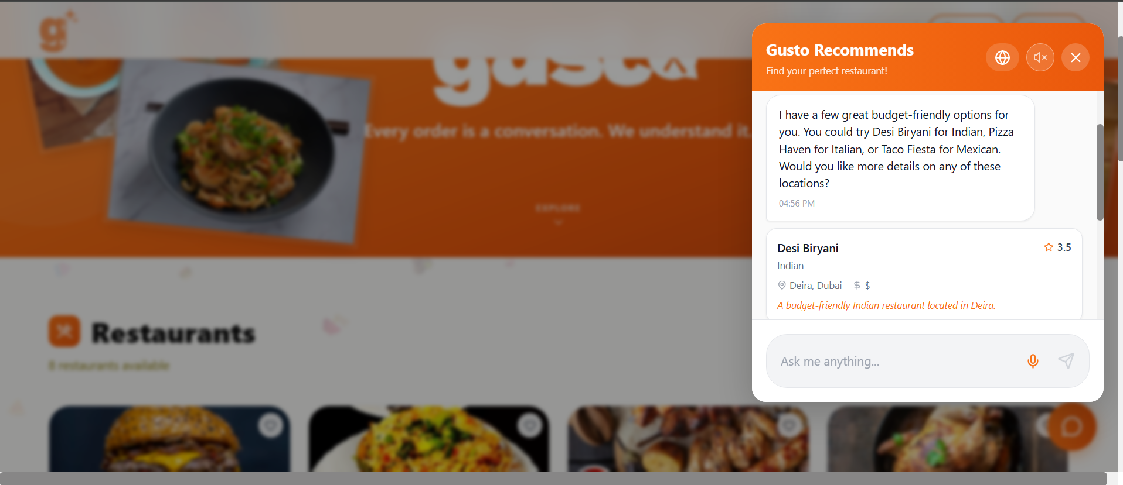

Admin User Guide
- Log in to the admin portal using valid staff credentials.
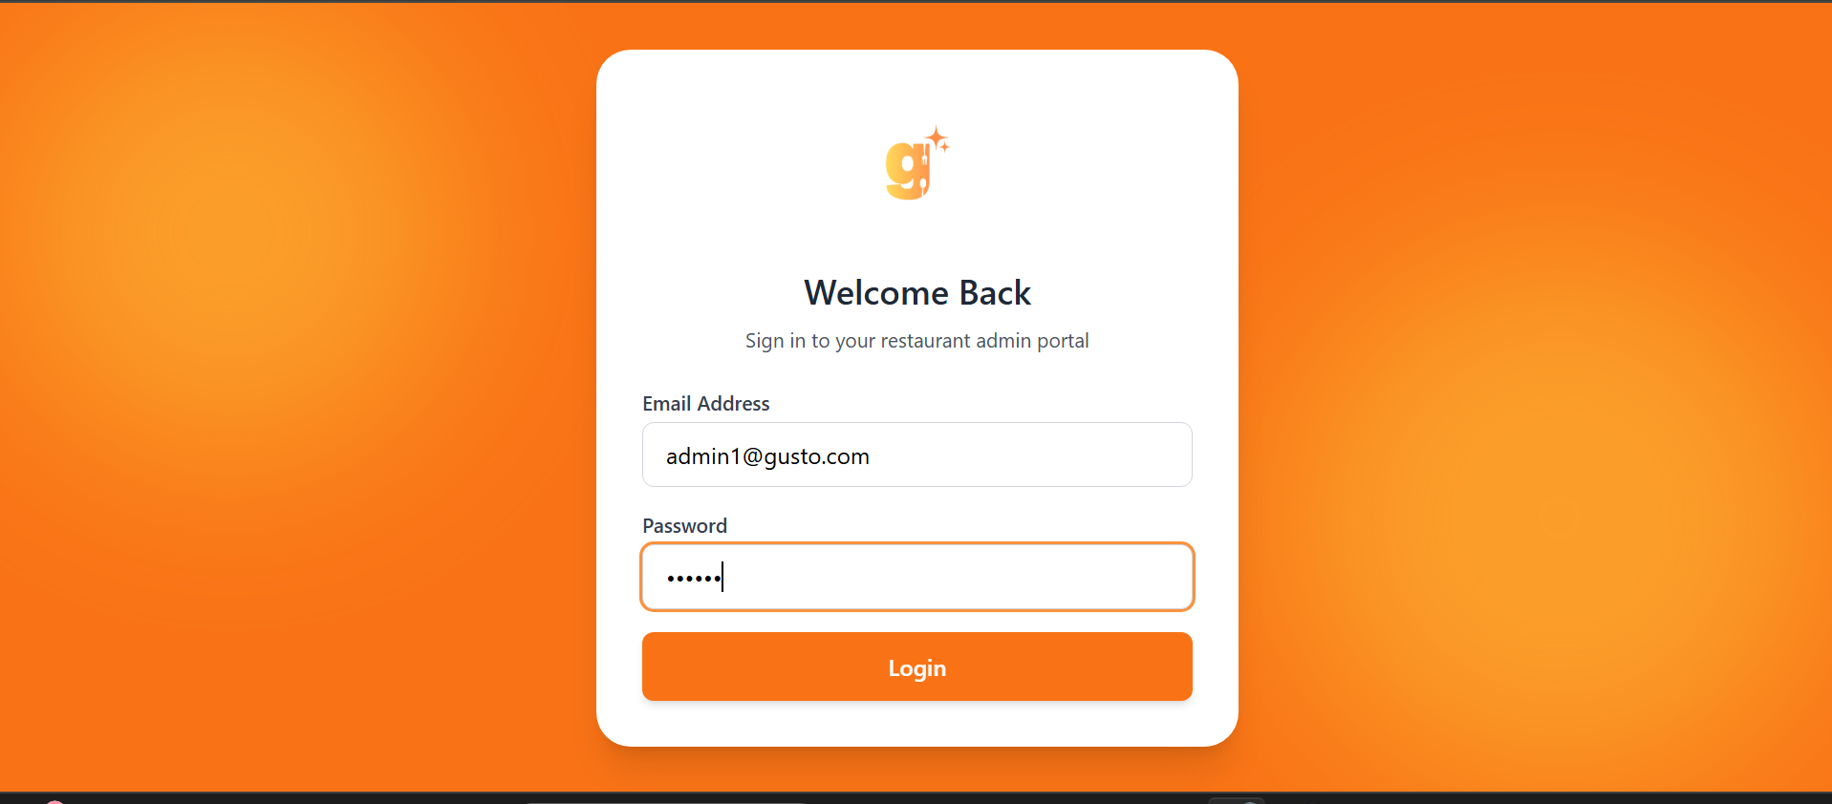
- Access menu management to add, edit, or delete menu items.
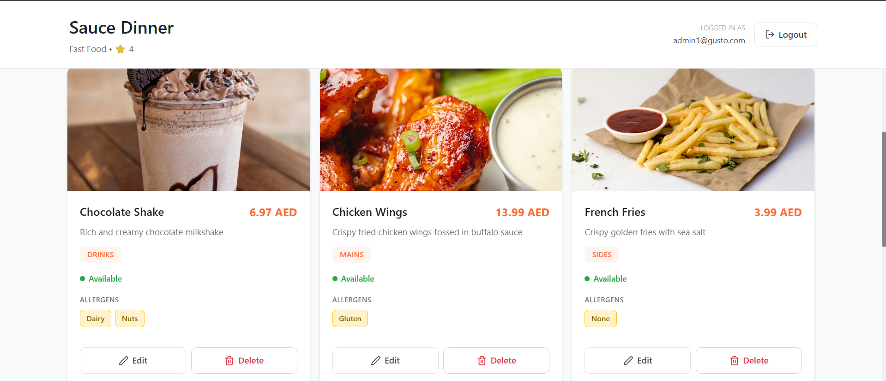
- Upload dish images and assign allergen tags to items.
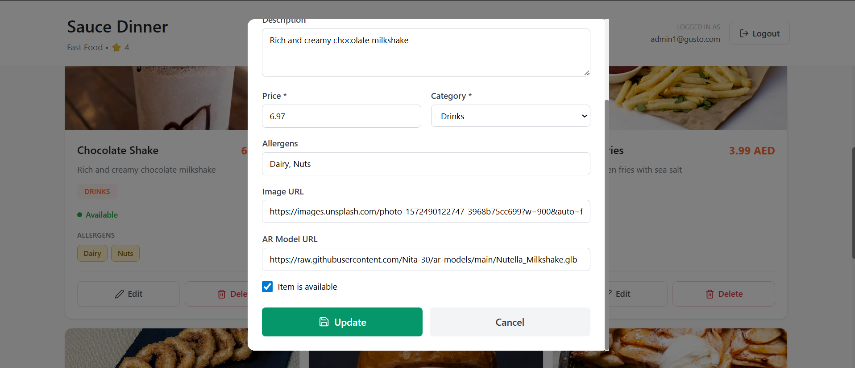
- Link AR model URLs to relevant dishes.
- Review analytics information from the dashboard.
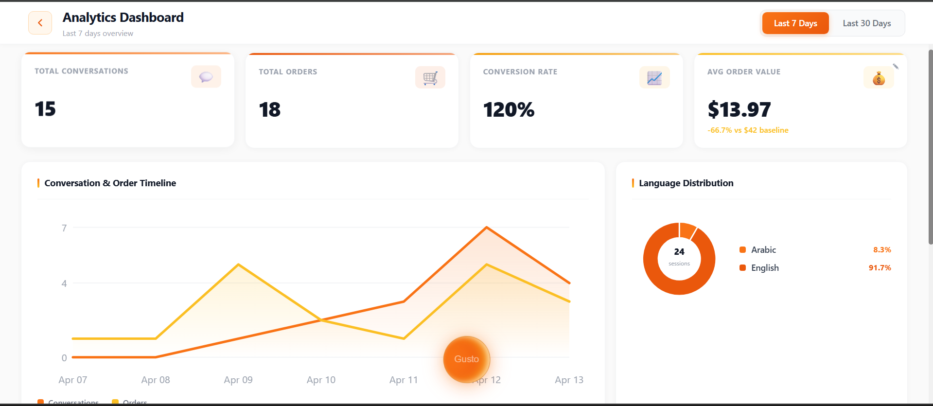
- Log out after completing administrative tasks to maintain account security.

Tutorial Notes
The system allows customers and restaurant staff to start using the system without requiring any complex installation processes. The user flow design allows users to complete their tasks through five simple steps, which include browsing, asking, filtering, visualizing, and selecting. The administrative team selected web forms together with structured menu management because these tools enable staff members who possess basic technical knowledge to operate the dashboard successfully.

References:

Educative. 2024. Software architecture diagramming and patterns. [online] Available at: https://www.educative.io/blog/software-architecture-diagramming-and-patterns [Accessed 25 Oct. 2025].
Made in Tandem. [no date]. Diagramming system architecture in 5 simple steps. [online] Available at: https://madeintandem.com/blog/diagramming-system-architecture-5-simple-steps/ [Accessed 25 Oct. 2025].
GeeksforGeeks. 2025. What is High Level Design? – Learn System Design. [online] Available at: https://www.geeksforgeeks.org/system-design/what-is-high-level-design-learn-system-design/ [Accessed 25 Oct. 2025].
Embassy of the United Arab Emirates. 2025. UAE Culture. [online] Available at: https://www.uae-embassy.org/discover-uae/traveling-in-the-uae/uae-culture [Accessed 25 Oct. 2025].
Roland Berger. 2022. UAE Tourism Strategy 2031: Key perspectives for propelling growth in the country’s tourism sector. [pdf] Available at: https://www.rolandberger.com/publications/publication_pdf/uae_tourism_strategy.pdf [Accessed 25 Oct. 2025].

World Wide Web Consortium (W3C) (n.d.) Web Content Accessibility Guidelines (WCAG) 2.1. Available at: https://www.w3.org/TR/WCAG21/#intro (Accessed: 12 November 2025).
OpenAI (2025) API Pricing. Available at: https://openai.com/api/pricing/ (Accessed: 12 November 2025).
Hamilton, T. (2025) What is Requirements Traceability Matrix (RTM) in Testing? Available at: https://www.guru99.com/traceability-matrix.html (Accessed: 13 November 2025).
GeeksforGeeks (2025) Use Case Diagram – Unified Modeling Language (UML). Available at: https://www.geeksforgeeks.org/system-design/use-case-diagram/ (Accessed: 26 November 2025).

ScienceDirect (n.d) Class Diagram. Available at: https://www.sciencedirect.com/topics/computer-science/class-diagram (Accessed: 26 November 2025).

GeeksforGeeks (2025) Unified Modeling Language (UML) Activity Diagrams. Available at: https://www.geeksforgeeks.org/system-design/unified-modeling-language-uml-activity-diagrams/ (Accessed: 27 November 2025).

Atlassian (n.d) Software Design Document – Tips & Best Practices. Available at: https://www.atlassian.com/work-management/knowledge-sharing/documentation/software-design-document (Accessed: 27 November 2025)

Team, H. (2025). What is a Test Environment? [online] Harness.io. Available at: https://www.harness.io/harness-devops-academy/test-environment [Accessed 16 Feb. 2026].

Geeksforgeeks.org. (2026). Automation Testing - Self Paced. [online] Available at: https://www.geeksforgeeks.org/courses/automation-testing-online-course [Accessed 17 Feb. 2026].

GeeksforGeeks (2022). Test Plan Software Testing. [online] GeeksforGeeks. Available at: https://www.geeksforgeeks.org/software-testing/test-plan-software-testing/ [Accessed 17 Feb. 2026].

son, H. (2023). How To Create A Test Plan (Steps, Examples, & Template) - TestRail. [online] www.testrail.com. Available at: https://www.testrail.com/blog/create-a-test-plan/ [Accessed 18 Feb. 2026].

Mahesh, H. (2024). What are Test Deliverables in Software Testing? - testRigor AI-Based Automated Testing Tool. [online] testRigor AI-Based Automated Testing Tool. Available at: https://testrigor.com/blog/test-deliverables-in-software-testing/ [Accessed 18 Feb. 2026].

Testsigma (2024). 9 Useful UI Test Cases for Testing User Interfaces. [online] Testsigma.com. Available at: https://testsigma.com/blog/ui-test-cases/ [Accessed 18 Feb. 2026].

